Local Insight profile for ‘Blackbird Leys CP’ area

Oxford City Council and District Data Service

Report created 13 January 2021

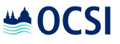

Finding your way around this Local Insight profile

Introduction Page 3 for an introduction to this report
  Population | There are 9,161 people living in Blackbird Leys CP  See pages 4-9 for more information on population by age and gender, ethnicity, country of birth, language, migration, household composition and religion |   Education & skills | 33% of people have no qualifications in Blackbird Leys CP compared with 22% across England  See pages 46-48 for more information on qualifications, pupil attainment and early years educational progress
  Vulnerable groups | 26% of children are living in poverty in Blackbird Leys CP compared with 17% across England  See pages 10-23 for more information on children in poverty, people out of work, people in deprived areas, disability, pensioners and other vulnerable groups |   Economy | 40% people aged 16-74 are in full-time employment in Blackbird Leys CP compared with 39% across England  See pages 49-55 for more information on people’s jobs, job opportunities, income and local businesses
  Housing | 2% of households lack central heating in Blackbird Leys CP compared with 3% across England  See pages 24-33 for more information on dwelling types, housing tenure, affordability, overcrowding, age of dwelling and communal establishments |   Access & transport | 39% of households have no car in Blackbird Leys CP compared with 26% across England  See pages 56-58 for more information on transport, distances services and digital services
  Crime & safety | The overall crime rate is higher than the average across England  See pages 34-35 for more information on recorded crime and crime rates |   Communities & environment | The % of people 'satisfied with their neighbourhood' (83.0%) is higher than the average across England (79.3%)  See pages 59-66 for more information on neighbourhood satisfaction, the types of neighbourhoods locally, local participation and the environment, air pollution
  Health & wellbeing | 17% of people have a limiting long-term illness in Blackbird Leys CP compared with 18% across England  See pages 36-45 for more information on limited long-term illness, life expectancy and mortality, general health and healthy lifestyles | Appendix A | Page 67 for information on the geographies used in this report, publication dates for new indicators and acknowledgements.

Oxford Consultants for Social Inclusion (OCSI), www.ocsi.co.uk / 01273 810 270. ©OCSI 2020.
This report, or any part, may be reproduced in any format or medium, provided that is reproduced accurately and not used in a misleading context. The source must be identified and the title of the publication specified with the copyright status acknowledged
Introduction

Local Insight for Oxford City Council and District Data Service  Local Insight gives you access to interactive maps and reports at small area level. These reports show key social and economic indicators and allow you to compare the area selected to comparator areas.  OCSI  Local Insight is a tool developed by Oxford Consultants for Social Inclusion (OCSI) based on a project developed jointly between OCSI and HACT.  OCSI develop and interpret the evidence base to help the public and community organisations deliver better services. A 'spin-out' from the University of Oxford Social Policy Institute, OCSI have worked with more than 100 public and community sector clients at local, national and international level. See www.ocsi.co.uk for more. | About the indicators  Information published by government as open data – appropriately visualised, analysed and interpreted – is a critical tool for Local Authorities.  OCSI collect all local data published by more than 50 government agencies, and have identified key indicators relevant to local authorities to use in this report and the interactive webtool (local.communityinsight.org).  How we have identified the “Blackbird Leys CP” area  This report is based on the definition of the “Blackbird Leys CP” area created by Oxford City Council and District Data Service, (you can view this area on the Local Insight map, through finding the area on the ‘show services’ dropdown in the top left hand corner of the map). We have aggregated data for all the neighbourhoods in “Blackbird Leys CP” to create the charts and tables used in this report.  Alongside data for the “Blackbird Leys CP”, we also show data for selected comparator areas: Oxfordshire and England.

Population: Age and gender
What information is shown here?  The information on this page shows the number of people living in Blackbird Leys CP. These population figures provide detail of the structure of the population by broad age bands and sex.  The first information box shows the total number of people usually resident in the area, with the male female breakdown. Also shown are numbers by age, and the ‘dependency ratio’. This is the ratio of non-working age (those aged 0-15 and over 65) to working age population and is useful in understanding the pressure on a productive population in providing for the costs of services and benefits used by the youngest and oldest in a population. For example, a ratio of 25% would imply one person of non-working age for every four people of working age.  The population pyramid compares the proportion of males and females by five-year age bands. The line chart shows how the population is changing over time in Blackbird Leys CP and comparator areas. The stacked bar chart, below, shows the age breakdown of the population in Blackbird Leys CP and comparator areas by broad age band.
  Total Population |  | Aged 0-15 |  | Working age population |  | Aged 65+ |  | Dependency ratio
  9,161 |  | 2,453 |  | 5,551 |  | 1,157 |  | 0.65
  49.2% male; 50.8% female |  | 26.8% (England average = 19.2%) |  | 60.6% (England average = 62.4%) |  | 12.6% (England average = 18.4%) |  | England average = 0.60
  Source: Mid-Year Estimates (ONS) 2019
Figure: Population estimates by 5-year age band
Source: Mid-Year Estimates (ONS) 2019
 | 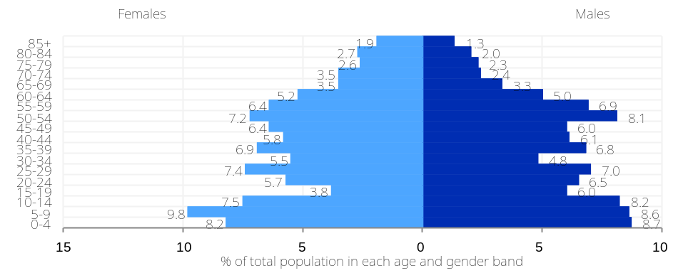
Figure: Population by age  Source: Mid-Year Estimates (ONS) 2019 | Figure: % change in total population from 2001-2019  Source: Mid-Year Estimates (ONS)
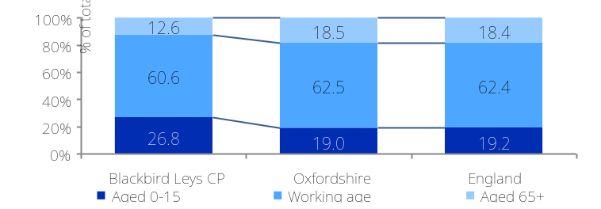 | 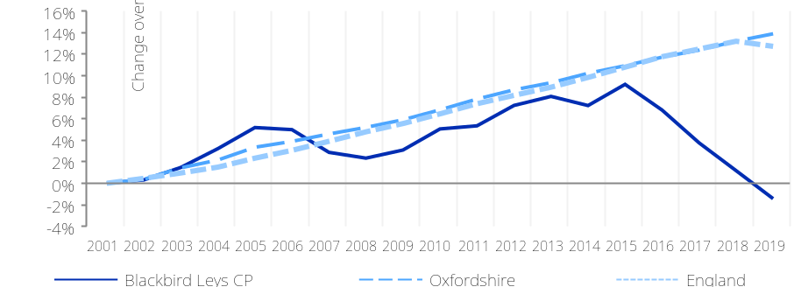
Population: Ethnicity

What information is shown here?  The information on the right shows the number of people in Blackbird Leys CP by ethnicity, based on each person’s perceived ethnic group and cultural background.  The information boxes display the number of people who have identified themselves as White British and the number from non-White ethnic minority groups, as well as the five broad ethnic minority groups (White non-British, Mixed, Asian, Black and other ethnic groups.  The final information box shows the proportion of households where not all household members are of the same ethnicity (households with multiple ethnic groups).  The bar chart on the right shows a detailed breakdown of the percentage of people in ethnic minority groups by ethnic category.
  White British |  | Non-White |  | White-non-British |  | Mixed
  6,529 |  | 2,535 |  | 816 |  | 559
  66.1% (England average = 79.8%) |  | 25.7% (England average = 14.6%) |  | 8.3% (England average = 5.7%) |  | 5.7% (England average = 2.3%)
  Asian |  | Black |  | Other ethnic group |  | Households with multiple ethnicities
  629 |  | 1,246 |  | 101 |  | 614
  6.4% (England average = 7.8%) |  | 12.6% (England average = 3.5%) |  | 1.0% (England average = 1.0%) |  | 15.7% (England average = 8.9%)
  Source: Census 2011
Figure: Population by ethnic group (excluding White British)
Source: Census 2011

 | 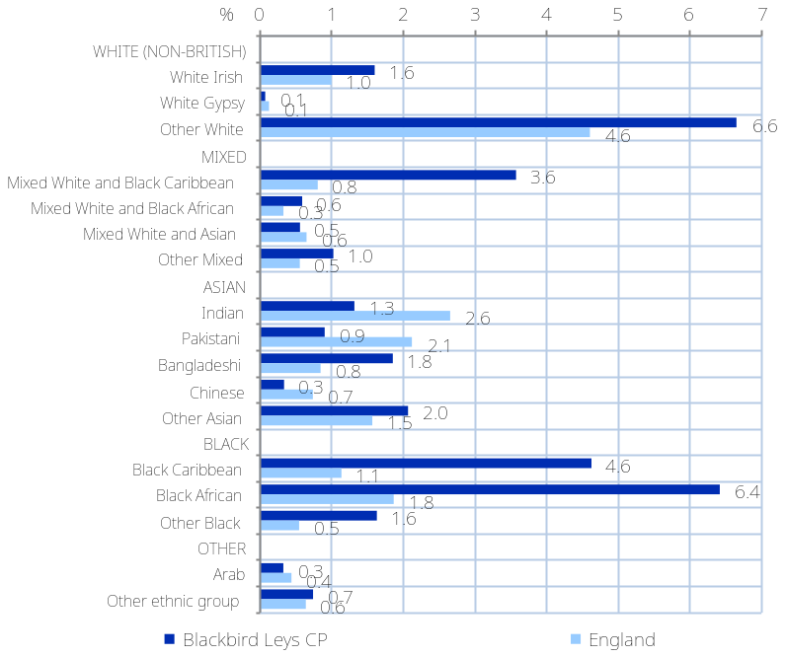
Population: Country of birth and household language

What information is shown here?  The information on the right shows the number of people in Blackbird Leys CP by country of birth.  The top row information boxes display the number of people in Blackbird Leys CP who were born in England and outside the UK as well as the number of people with a UK passport and non-UK passport.  The second row information boxes show the language breakdown of households, identifying the number of households in Blackbird Leys CP with one or more members who cannot speak English.  The bar chart on the right shows a detailed breakdown of the percentage of people in Blackbird Leys CP born outside of England by the geographic region of birth.
  Born in England |  | Born Outside the UK |  | With a UK passport |  | With a non-UK passport
  7,597 |  | 2,064 |  | 6,214 |  | 1,343
  76.9% (England average = 83.5%) |  | 20.9% (England average = 13.8%) |  | 62.9% (England average = 75.8%) |  | 13.6% (England average = 8.8%)
  All people in households have English as main language |  | At least one adult (not all) has English as main language |  | No adults but some children have English as main language |  | No household members have English as main language
  3,395 |  | 163 |  | 98 |  | 252
  86.9% (England average = 90.9%) |  | 4.2% (England average = 3.9%) |  | 2.5% (England average = 0.8%) |  | 6.4% (England average = 4.4%)
  Source: Census 2011
Figure: Population born outside England
Source: Census 2011
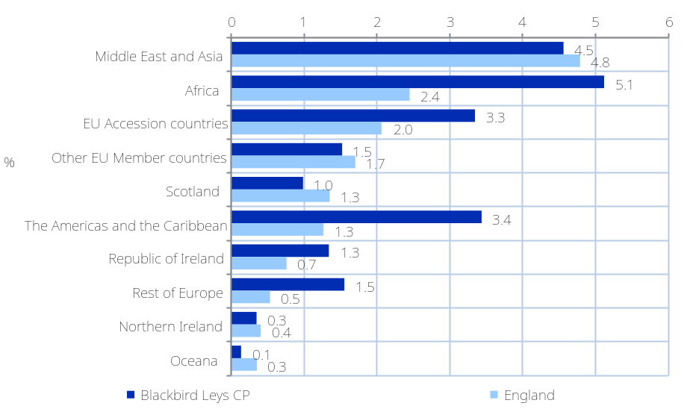
Population: Migration

Population: Migration

What information is shown here?  The information box shows the number and percentage of migrants in Blackbird Leys CP and across England as a whole. A migrant is defined as a person with a different address one year before Census day. The migrant status for children aged under one in households is determined by the migrant status of their ‘next of kin’ (defined as in order of preference, mother, father, sibling (with nearest age), other related person, Household Reference Person).  The chart on the right shows the population turnover rate by age band. This is calculated as the rate of in or out migratory moves within England and Wales per 1,000 resident population. Figures are based on GP patient register records. The left-hand bars (lighter colour) show people moving out of the area – higher values for a particular group indicate that this age-group is more likely to move away from the area. The right-hand bars (darker colour) show people moving into the area – higher values for a particular group indicate that this age-group is more likely to move into the area.  The data table on the top right and the chart on the bottom right show the total number of people registering with a National Insurance number who have come from overseas. This is a measure of the number of people who have migrated to the UK from overseas to work, who have registered for a National Insurance number in the local area.
  People who have moved address within the last 12 months (Census 2011) |  | Overseas migrants (National Insurance no. registrations of overseas nationals) (DWP 2019/20)
  991 |  | 185
  10.0% ( average = 12.3%) |  | 3.3% (average = 1.9%)
Figure: Level of inward and outward migration (by age)
Source: Population Turnover Rates – Office for National Statistics (2010)
 | 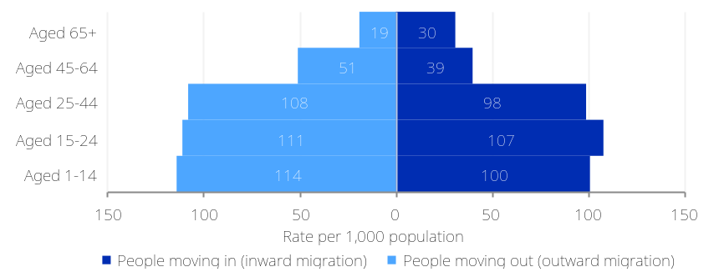
Figure: Number of overseas nationals registering with a National Insurance Number
Source: National Insurance No. registrations – Department for Work and Pensions (2019/20)
 | 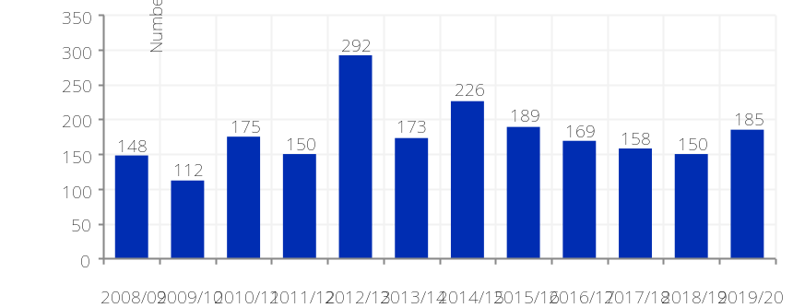

What information is shown here?  Population: All households  The information on this page shows the composition of household types in Blackbird Leys CP. The information boxes contain the number of households in Blackbird Leys CP classified under the main household composition breakdowns. The chart shows the same information as a percentage of all households.
  Pensioner households |  | One person households (aged under 65) |  | Lone parent families with dependent children
  595 |  | 804 |  | 654
  15.2% (England average = 20.7%) |  | 20.6% (England average = 17.9%) |  | 41.6% of all families with dependent children (England average = 24.5%)
  Married households |  | Cohabiting households |  | Student households
  947 |  | 368 |  | 7
  24.2% (England average = 33.2%) |  | 9.4% (England average = 9.8%) |  | 0.2% (England average = 0.6%)
  Source: Census 2011
Figure: Population by household composition
Source: Census 2011
 | 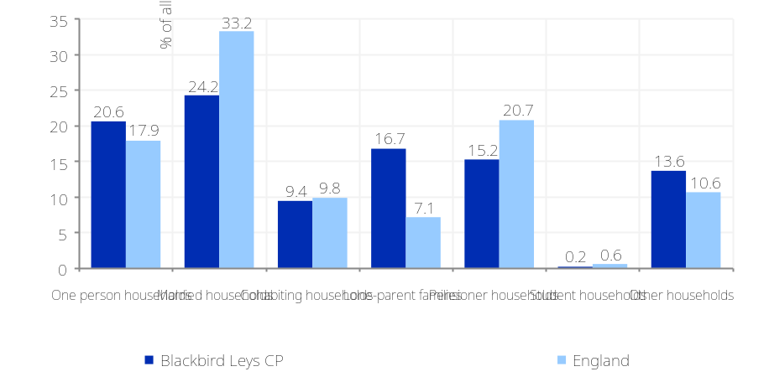

Population: Religion

What information is shown here?  The information on the right shows the number of people living in Blackbird Leys CP by religious belief, categorised by the six major religions, other religion and no religion.  The bar chart shows the percentage of people in Blackbird Leys CP and comparator areas who are of non-Christian religious belief, displayed by religion.  Note, figures in the table and charts may not add up to 100% because they do not include figures for those for who did not reply to the religion question – who were recorded as ‘religion not stated’ in the census data publication.
  Christian |  | Buddhist |  | Hindu |  | Jewish
  5,654 |  | 35 |  | 36 |  | 0
  57.2% (England average = 59.4%) |  | 0.4% (England average = 0.5%) |  | 0.4% (England average = 1.5%) |  | 0.0% (England average = 0.5%)
  Muslim |  | Sikh |  | Other religion |  | No religion
  539 |  | 21 |  | 40 |  | 2,850
  5.5% (England average = 5.0%) |  | 0.2% (England average = 0.8%) |  | 0.4% (England average = 0.4%) |  | 28.8% (England average = 24.7%)
  Source: Census 2011
Figure: Population with non-Christian religion
Source: Census 2011
 | 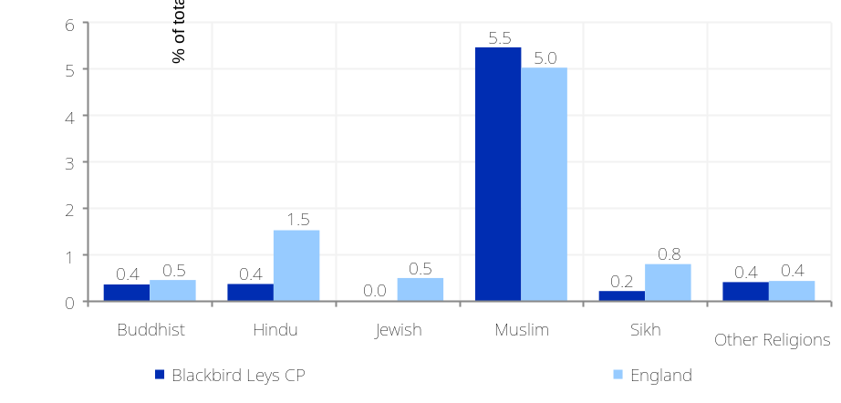

Vulnerable groups: People out of work (1)

What information is shown here?  The information in this section shows counts of people who are out of work and receiving workless benefits: Jobseekers Allowance (JSA)/Universal Credit (UC) and Incapacity Benefit (IB)/Employment and Support Allowance (ESA).  JSA is payable to people under pensionable age who are available for, and actively seeking, work of at least 40 hours a week. A subset of UC claimants (claimants in the ‘searching for work’ conditionality group) are additionally included in the ‘Unemployment Benefit’ count, as UC is slowly replacing JSA for new claims. Note, ‘the searching for work’ conditionality group includes a small number of claimants who would not be considered unemployed under the previous JSA benefits regime e.g. those with work limiting illness awaiting health checks. Therefore, there is likely to be a slight overcount of the proportion of Unemployed Benefit claimants in areas where the UC rollout is more advanced.  IB and ESA are workless benefits are payable to people who are out of work and have been assessed as being incapable of work due to illness or disability and who meet the appropriate contribution conditions. Note, since March 2016, ESA is being replaced by UC for new claimants. It is not possible to capture the total number of claimants of sickness benefits as the UC does not provide a breakdown for health condition; therefore, the total count of ESA/IB claimants presented here is likely to be an underestimate of the full count of those workless and receiving benefits due to sickness or disability.  The information boxes on the top right show: the total number of adults (aged 16-64) receiving JSA and UC; the total claiming for more than 12 months; claimants aged 18-24 and 50+, the number of people receiving ‘Incapacity benefits’ (IB or ESA); and the number and proportion of 16-64 year olds receiving workless benefits (UC, JSA, IB or ESA).
  Unemployment Benefit (JSA and UC) claimants (Oct-20) |  | Youth unemployment (JSA/UC) claimants aged 18-24) (Oct-20) |  | Older unemployed (JSA/UC claimants aged 50+) (Oct-20)
  528 |  | 94 |  | 126
  9.5% (England average = 6.4%) |  | 12.5% (England average = 9.3%) |  | 4.3% (England average = 2.5%)
  Male unemployment claimants (JSA and UC) (Oct-20) |  | Female unemployment claimants (JSA and UC) (Oct-20) |  | Working age workless benefit claimants * (May-20) |  | Incapacity benefits claimants (May-20)
  311 |  | 215 |  | 908 |  | 355
  11.2% (England average = 7.5%) |  | 7.8% (England average = 5.3%) |  | 16.4% (England average = 11.1%) |  | 6.4% (England average = 4.5%)
  Source: Department for Work and Pensions
  * ‘Working age workless benefit claimants’ is a combination of ‘Unemployment benefit claimants (JSA and Universal Credit)’ + and ‘Incapacity benefits claimants (IB/ESA)’
Figure: Unemployment benefit (Jobseekers Allowance/Universal Credit) claimants
Source: Department for Work and Pensions
 | 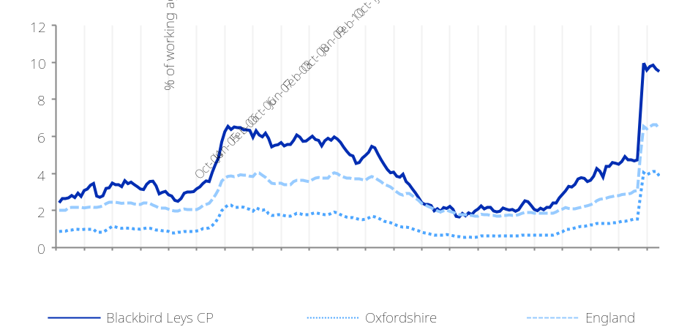

Vulnerable groups: People out of work (2)

The line charts below show month on month changes in the proportion of people claiming IB or ESA and the proportion claiming JSA or UC in the searching for work conditionality group across Blackbird Leys CP and comparator areas.
Figure: % of Jobseekers Allowance claimants claiming for more than 12 months  Source: Department for Work and Pensions (Oct-20) | Figure: Workless benefit claimants aged 16-24 and 16-64  Source: Jobseekers Allowance/Universal Credit/Incapacity benefits/Employment and Support Allowance – Department for Work and Pensions (May-20)
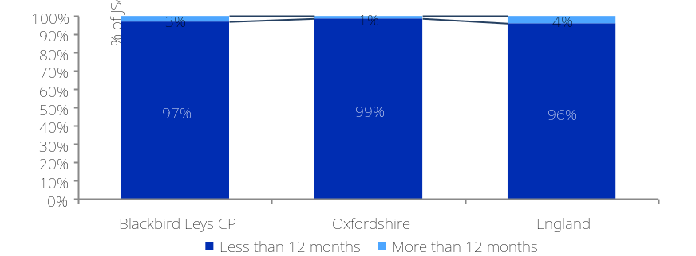 | 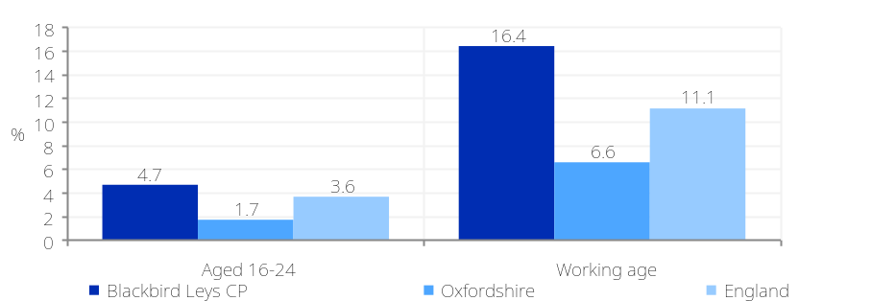
Figure: Working age population (16-64) claiming incapacity benefits (Employment Support Allowance and Incapacity Benefit)  Source: Department for Work and Pensions | Figure: 16-24-year olds receiving ‘Workless’ benefits (Incapacity Benefit, Employment Support Allowance, Jobseekers Allowance and Universal Credit)  Source: Department for Work and Pensions
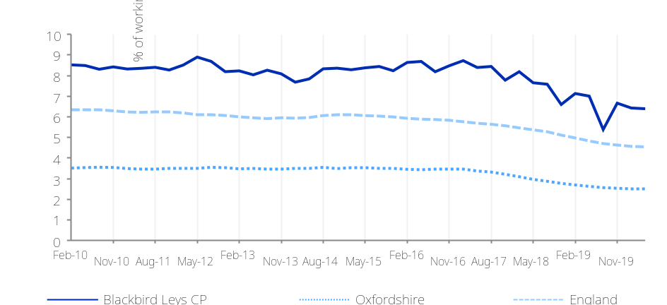 | 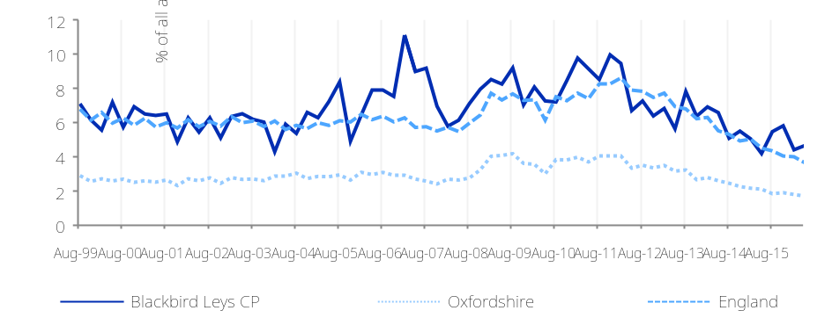

What information is shown here?  Vulnerable groups: Disability  The information in this section looks at the prevalence of disability among people living in Blackbird Leys CP. There are three measures of disability presented: those claiming Attendance Allowance, Personal Independence Payments and Disability Living Allowance.  Attendance Allowance is payable to people over the age of 65 who are so severely disabled, physically or mentally, that they need a great deal of help with personal care or supervision.  Until April 2013, Disability Living Allowance was payable to children and adults in or out of work who are below the age of 65 and who were disabled, and required help with personal care or had walking difficulties. It is a non-means tested benefit, which means it is not affected by income. From April 2013 Personal Independence Payments (PIP) have been introduced to replace Disability Living Allowance for all new claimants. PIP helps with some of the extra costs caused by long-term disability, ill-health or terminal ill-health.  The information boxes on the right show the total number of people receiving Attendance Allowance, Disability Living Allowance and PIP (by key breakdown) and for household receiving Universal Credit due to poor physical or mental health (Limited Capability for Work Entitlement) across Blackbird Leys CP.
  Attendance Allowance claimants (May-20) |  | Personal Independence Payment (PIP) (July-20) |  | PIP Males (July-20) |  | PIP Females (July-20)
  181 |  | 456 |  | 194 |  | 293
  15.6% of people (England= 12.5%) |  | 8.2% of people (England= 6.0%) |  | 7.0% of males (England= 5.6%) |  | 10.6% of females (England= 6.5%)
  PIP with mental health conditions (July-20) |  | PIP with respiratory disease (July-20) |  | Households on Universal Credit - Limited Capability for Work Entitlement (Aug-20) |  | Disability Living Allowance claimants (May-20)
  191 |  | 15 |  | 134 |  | 369
  3.4% of people (England= 2.1%) |  | 0.3% of people (England= 0.2%) |  | 3.4% of households (England= 1.6%) |  | 4.0% of people (England= 2.1%)
  Source: Department for Work and Pensions
Figure: Personal Independence Payment (PIP) recipients
Source: Department for Work and Pensions (July-20)
 | 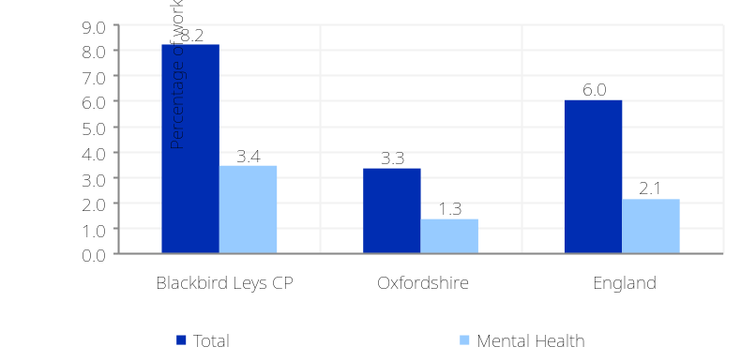

What information is shown here?  The information in this page shows the proportion of people in receipt of Universal Credit against six levels of conditionality. Conditionality refers to work-related activities an eligible adult will have to do in order to get full entitlement to Universal Credit.  - Searching for work: Claimants who are not working, or with very low earnings. The claimant is required to take action to secure work - or more / better paid work. The Work Coach supports them to plan their work search and preparation activity.  - Working with requirements: Claimants who are in work but could earn more, or not working but has a partner with low earnings.  - No work requirements: Claimants who are not expected to work at present. Health or caring responsibility prevents claimant from working or preparing for work.  - Planning for work: Claimants who are expected to work in the future. Lone parent / lead carer of child aged 1 (Aged 1 - 2, prior to April 2017). The claimant is required to attend periodic interviews to plan for their return to work.  - Working no requirements: Claimants whose individual or household earnings is over the level at which conditionality applies. Required to inform DWP of changes of circumstances, particularly if at risk of decreasing earnings or losing job.  - Preparing for work: Claimants who are expected to start preparing for future even with limited capability for work at the present time or a child aged 2 (Aged 3 - 4, prior to April 2017), the claimant is expected to take reasonable steps to prepare for work including Work Focused Interview.
  Universal Credit claimants: Searching for work (Oct-20) |  | Universal Credit claimants: Working with requirements (Oct-20) |  | Universal Credit claimants: No work requirements (Oct-20)
  491 |  | 243 |  | 274
  8.8% (England average = 5.7%) |  | 4.4% (England average = 2.3%) |  | 4.9% (England average = 2.5%)
  Universal Credit claimants: Planning for work (Oct-20) |  | Universal Credit claimants: Working no requirements (Oct-20) |  | Universal Credit claimants: Preparing for work (Oct-20)
  16 |  | 244 |  | 28
  0.3% (England average = 0.3%) |  | 4.4% (England average = 3.1%) |  | 0.5% (England average = 0.5%)
  Source: Department for Work and Pensions (DWP)
Figure: Working age population claiming Universal Credit by conditionality breakdown
Source: Department for Work and Pensions
 | 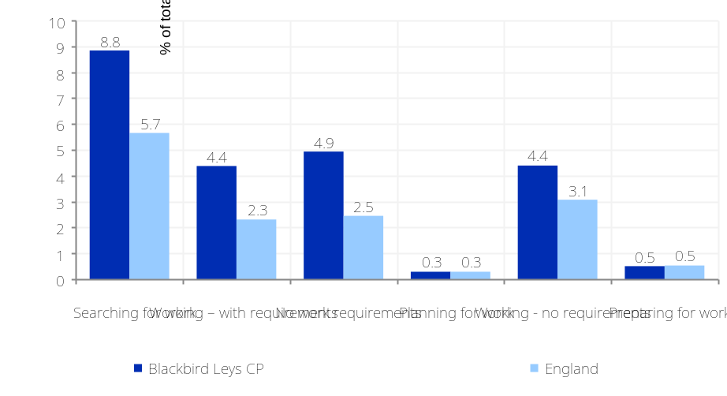
Universal Credit: Conditionality Regime
What information is shown here?  The information in this page shows the number of people in receipt of key welfare benefits payable by the Department for Work and Pensions (DWP).  Working age DWP Benefits are benefits payable to all people of working age (16-64) who need additional financial support due to low income, worklessness, poor health, caring responsibilities, bereavement or disability.  Housing Benefit (HB) can be claimed by a person if they are liable to pay rent and if they are on a low income and provides a measure of the number of households in poverty.  Income Support is a measure of people of working age with low incomes and is a means tested benefit payable to people aged over 16 working less than 16 hours a week and having less money coming in than the law says they need to live on.  Universal Credit (UC) has started to replace these legacy benefits for new claimants. The UC rollout began in April 2013, with single jobseeker’s moving on to the new benefit and by March 2016 the rollout intensified to include other groups who are out of work or on low incomes.  The chart on the right shows the change in the proportion of working age people receiving DWP benefits. The charts on the following page show the change in the proportion of Income Support and Housing Benefits claimants and the age breakdown of DWP benefit claimants across Blackbird Leys CP and comparator areas. Note, recent changes observed in these charts can be partially attributed to the migration of claimants from legacy working age DWP benefits, Housing Benefit and Income Support towards Universal Credit.
  Working age DWP Benefit claimants (Nov-16) |  | Female working age benefit claimants (Nov-16) |  | Male working age benefit claimants (Nov-16)
  974 |  | 576 |  | 396
  15.7% (England average = 10.7%) |  | 18.3% (England average = 11.8%) |  | 12.9% (England average = 9.6%)
  Income Support (IS) claimants  (May-20) |  | Housing Benefit claimants (Aug-20) |  | Universal Credit claimants (Oct-20)
  122 |  | 823 |  | 1,297
  2.2% (England average = 0.7%) |  | 20.8% (England average = 11.2%) |  | 23.4% (England average = 14.3%)
  Source: Department for Work and Pensions (DWP)
Figure: Working age population claiming DWP benefit claimants (for all DWP benefits)
Source: Department for Work and Pensions
 | 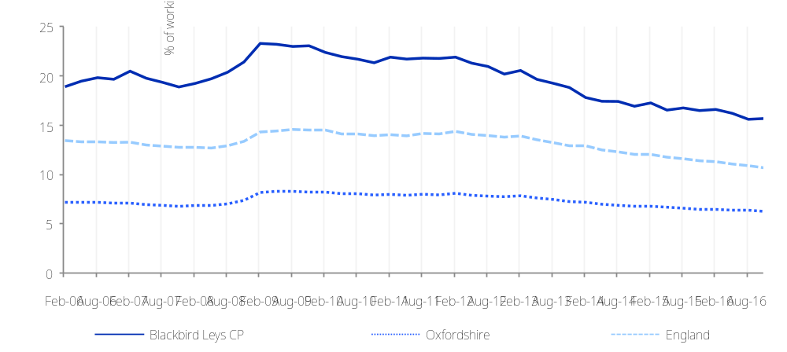
Vulnerable groups: Working age benefit claimants (1)
Vulnerable groups: Working age benefit claimants (2)
Figure: Income Support claimants  Source: Department for Work and Pensions (May-20) | Figure: Age breakdown of working age DWP benefit claimants (for all DWP benefits)  Source: Department for Work and Pensions (Nov-16)
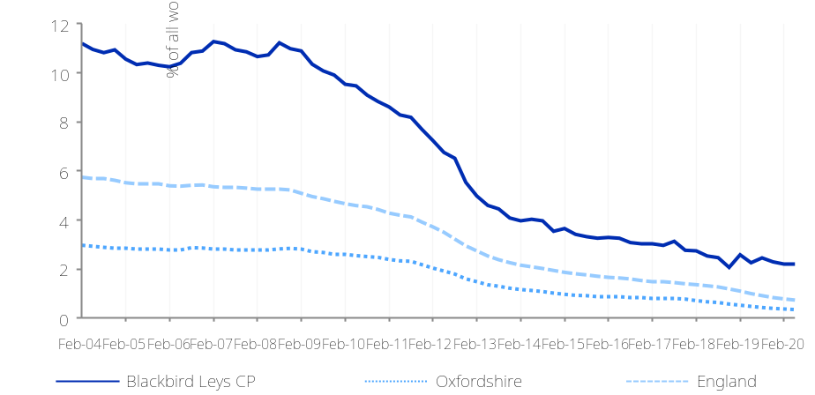 | 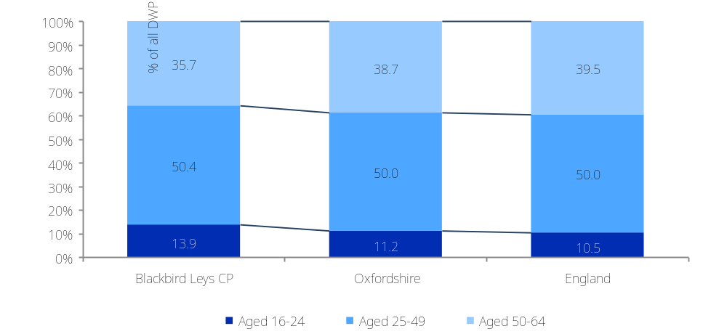
Figure: Housing Benefit claimants  Source: Department for Work and Pensions | Figure: Breakdown of working age DWP benefit claimants by reason for claim  Source: Department for Work and Pensions (Nov-16)
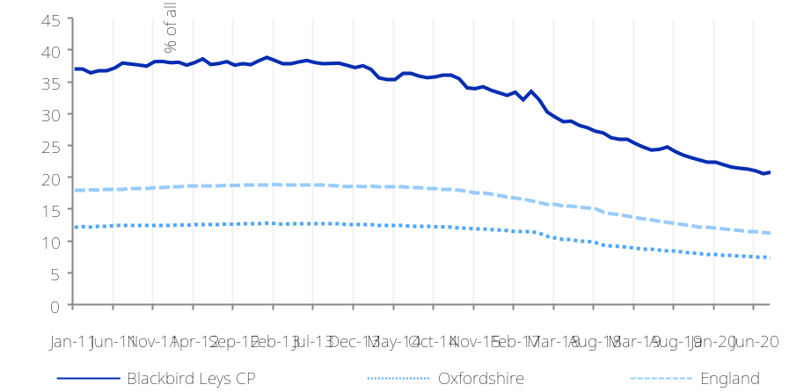 | 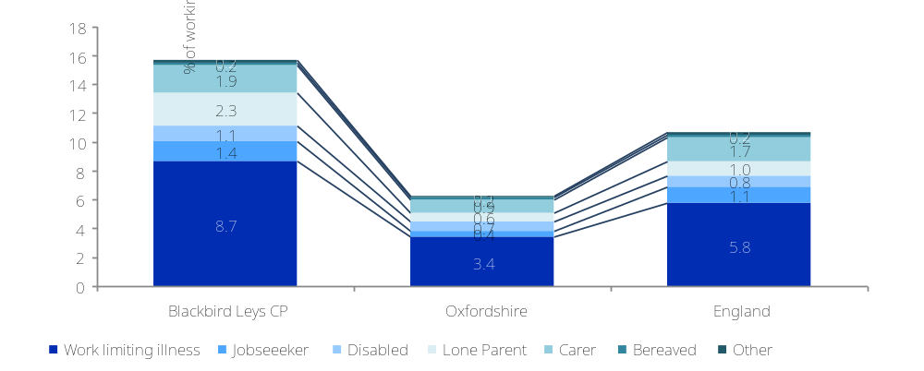

Vulnerable groups: Deprived neighbourhoods (1)
What information is shown here?  The information on this page looks at overall levels of deprivation across Blackbird Leys CP based on the Index of Multiple Deprivation (IMD) 2019. IMD 2019 is the most comprehensive measure of multiple deprivation available. The concept of multiple deprivation upon which the IMD 2019 is based is that separate types of deprivation exist, which are separately recognised and measurable. The IMD 2019 therefore consists of seven types, or domains, of deprivation, each of which contains a number of individual measures, or indicators.  The information boxes on the right show the number of people in Blackbird Leys CP living in neighbourhoods ranked among the most deprived 20% of neighbourhoods in England on IMD 2019 and the seven IMD domains. The chart on the right shows the number of people living in neighbourhoods grouped according to level of deprivation. The charts on the following pages show the same information for each of the domains. All neighbourhoods in England are grouped into ten equal sized groups “deciles”; the 10% of neighbourhoods with the highest level of deprivation (as measured in the IMD) are grouped in decile 10, and so on with the 10% of neighbourhoods with the lowest levels of deprivation grouped in decile 1.
  Number of people in Blackbird Leys CP living in the most deprived 20% of areas of England by Indices of Deprivation (ID) 2019 domain
  Index of Multiple Deprivation |  | Income domain |  | Employment domain |  | Education domain
  6,944 |  | 4,667 |  | 3,015 |  | 8,377
  75.8% (England average = 20.0%) |  | 50.9% (England average = 20.0%) |  | 32.9% (England average = 19.5%) |  | 91.4% (England average = 19.8%)
  Health domain |  | Barriers to Housing and Services domain |  | Living Environment domain |  | Crime domain
  3,015 |  | 1,924 |  | 0 |  | 3,465
  32.9% (England average = 19.6%) |  | 21.0% (England average = 21.4%) |  | (England average = 21.0%) |  | 37.8% (England average = 20.4%)
  Source: Ministry of Housing, Communities and Local Government (Indices of Deprivation 2019)
Figure: Number of people in each deprivation decile, Index of Multiple Deprivation 2019
Source: Ministry of Housing, Communities and Local Government (Indices of Deprivation 2019)
 | 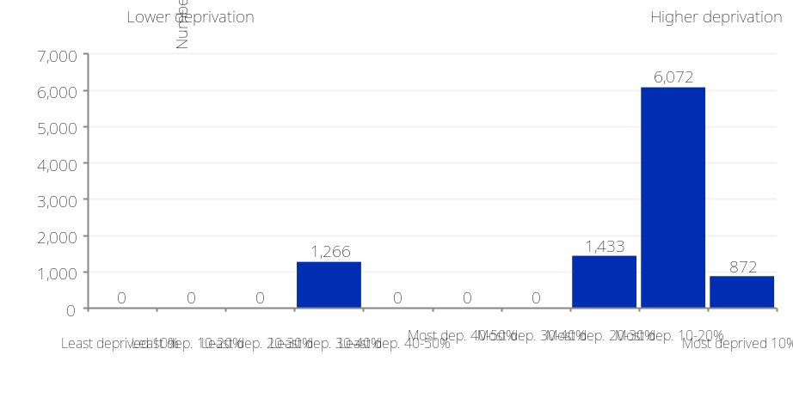

Vulnerable groups: Deprived neighbourhoods (2)

Figure: Number of people in each deprivation decile, ID 2019 Income domain  Source: Ministry of Housing, Communities and Local Government (Indices of Deprivation 2019)  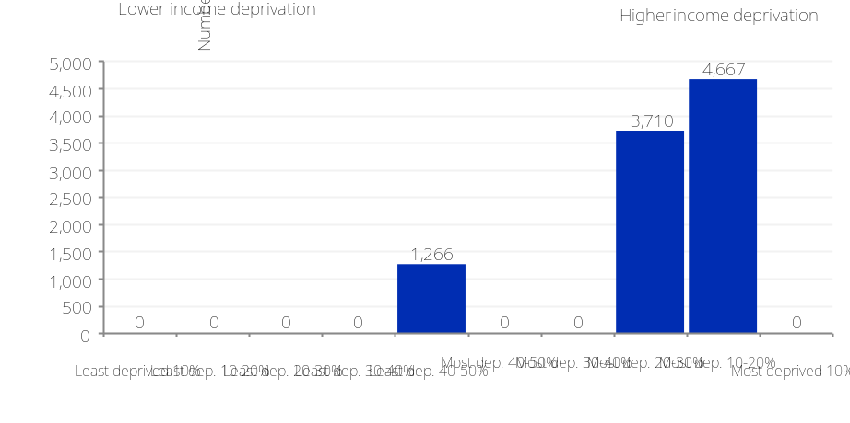 | Figure: Number of people in each deprivation decile, ID 2019 Education domain  Source: Ministry of Housing, Communities and Local Government (Indices of Deprivation 2019)  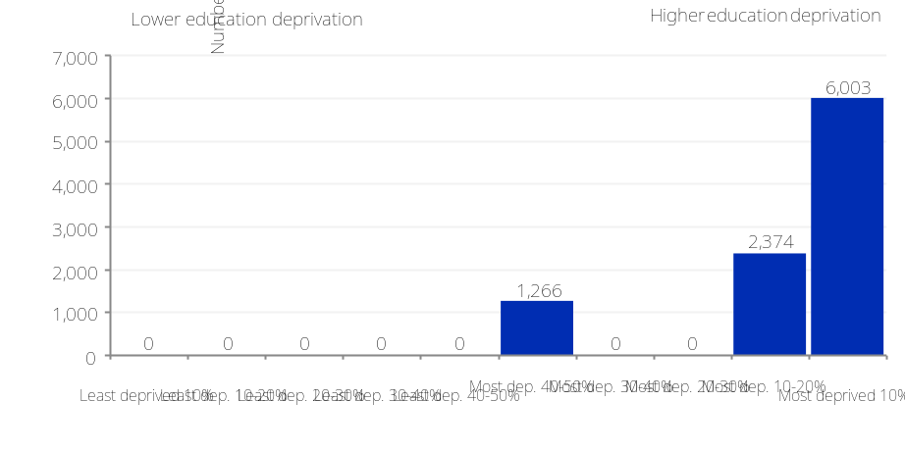
Figure: Number of people in each deprivation decile, ID 2019 Employment domain  Source: Ministry of Housing, Communities and Local Government (Indices of Deprivation 2019)  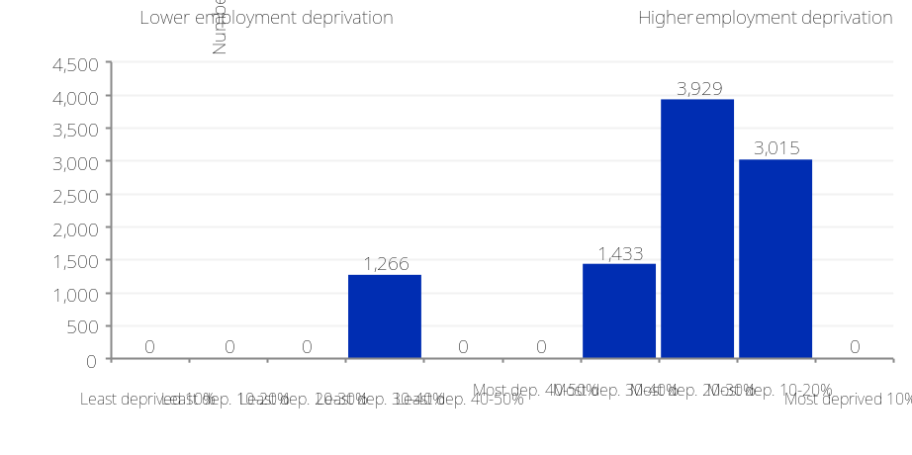 | Figure: Number of people in each deprivation decile, ID 2019 Health domain  Source: Ministry of Housing, Communities and Local Government (Indices of Deprivation 2019)  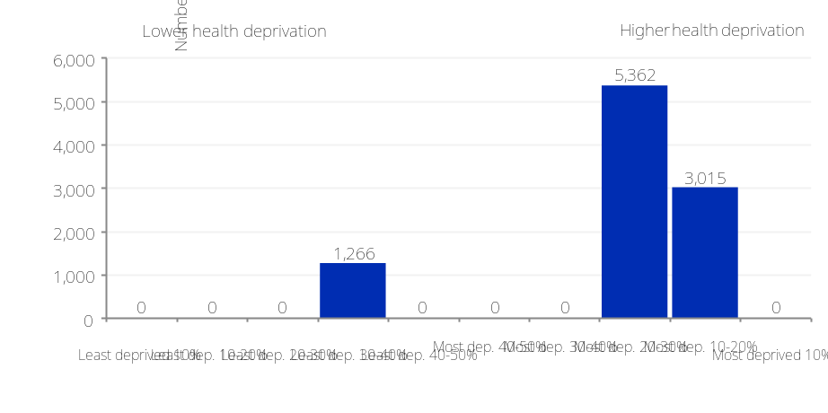

Vulnerable groups: Deprived neighbourhoods (3)

Figure: Number of people in each deprivation decile, ID 2019 Barriers to Housing and Services domain  Source: Ministry of Housing, Communities and Local Government (Indices of Deprivation 2019)  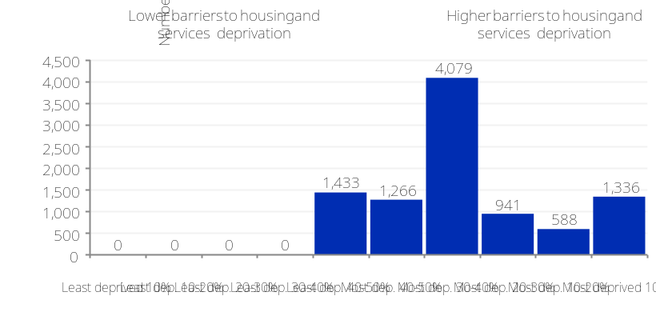 | Figure: Number of people in each deprivation decile, ID 2019 Crime domain  Source: Ministry of Housing, Communities and Local Government (Indices of Deprivation 2019)  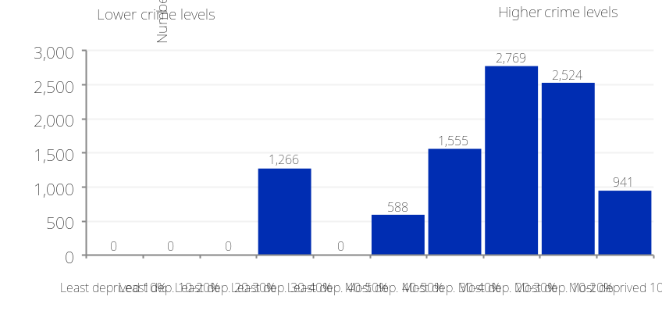
Figure: Number of people in each deprivation decile, ID 2019 Living Environment domain
Source: Ministry of Housing, Communities and Local Government (Indices of Deprivation 2019)
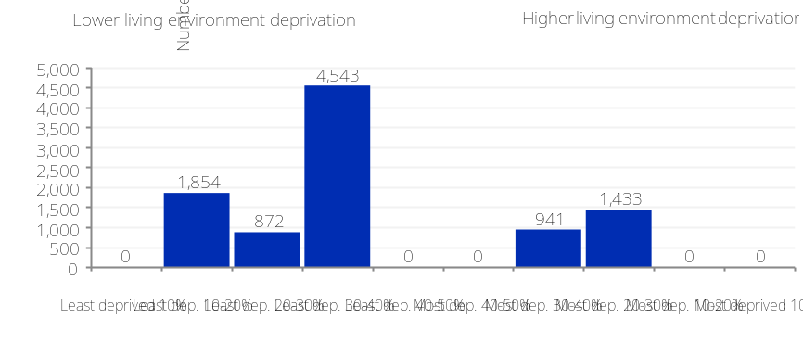

Vulnerable groups: Children (1)

What information is shown here?  This page looks at children in low-income families, out of work households and lone parent households. Relative low income is defined as a family in low income Before Housing Costs (BHC) in the reference year. Absolute low income is a family in low income Before Housing Costs (BHC) in the reference year in comparison with incomes in 2010/11. A family must have claimed one or more of Universal Credit, Tax Credits or Housing Benefit at any point in the year to be classed as low income in these statistics. Children are dependent individuals aged under 16; or aged 16 to 19 in full-time non-advanced education.  This is the first release of these statistics, which have replaced DWP’s Children in out-of-work benefit households and HMRC’s Personal Tax Credits: Children in low-income families local measure. See here for more information: https://www.gov.uk/government/publications/children-in-low-income-families-local-area-statistics-201415-to-201819/children-in-low-income-families-local-area-statistics-201415-to-201819  The information boxes on the right show the count of people in each of these categories in Blackbird Leys CP. The bar chart shows the percentage of children in relative and absolute low-income families.
  Children in relative low income families |  | Children in absolute low income families |  | Children in relative low income lone parent families |  | Children in relative low income out of work families
  602 |  | 532 |  | 293 |  | 242
  21.1% (England average = 18.2%) |  | 18.6% (England average = 15.2%) |  | 48.7% of relative low-income families (England average = 40.8%) |  | 40.2% of relative low-income families (England average = 30.7%)
  Source: Children in low-income families, Department for Work and Pensions (2018)
Figure: Children living in low-income families
Source: Department for Work and Pensions (2018)
 | 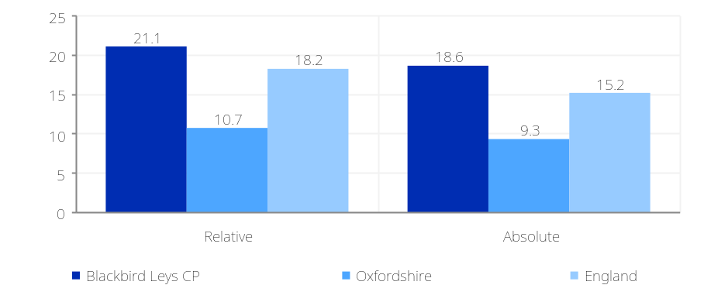

What information is shown here?  The information on this page shows levels of child wellbeing across Blackbird Leys CP as measured using the Child Wellbeing Index (CWI) from 2009. The CWI is a small area index measuring child wellbeing – how children are doing in a number of different aspects of their life. The index covers the major domains of a child’s life that have an impact on child wellbeing and that are available for neighbourhoods in England. The CWI is made up of seven domains.  The eight information boxes on the right show the number of people in Blackbird Leys CP living in areas ranked among the most deprived 20% of neighbourhoods in England on CWI and the seven domains. The chart on the right shows the number of people living in neighbourhoods grouped according to level of child wellbeing deprivation. All neighbourhoods in England are grouped into ten equal sized groups “deciles”; the 10% of neighbourhoods with the highest level of deprivation (lowest level of child wellbeing) are grouped in decile 10, and so on with the 10% of neighbourhoods with the lowest levels of deprivation grouped in decile 1.
  Number of people in Blackbird Leys CP living in the most deprived 20% of areas of England by Child Wellbeing Index domain
  Child Wellbeing Index |  | Children in Need domain |  | Material Wellbeing domain |  | Education domain
  7,247 |  | 10,043 |  | 7,247 |  | 10,043
  72.2% (England average = 20.2%) |  | 100.0% (England average = 20.1%) |  | 72.2% (England average = 20.2%) |  | 100.0% (England average = 19.8%)
  Environment domain |  | Health domain |  | Housing domain |  | Crime domain
  0 |  | 5,556 |  | 2,422 |  | 8,699
  (England average = 20.5%) |  | 55.3% (England average = 19.9%) |  | 24.1% (England average = 20.4%) |  | 86.6% (England average = 19.8%)
  Source: Communities and Local Government (Child Wellbeing Index 2009)
Figure: Number of people in each deprivation decile, Child Wellbeing Index 2009
Source: Communities and Local Government (Child Wellbeing Index 2009)
 | 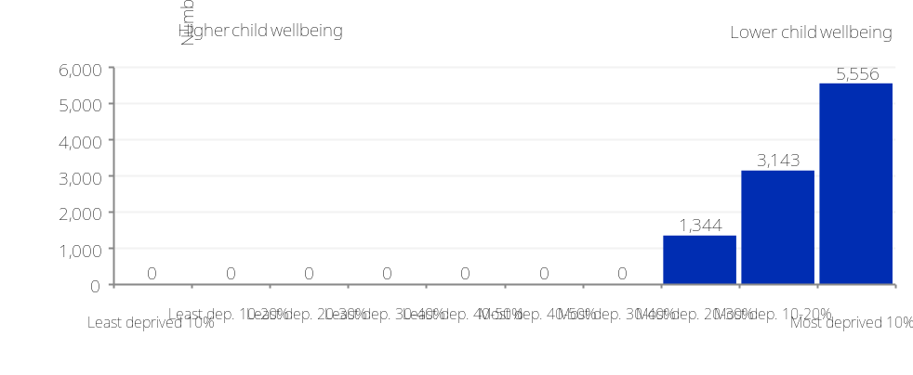

Vulnerable groups: Children (2) - Child Wellbeing Index

Vulnerable groups: Pensioners

What information is shown here?  The information on this page looks at pensioner groups including those that may face greater risks or who may have different types of need. There are three measures included: pensioners without access to transport, pensioner loneliness and pensioners in poverty.  Pensioners without access to transport are those with no access to a car or van. The dataset only includes pensioners living in private households.  There are two indicators of pensioner loneliness. The census provides a measure of the proportion of pensioners living alone (defined as households of one pensioner and no other household members). In addition, Age Concern have developed a Loneliness Index (which predicts the prevalence of loneliness amongst people aged 65+) based on census data. Areas with a value closer to 0 predict a greater prevalence of loneliness amongst those aged 65 and over and living in households compared to areas with a value further away from 0.  Pensioners in poverty are those in receipt of Pension Credit. Pension Credit provides financial help for people aged 60 or over whose income is below a certain level set by the law.  The information boxes present information on the counts of pensioner households or pensioners in each category. The chart on the top right shows the change in the proportion of people receiving Pension Credit across Blackbird Leys CP and comparator areas.  The chart on the bottom right compares Loneliness Index scores across Blackbird Leys CP and comparator areas - a value closer to 0 predicts a greater prevalence of loneliness amongst those aged 65.
  Private pensioner households with no car or van (Census 2011) |  | Households of one pensioner (Census 2011) |  | State pension claimant (DWP May-20) |  | Pension credit claimant (DWP May-20)
  515 |  | 381 |  | 1,062 |  | 297
  44.9% of pensioner households (England average = 40.8%) |  | 64.0% of pensioner households (England average = 59.6%) |  | 91.8% (England average = 94.2%) |  | 25.7% (England average = 12.4%)
 | Figure: Pension Credit claimants, Source: Department for Work and Pensions (May-20)
 | 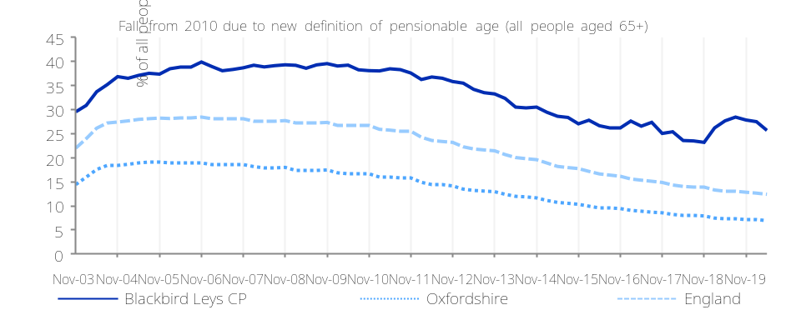
 | Figure: Loneliness index (probability of loneliness for those aged 65 and over). Source: Age UK (2011)
 | 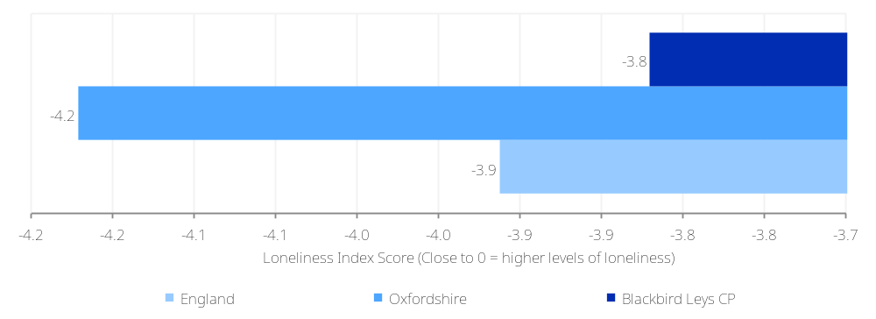

Vulnerable groups: Households with multiple needs

What information is shown here?  The information on this page looks at household deprivation and households with multiple deprivation.  The information boxes show the number of households which are deprived in one of the four Census 2011 deprivation dimensions. The Census 2011 has four deprivation dimension characteristics: a) Employment: Any member of the household aged 16-74 who is not a full-time student is either unemployed or permanently sick; b) Education: No member of the household aged 16 to pensionable age has at least 5 GCSEs (grade A-C) or equivalent AND no member of the household aged 16-18 is in full-time education c) Health and disability: Any member of the household has general health 'not good' in the year before Census or has a limiting long term illness d) Housing: The household's accommodation is either overcrowded; OR is in a shared dwelling OR does not have sole use of bath/shower and toilet OR has no central heating. These figures are taken from responses to various questions in census 2011.  Households with multiple deprivation are households experiencing four key measures of deprivation:  - All adult household members have no qualifications  - At least one household member is out of work (due to unemployment or poor health)  - At least one household member has a limiting long-term illness  - The household is living in overcrowded conditions
  Household is not deprived in any dimension  (Census 2011) |  | Household is deprived in 1 dimension  (Census 2011) |  | Household is deprived in 2 dimensions  (Census 2011) |  | Household is deprived in 3 dimensions  (Census 2011)
  1,171 |  | 1,378 |  | 990 |  | 332
  30.0% (England average = 42.5%) |  | 35.3% (England average = 32.7%) |  | 25.3% (England average = 19.1%) |  | 8.5% (England average = 5.1%)
Households suffering multiple deprivation (Census 2011)
37
0.9% (England average = 0.5%)

What information is shown here?  Vulnerable groups: Other groups  The information on this page looks at the number and proportion of people in two groups with specific needs: mental health issues and people providing unpaid care.  The figures for people with mental health issues are based on Employment Support Allowance/Incapacity Benefit claimants who are claiming due to mental health related conditions. Incapacity Benefit is payable to persons unable to work due to illness or disability.  Informal care figures show people who provide any unpaid care by the number of hours a week they provide that care. A person is a provider of unpaid care if they give any help or support to another person because of long-term physical or mental health or disability, or problems related to old age.  The line chart on the right shows the change in the number of people claiming Incapacity benefit for mental health reasons as a proportion of the working age population and the chart below it includes figures for children and all people providing unpaid care across Blackbird Leys CP.
  Mental health related benefits (DWP May-20) |  | People providing unpaid care (Census 2011) |  | Unpaid care (50+ hours per week) (Census 2011)
  180 |  | 883 |  | 240
  3.2% of working age adults (England average = 2.3%) |  | 8.9% (England average = 10.2%) |  | 2.4% (England average = 2.4%)
Figure: Receiving Employment Support Allowance (ESA) and Incapacity Benefit (IB) due to mental health
Source: Department for Work and Pensions
 | 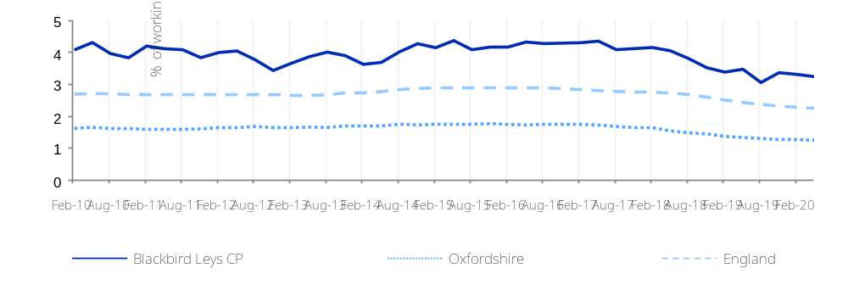
Figure: People providing unpaid care
Source: Census 2011
 | 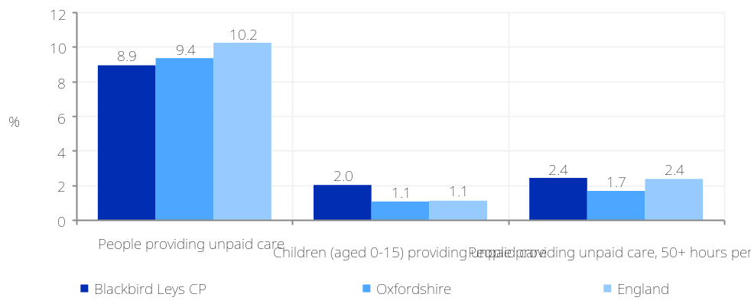

Housing: Type
What information is shown here?  The information on this page looks at the type of dwelling space people live in. A dwelling space is the accommodation occupied by an individual household or, if unoccupied, available for an individual household, for example the whole of a terraced house, or a flat in a purpose-built block of flats.  The information boxes to the right show the number of people in Blackbird Leys CP living in each accommodation type. The chart on the right shows a breakdown of households by accommodation type across Blackbird Leys CP and comparator areas.
  Detached |  | Semi-detached |  | Terraced |  | Purpose built flat
  193 |  | 942 |  | 1,669 |  | 1,102
  4.9% (England average = 22.3%) |  | 23.8% (England average = 30.7%) |  | 42.2% (England average = 24.5%) |  | 27.9% (England average = 16.7%)
  Flat (in converted house) |  | Flat (in commercial property) |  | Caravan or other temporary dwelling |  | Second homes (2001)
  36 |  | 10 |  | 04 |  | 00
  0.9% (England average = 4.3%) |  | 0.3% (England average = 1.1%) |  | 0.1% (England average = 0.4%) |  | 0.0% (England average = 0.6%)
  Source: Census 2011
Figure: Dwellings type breakdown
Source: Census 2011
 | 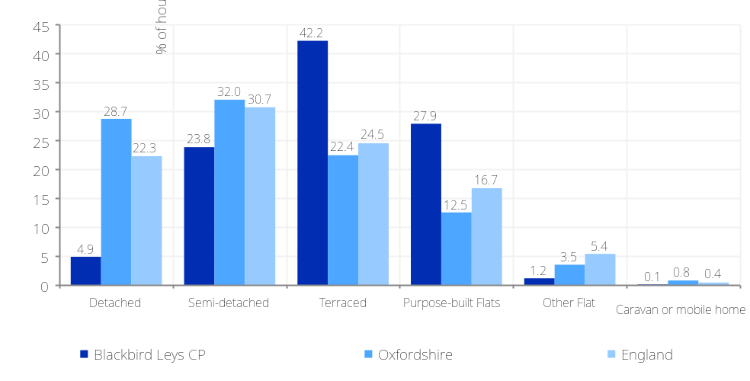
Housing: Tenure
What information is shown here?  The information on this page looks at the tenure of housing in Blackbird Leys CP. The information boxes show the number of households broken down by tenure type and the chart shows the tenure breakdown across Blackbird Leys CP and comparator areas.  - ‘Owner occupied’ housing includes accommodation that is either owned outright, owned with a mortgage or loan, or shared ownership (paying part rent and part mortgage).  - ‘Social rented’ housing includes accommodation that is rented from a council (Local Authority) or a Housing Association, Housing Co-operative, Charitable Trust, Non-profit housing company or Registered Social Landlord.  - ‘Rented from the Council includes accommodation rented from the Local Authority  - ‘Housing Association or Social Landlord’ includes rented from Registered Social Landlord, Housing Association, Housing Co-operative, Charitable Trust and non-profit housing Company.  - ‘Private rented or letting agency’ includes accommodation that is rented from a private landlord or letting agency.  - ‘Other Rented’ includes employer of a household member and relative or friend of a household member and living rent free.
  Owner occupied |  | Owner-occupied: owned outright |  | Owner-occupied owned: with mortgage or loan
  1,512 |  | 477 |  | 880
  38.7% (England average = 64.1%) |  | 12.2% (England average = 30.6%) |  | 22.5% (England average = 32.8%)
  Owner-occupied: shared ownership |  | Social rented households |  | Rented from Council
  155 |  | 1,948 |  | 1,269
  4.0% (England average = 0.8%) |  | 49.8% (England average = 17.7%) |  | 32.5% (England average = 9.4%)
  Rented from Housing Association or Social Landlord |  | Rented from private landlord or letting agency |  | Other rented dwellings
  679 |  | 379 |  | 69
  17.4% (England average = 8.3%) |  | 9.7% (England average = 15.4%) |  | 1.8% (England average = 2.8%)
  Source: Census 2011
Figure: Housing tenure breakdowns
Source: Census 2011
 | 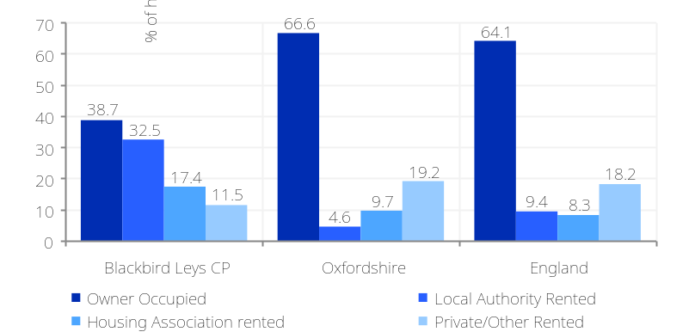

Housing: How affordable is local housing? (1)
What information is shown here?  The information in this section shows measures of housing costs in Blackbird Leys CP. Data on house prices is from the Land Registry open data price-paid dataset (www.landregistry.gov.uk/market-trend-data/public-data/price-paid-data), which is updated monthly.  House prices by dwelling type  The information boxes on the right and the top-left chart on the following page show the mean house prices by accommodation type across Blackbird Leys CP and comparator areas for four key dwelling types (detached houses, semi-detached houses, flats and terraced houses). The bottom-left chart on page 25 shows the 10-year inflation adjusted average change in house prices across Blackbird Leys CP and comparator areas.  The top-right chart on page 25 displays the monthly change in the number of transactions and average price across Blackbird Leys CP and the bottom-right chart displays the ratio of the number of residential property transactions (Land Registry Sep18-Aug19) to the number of owner occupied and privately rented dwellings (Census 2011) – an approximate measure of the proportion of housing stock that has change hands of the year, or the housing ‘churn’.  Council tax bands  The data on Council Tax bands shows the number and proportion (as a percentage of all rateable households) of houses in bands A, B or C (the lowest price bands) and F, G and H (the highest price bands) locally. These price bands are set nationally, so can be used to show how the cost of all local property (not just those properties that have recently been sold) compares with other areas; the chart on the right compares Blackbird Leys CP and comparator areas for these Council Tax bands.
  Average house price (all types of housing) (Land registry Sept-19 to August-20) |  | Average house price (detached) (Land registry Sept-19 to August-20) |  | Average house price (flats) (Land registry Sept-19 to August-20)
  £295,361 |  |  |  | £165,000
  England average = £304,430 |  | England average = £428,202 |  | England average = £301,449
  Average house price (semi-detached) (Land registry Sept-19 to August-20) |  | Average house price (terraced) (Land registry Sept-19 to August-20) |  | Households in Council Tax Band A (Valuation Office Agency (VOA) 2020)
  £371,000 |  | £281,107 |  | 241
  England average = £263,140 |  | England average = £248,047 |  | 6.2% (England average = 24.2%)
  Households in Council Tax Band B (VOA 2020) |  | Households in Council Tax Band C (VOA 2020) |  | Households in Council Tax Band F-H (VOA 2020)
  963 |  | 2,369 |  | 00
  24.7% (England average = 19.6%) |  | 60.7% (England average = 21.8%) |  | 0.0% (England average = 9.2%)
Figure: Dwelling stock by council tax band
Source: Valuation Office Agency (2020)
 | 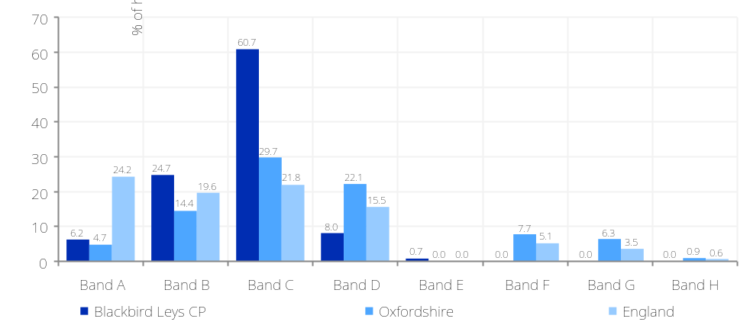

Housing: How affordable is local housing? (2)
Figure: Average property price by dwelling type  Source: Land registry | Figure: Average house prices and no. of transactions (note: there were no recorded transactions during the COVID-19 lockdown period so figures are shown as zero for this period), Source: Land Registry
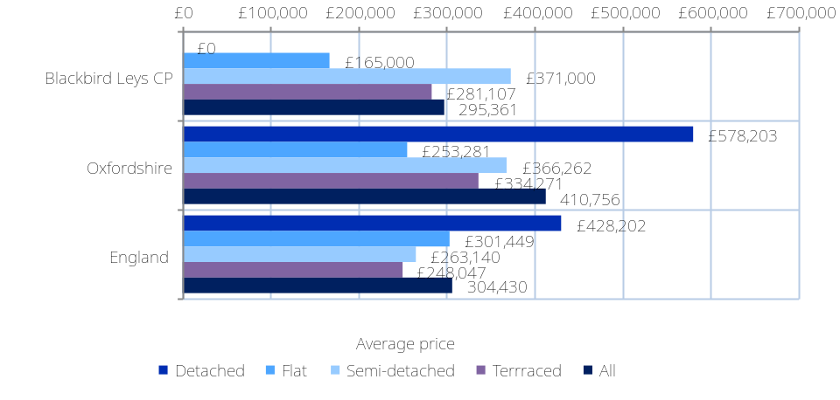 | 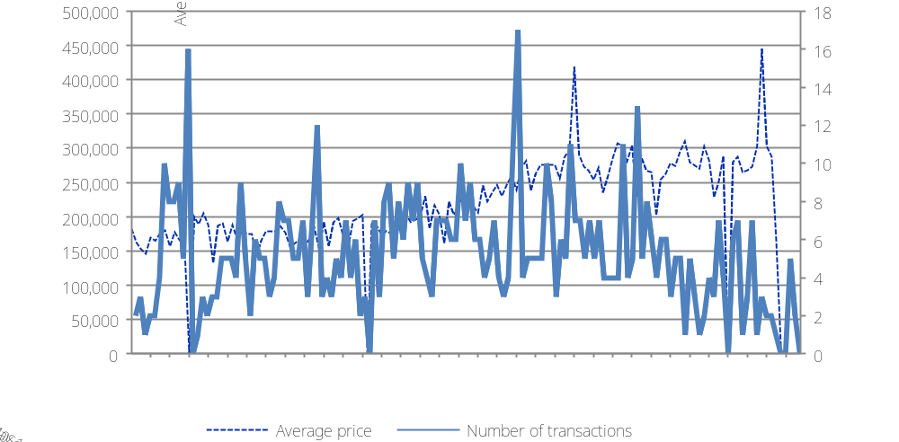
Figure: 10-year average house price change (inflation adjusted)  Source: Land registry Oct06-Oct07 to Oct16-Sep17 | Figure: Ratio of residential property transactions to the total number of private dwellings  Source: Land Registry Sept-19 to August-20, Census 2011
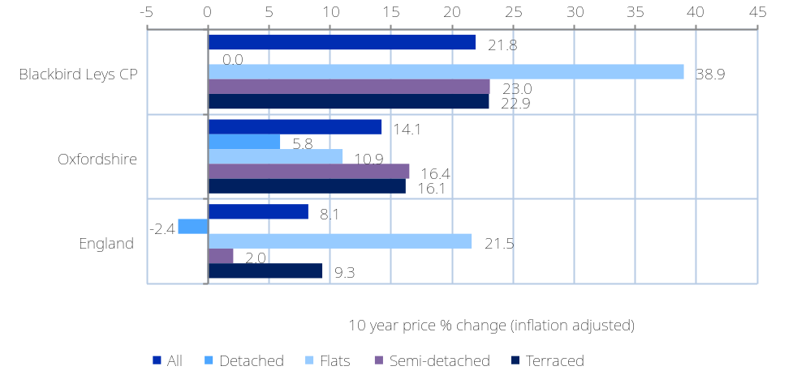 | 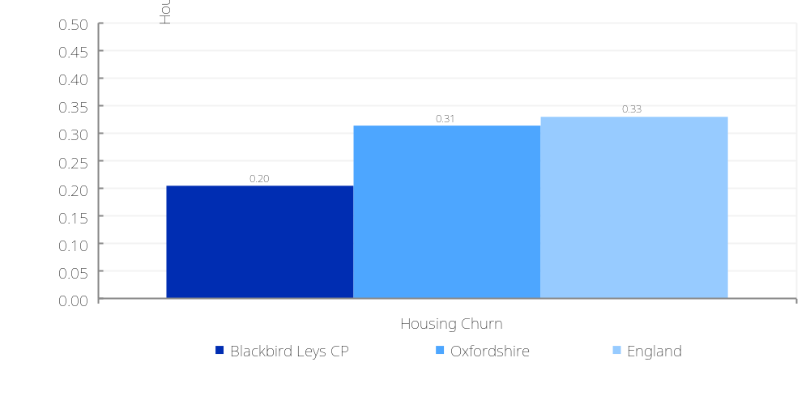

What information is shown here?  The information in this section combines measures of local house prices and local earnings to provide a more balanced picture of housing affordability.  There are three indicators displayed here: housing affordability gap, savings ratio and total affordability ratio. Each of these indicators is given for two measures of house price: the average (median) house price and the lower quartile house price. The lower quartile house price is set such that the cheapest 25% of houses fall within this price and is a measure of the cost of cheaper, more affordable housing in the area.  Housing affordability gap: An estimate of the gap between the cost of local houses and the amount residents can borrow. This is defined as the difference between the local house price (either median or lower quartile) and 4.5 times local annual earnings (mortgage lenders are typically willing to lend 4-5 times annual salaries). Higher figures represent more unaffordable houses.  Savings ratio: The ratio between 15% of the house price (an estimate of the savings required for a deposit) and monthly earnings. It can be interpreted as the number of months’ worth of earnings required for a deposit (not accounting for inflation or changes in earnings or house prices).  Total affordability ratio: This is the ratio between the total house price and annual earnings. It can be interpreted as the number of years’ worth of earnings required for a deposit (not accounting for inflation or changes in earnings or house prices).  The data for these measures come from the ONS House Price Statistics for Small Areas (HPSSA) and ONS Income Estimates. Earnings data is published at MSOA level and house price data is published at LSOA level and above) Where necessary, we have modelled data to LSOA and OA geographies. The methodology used to produce these statistics is based ONS’s housing affordability analysis.
  Lower quartile house price (‘affordable housing’) |  | Average house price
  Affordability gap |  | Affordability gap
  £72,377 |  | £99,411
  England average = -£39,328 |  | England average = £42,272
  Savings ratio  (months of earnings for a deposit) |  | Savings ratio  (months of earnings for a deposit)
  12.07 |  | 13.55
  England average = 6.54 |  | England average = 10.41
  Total ratio  (years of earnings for a house) |  | Total ratio  (years of earnings for a house)
  6.32 |  | 6.98
  England average = 3.57 |  | England average = 5.5
Figure: Housing affordability gap for lower quartile house prices and average house prices.
Source: ONS House Price Statistics for Small Areas Oct16-Sep17; ONS earnings data 2015/2016
Housing: How affordable is local housing? (3)
Housing: Central heating, household overcrowding and dwelling size
What information is shown here?  The information on this page details indicators of the built environment: overcrowded housing, vacant housing, population density, the size of housing units and the proportion of households lacking central heating.  A household's accommodation is described as 'without central heating' if it had no central heating in any of the rooms (whether used or not). The data also shows breakdowns by tenure. This enables users to compare differences in the proportion of households with inadequate heating supply in the owner occupied, social rented and private rented sectors.  Households are classified as overcrowded if there is at least one room fewer than needed for household requirements using standard definitions. The standard used to measure overcrowding is called the ‘occupancy rating’ which relates to the actual number of rooms in a dwelling in relation to the number of rooms required by the household, taking account of their ages and relationships. The room requirement states that every household needs a minimum of two common rooms, excluding bathrooms, with bedroom requirements that reflect the composition of the household. The occupancy rating of a dwelling is expressed as a positive or negative figure, reflecting the number of rooms in a dwelling that exceed the household’s requirements, or by which the home falls short of its occupants’ needs.  Vacant dwellings are households that do not have any usual residents. This includes households that may still be used by short-term residents, visitors who were present on census night, or a combination of short-term residents and visitors. It also includes vacant household spaces and household spaces that are used as second addresses.
  Population density (persons / hectare) |  | Houses lacking central heating |  | Overcrowded Housing |  | Vacant Dwellings
  54.2 |  | 88 |  | 518 |  | 48
  England average = 4.3 |  | 2.3% (England average = 2.7%) |  | 13.3% (England average = 8.7%) |  | 1.2% (England average = 4.3%)
  Dwellings with 2 rooms or fewer |  | Dwellings with 8 or more rooms |  | Average dwelling size (persons)
  145 |  | 127 |  | 2.55
  3.7% (England average = 3.7%) |  | 3.2% (England average = 12.7%) |  | England average = 2.36 people)
  Source: Census 2011. Population density data – Office for National Statistics (ONS) 2016
Figure: Top - Housing Environment; Bottom - Dwelling size (number of rooms per household)
Source: Census 2011
 | 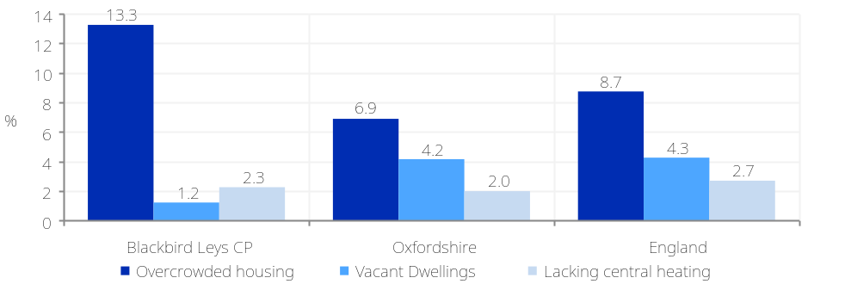
 | 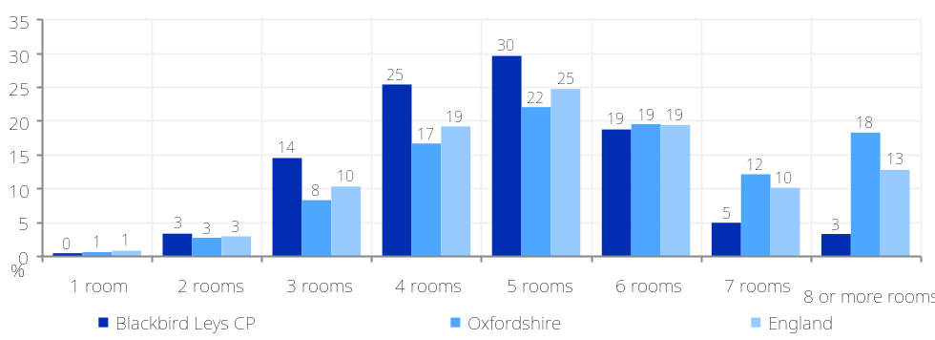

Housing: Domestic gas and electricity consumption
What information is shown here?  The Department for Business, Energy and Industrial Strategy publishes small area estimates of domestic gas and electricity consumption in megawatt hours (Mwh). Gas consumption data are weather corrected annual estimates of consumption for all domestic meters. A similar methodology is used for collecting domestic electricity consumption data; however, these values are not weather corrected. The methodologies are sufficiently similar that summing the electricity consumption and gas consumption gives an estimate of total annual energy consumption.  The data on this page were originally published by BEIS at postcode level and have been designated as experimental statistics. Experimental statistics are statistics that are new and subject to possible changes to meet user needs or that do not meet the rigorous quality standards of National Statistics. To avoid disclosure, postcodes are excluded if they contain less than 6 meters or that have average consumption figures of 0 or 1.  The estimated number households not connected to the gas network is based on the difference between the number of households and the number of domestic gas meters.  To read more about the data and methodology here please visit https://www.gov.uk/government/collections/sub-national-electricity-consumption-data
  Electricity consumption (Mwh) |  | Gas consumption (Mwh) |  | Households not connected to the gas network
  14,414 |  | 34,131 |  | 0,385
  (3.77 Mwh per meter) England average = 3.78 Mwh per meter |  | (10.34 Mwh per meter) England average = 13.07 Mwh per meter |  | (9.89% of households) England average = 13.57%
Source: Department for Business, Energy and Industrial Strategy, 2015 (consumption), Not connected to gas network, 2018
Figure: Domestic gas and electricity consumption, 2015
 | 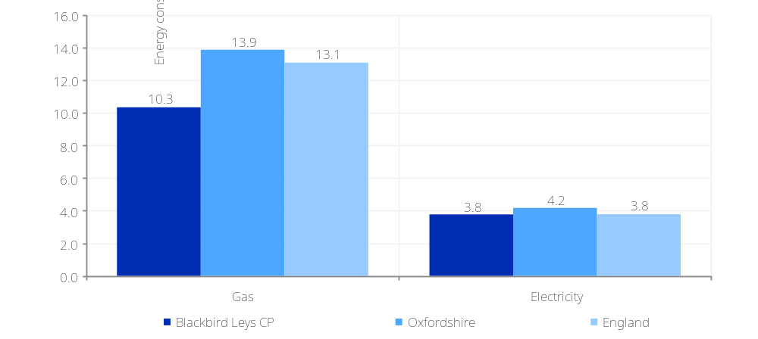

What information is shown here?  This page details the energy efficiency ratings of domestic buildings within Blackbird Leys CP.  The data are taken from Energy Performance Certificates (EPC) for domestic buildings published by DCLG and have been aggregated to Output Areas by the Consumer Data Research Centre. The definitions of the measures on the right are given below.  The energy efficiency rating, expressed in Standard Assessment Procedure (SAP) points, is a score between 1-100 with 1 being poor energy efficiency and 100 being excellent energy efficiency. The current average rating of buildings is given alongside the potential rating (if improvements to the buildings were made) and the difference between the two - the ‘energy efficiency gap’.  Buildings are awarded a band A EPC ratting if their energy efficiency rating is equal or above 92. The number and proportion of inspected band A buildings is given as well as the potential numbers. Again, the difference between current and potential is given. Please be aware that these figures do not account for all domestic buildings in an area.  Only homes that have been built, bought, sold or retrofitted since 2008 have an EPC, which represents about 50 to 60 per cent of homes within a local authority area. Additionally, data has not been published where the holder of the energy certificate has opted-out of disclosure, energy certificates are excluded on grounds of national security or energy certificates are marked as “cancelled” or “not for issue”.
  Energy efficiency rating, current  (SAP points) |  | Energy efficiency rating, potential  (SAP points) |  | Energy efficiency gap  (SAP points)
  69.16 |  | 79.47 |  | 10.31
  England average = 64.99 |  | England average = 78.25 |  | England average = 13.25
  Band A buildings, current |  | Band A buildings, potential |  | Difference between current and potential
  1 |  | 32 |  | 31
  (0.06%) England average = 0.14% |  | (1.86%) England average = 3.07% |  | (1.81%) England average = 2.93%
  Source: DCLG. Data collected between 2009-2016.
 | Figure: Energy efficiency rating (SAP points)
 | 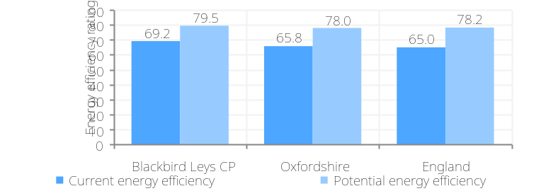
 | Figure: Band A (high energy efficiency) rated buildings
 | 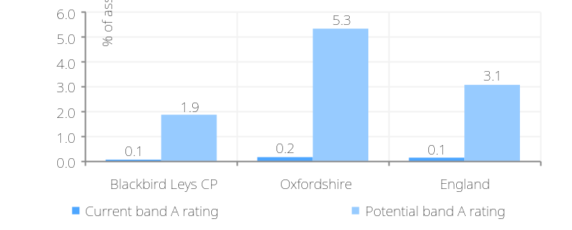
Housing: Energy efficiency of domestic buildings

Housing: Dwellings by age of dwelling
What information is shown here?  The information on this page shows the number of domestic properties (the 'dwelling stock') broken down by age of property (when the property was constructed). The rate figures refer to the proportion of all properties whose build age is known.
  Built before 1900 |  | Built between 1900 and 1939 |  | Built between 1945 and 1999 |  | Built after 2000
  00 |  | 03 |  | 3,754 |  | 109
  0.0% (England average = 15.5%) |  | 0.1% (England average = 20.8%) |  | 96.2% (England average = 48.2%) |  | 2.8% (England average = 14.5%)
Figure: Dwellings by age of dwelling (year property was constructed)
Source: Valuation Office Agency (VOA) 2020
 | 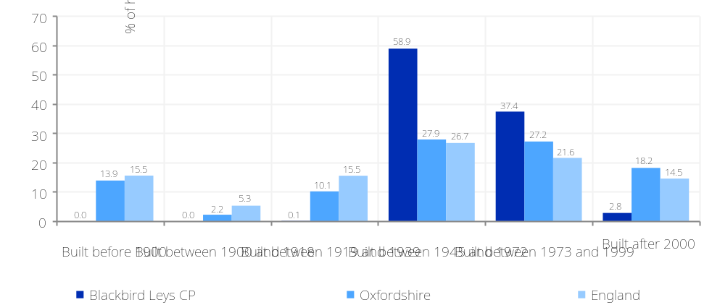
Housing: Communal establishment residents
What information is shown here?  The information on this page shows the number of people living in communal establishments, with breakdowns by the main types.  A communal establishment is defined as an establishment providing managed (full-time or part-time supervised) residential accommodation.  The information boxes on the right show the number and proportion of people in communal establishments by main type of establishment. Medical and care establishments include psychiatric hospital / homes, other hospital homes children's homes, residential care homes, nursing homes managed by the NHS, Local Authority or private organisation; Educational establishments include primarily University halls of residence; Defence establishments include barracks, air bases and naval ships; Other establishments include prison service establishments, bail hostels, hotels, boarding houses or guest houses, hostels and civilian ships.  The chart on the top right provides the same information with associated comparator areas.
  All in communal establishments |  | Medical and care establishments |  | Education establishments |  | Defence establishments |  | Other establishments
  46 |  | 46 |  | 00 |  | 00 |  | 00
  0.5% (England average = 1.8%) |  | 0.5% (England average = 0.7%) |  | 0.0% (England average = 0.7%) |  | 0.0% (England average = 0.1%) |  | 0.0% (England average = 0.1%)
  Source: Census 2011
Figure: Communal establishments by type
Source: Census 2011
 | 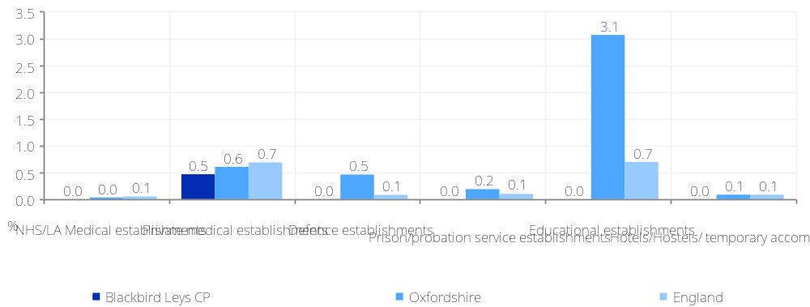

What information is shown here?  Crime and safety: Recorded crime (1)  The information on this page and the following shows the level of recorded crime in Blackbird Leys CP and comparator areas. This is based on data for individual crime incidents published via the www.police.uk open data portal, which has been linked by Local Insight to selected neighbourhoods. Further information on how these crimes and incidents have been categorised, as well as which crimes and incidents have been mapped and why, is available at: www.police.uk/about-this-site/faqs/#why-are-some-crimes-not-displayed-on-the-map  The information boxes show counts and rates for the main crime types and anti-social behaviour incidents. The overall crime rate is presented for monthly, quarterly and annual snapshots, with the underlying crime types shown as annual totals.  The line charts to the right and on the following page track monthly change in recorded crime across five key offences (violent crime, anti-social behaviour, burglaries, criminal damage and vehicle crime) across Blackbird Leys CP and comparator areas.  Note: Police.uk crime counts were not recorded for Cambridgeshire or Gloucestershire for May 2018, so data is missing for areas covered by these police forces for this time point.
  All crimes  August 2020 monthly total |  | All crimes  June-20 to August-20 |  | All crimes  Sept-19 to August-20
  115 |  | 345 |  | 1,224
  13.1 per 1,000 population (England average = 9.7) |  | 38.4 per 1,000 population (England average = 28.6) |  | 133.6 per 1,000 population (England average = 102.2)
  Violent crimes  Sept-19 to August-20 |  | Criminal damage incidents  Sept-19 to August-20 |  | Anti-social behaviour incidents  Sept-19 to August-20
  415 |  | 114 |  | 151
  45.3 per 1,000 population (England average = 29.7) |  | 12.4 per 1,000 population (England average = 7.9) |  | 16.5 per 1,000 population (England average = 26.1)
  Burglaries  Sept-19 to August-20 |  | Robberies  Sept-19 to August-20 |  | Vehicle crimes  Sept-19 to August-20
  60 |  | 17 |  | 58
  15.2 per 1,000 households (England average = 12.5) |  | 1.9 per 1,000 population (England average = 1.2) |  | 6.3 per 1,000 population (England average = 6.3)
  Source: Recorded crime offences – https://data.police.uk/ (2019/2020)
Figure: Violent crime offences
Source: https://data.police.uk/
 | 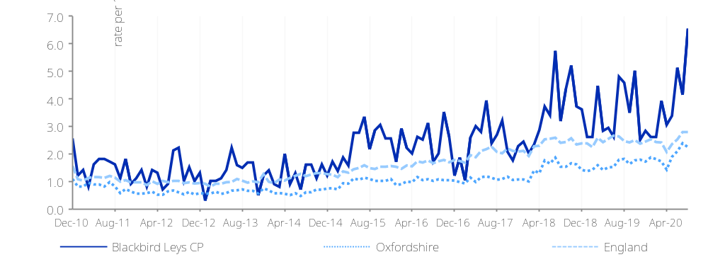


Crime and safety: Recorded crime (2)

Figure: Anti-social behaviour offences  Source: https://data.police.uk/ | Figure: Burglary offences  Source: https://data.police.uk/
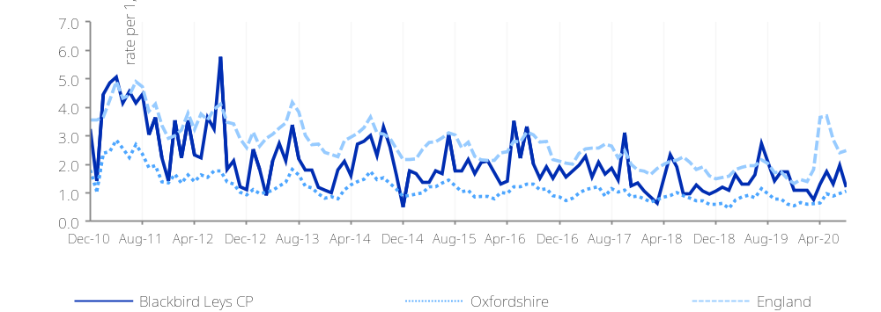 | 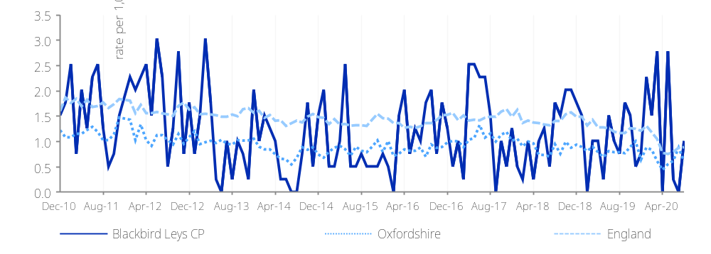
Figure: Criminal damage offences  Source: https://data.police.uk/ | Figure: Vehicle crime offences  Source: https://data.police.uk/
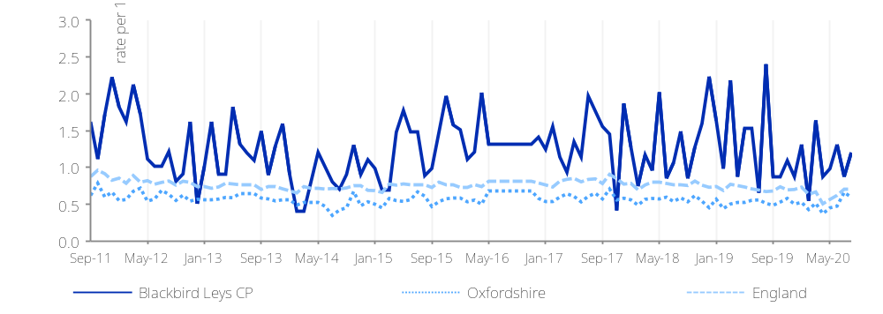 | 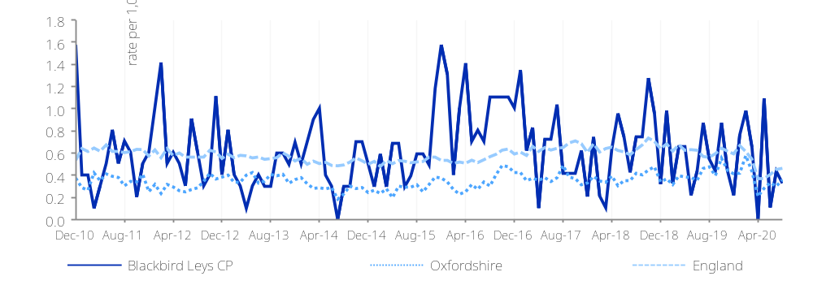

What information is shown here?  The information in this section explores variations in life expectancy and premature mortality. Life expectancy is a measure of the age a person born today can expect to live until, if they experience current mortality rates throughout their life. The chart on the right shows life expectancy at birth for females and males in Blackbird Leys CP and comparator areas.  The first chart on the following page shows the standardised mortality ratio for all causes and all ages for Blackbird Leys CP. This indicator highlights the ratio of observed to expected deaths (given the age profile of the population). A mortality ratio of 100 indicates an area has a mortality rate consistent with the age profile of the area, less than 100 indicates that the mortality rate is lower than expected and higher than 100 indicates that the mortality rate is higher than expected.  The second chart on the following page show incidence of cancer (with breakdowns for the most common forms of cancer). The data is presented as an incidence ratio (ratio of observed incidence vs expected incidence given the age profile of the population). | Figure: Life expectancy  Source: Office for National Statistics (2013-2017)
 | 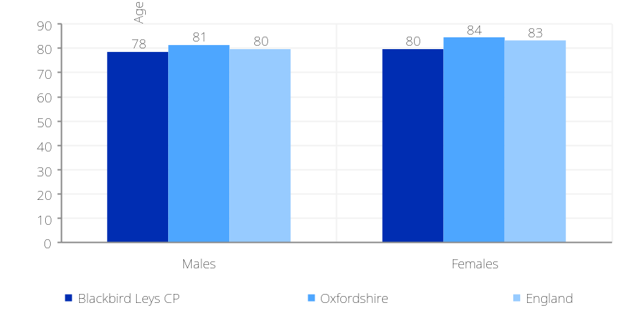
Figure: Healthy Life Expectancy  Source: Office for National Statistics (2009-2013) | Figure: Disability-free Life Expectancy  Source: Office for National Statistics (2009-2013)
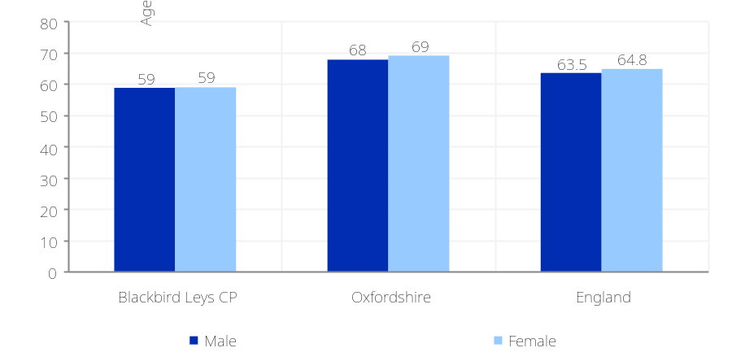 | 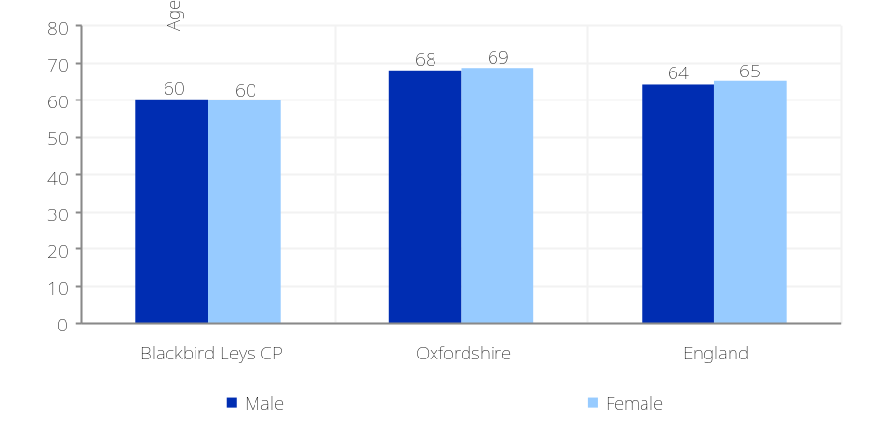

Health and wellbeing: Life expectancy and mortality

Health and wellbeing: Life expectancy and mortality (2)

Figure: Incidence of cancer: Standardised incidence ratio (select causes)  Source: Office for National Statistics (2012-2016) | Figure: Standardised mortality ratio (select causes)  Source: Office for National Statistics (2013-2017)
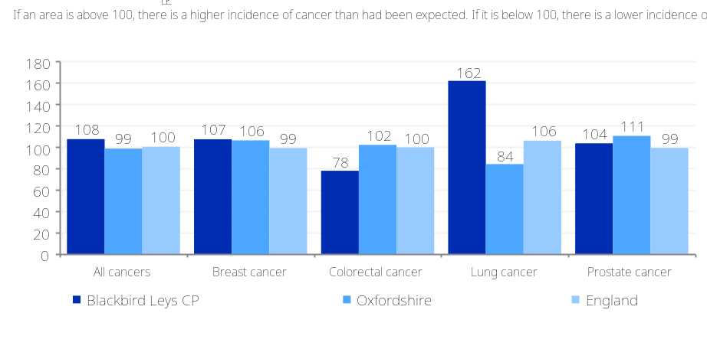 | 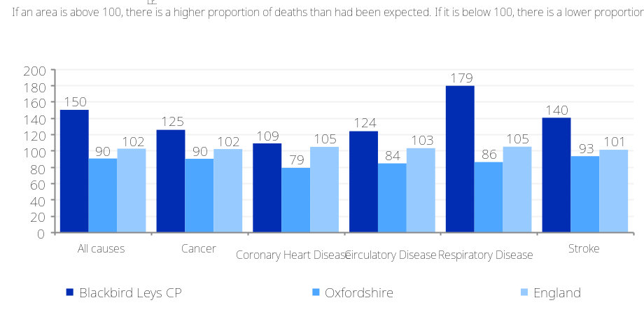

Health and wellbeing: General health and limiting long-term illness
What information is shown here?  The information in this section looks at general levels of health, focusing on the number of people living in neighbourhoods with poor levels of overall health (health deprivation hotspots) and the number of people with a limiting long-term illness.  Limiting long-term illness is defined as any long-term illness, health problem or disability which limits someone's daily activities or the work they can do. Health deprivation ‘hotspots’ are neighbourhoods ranked among the most deprived 20% of neighbourhoods in England on the Indices of Deprivation 2015 Health domain. The domain measures morbidity, disability and premature mortality. All neighbourhoods in England are grouped into ten equal sized groups “deciles”; the 10% of neighbourhoods with the highest level of health deprivation are grouped in decile 10, and so on with the 10% of neighbourhoods with the lowest levels of health deprivation grouped in decile 1.  The chart on the right shows the number of people in Blackbird Leys CP living in each health decile. The charts below shows the proportion of residents in Blackbird Leys CP with a limiting long-term illness by age.
  Number of people living in health deprivation ‘hotspots’ (Indices of Deprivation 2015) |  | People with a limiting long-term illness (Census 2011) |  | People aged 16-64 with a limiting long-term illness (Census 2011) |  | Babies born with a low birth weight (ONS 2011-2015)
  3,015 |  | 1,690 |  | 884 |  | 30
  32.9% (England average = 19.6%) |  | 17.1% (England= 17.6%) |  | 14.5% (England= 12.7%) |  | 3.8% (England= 2.8%)
Figure: Number of people in each deprivation decile, Health domain
Source: Indices of Deprivation 2015
 | 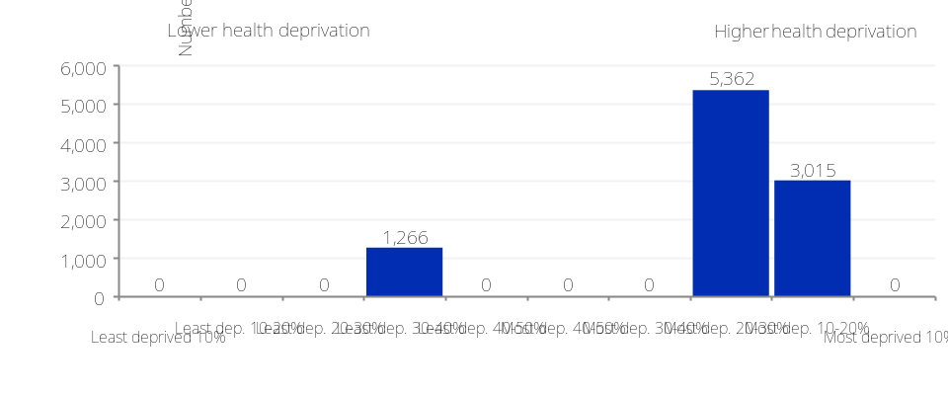
Figure: People with a limiting long-term illness
Source: Census 2011
 | 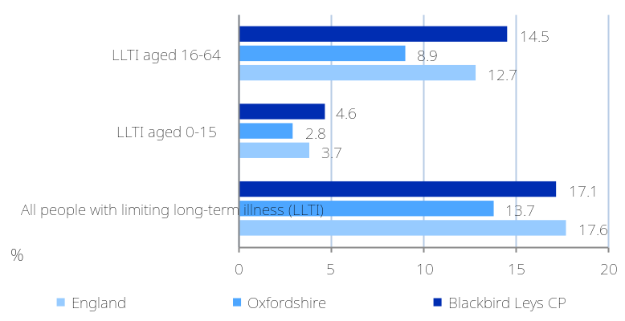

Health and wellbeing: Hospital admissions
What information is shown here?  The information in this section looks at admissions to hospital by main health condition and hospital admissions and A&E attendance rates for children (aged under 5 years). The chart on the top right shows emergency admissions to hospital across Blackbird Leys CP and comparators. The chart on the bottom right shows elective in-patient hospital admissions (admissions that have been arranged in advance).  The data are presented as standardised ratios; a ratio of 100 indicates an area has an admission rate consistent with the national average, less than 100 indicates that the admission rate is lower than expected and higher than 100 indicates that the admission rate is higher than expected.  The information boxes at the bottom show the rate of emergency hospital admissions and A&E attendances for children (aged under 5 years) per 1,000 resident population in Blackbird Leys CP. Approximately 35% of all admissions in the NHS in England are classified as emergency admissions, costing approximately £11 billion a year. Over one quarter of emergency hospital admissions in children aged under 5 years in 2014/15 was for respiratory infections. A&E attendances in children aged under five years are often preventable, and commonly caused by accidental injury or by minor illnesses which could have been treated in primary care.  Source: Hospital Episode Statistics, Information Centre for Health and Social Care, Office for National Statistics (2013/14-2015/16) | Figure: Emergency hospital admissions: Standardised ratio (select causes)  Source: Hospital Episode Statistics, Information Centre for Health and Social Care, Office for National Statistics (2013/14 – 2017/18)
  Emergency hospital admissions for children under 5 (per 1,000 population) |  | A&E attendance for children under 5 (per 1,000 population)
  118 |  | 395
  (England = 149) |  | (England = 536)
 | 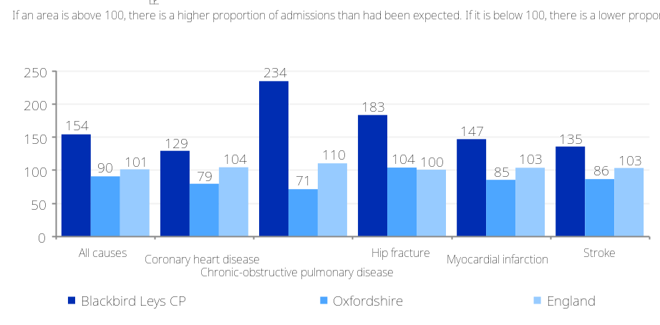
Figure: Elective hospital admissions: Standardised ratio (select causes)
Source: Hospital Episode Statistics, Information Centre for Health and Social Care, Office for National Statistics (2011/12-2014/15)
 | 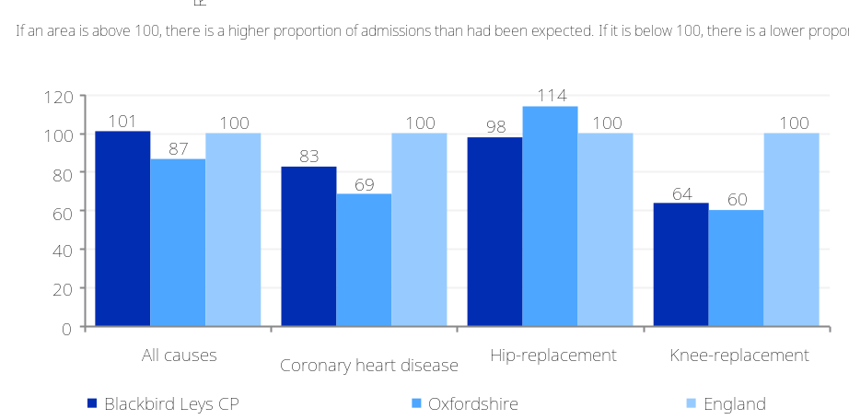

Health and wellbeing: Musculoskeletal conditions
What information is shown here?  Arthritis UK have partnered with Imperial College London to produce modelled estimates of the prevalence of musculoskeletal conditions for MSOAs in England. The estimates were calculated by identifying risk factors, sourcing suitable data sources and using statistical techniques to produce synthetic estimates of the numbers of people with hip osteoarthritis, knee osteoarthritis and back pain.  We have defined percentages consistently with Arthritis UK’s methodology. Knee and hip osteoarthritis figures are expressed as a percentage of the population aged 45 and over. Back pain figures are express as a percentage of the total population.  People are deemed to have severe pain if they have pain most of the time or they are unable to walk a quarter of a mile unaided or they have previously undergone hip or knee replacement due to arthritis.  For more information visit https://www.arthritisresearchuk.org/arthritis-information/data-and-statistics/musculoskeletal-calculator.aspx  © Arthritis Research UK
  Number of people with knee osteoarthritis (Arthritis UK 2011) |  | Number of people with hip osteoarthritis (Arthritis UK 2011) |  | Number of people with back pain (Arthritis UK 2011)
  513 |  | 312 |  | 1535
  16.2% (England= 18.2%) |  | 9.9% (England= 10.9%) |  | 15.4% (England= 16.9%)
  Number of people with severe knee osteoarthritis (Arthritis UK 2011) |  | Number of people with severe hip osteoarthritis (Arthritis UK 2011) |  | Number of people with severe back pain (Arthritis UK 2011)
  165 |  | 80 |  | 988
  5.2% (England= 6.1%) |  | 2.5% (England= 3.2%) |  | 9.9% (England= 10.3%)
Figure: Prevalence of hip and knee arthritis in people aged 45 and over
Source: Arthritis UK (2011)
 | 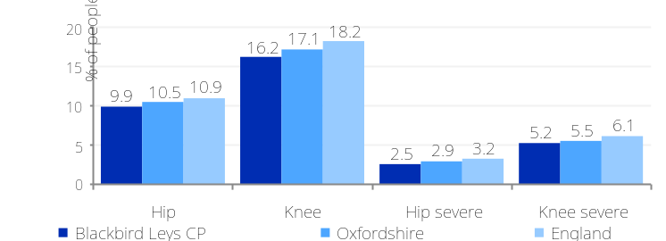
Figure: Prevalence of back pain in people of all ages
Source: Arthritis UK (2011)
 | 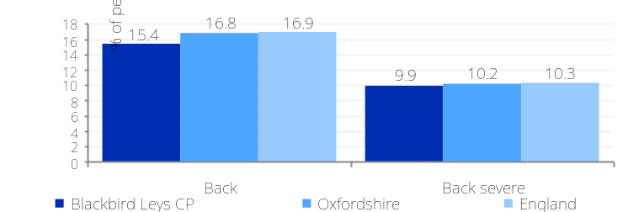

Health and wellbeing: Healthy lifestyles

What information is shown here?  The information on this page looks at lifestyle behaviours of people living in Blackbird Leys CP. Lifestyle behaviours are risk factors which play a major part in an individual’s health outcomes and will have varying physical and psychological consequences.  The chart on the top right shows the healthy eating levels (consumption of five or more portions of fruit and vegetables a day among adults) in Blackbird Leys CP. It also shows smoking prevalence and levels of binge drinking in these areas. Binge drinking is defined as the consumption of at least twice the daily recommended amount of alcohol in a single drinking session (8 or more units for men and 6 or more units for women).  The chart on the bottom right shows the percentage of people children (in reception year and year 6) and adults classified as obese in Blackbird Leys CP. People are considered obese when their body mass index (BMI) a measurement obtained by dividing a person's weight by the square of the person's height, exceeds 30 kg/m2.  Data for adult health are modelled estimates created from Health Survey for England 2006-2008. This is due to a lack of alternative small-area data for these indicators. | Figure: “Healthy eating” (consumptions of 5+ fruit and veg a day), binge drinking and smoking  Source: Health Survey for England 2006-2008
 | 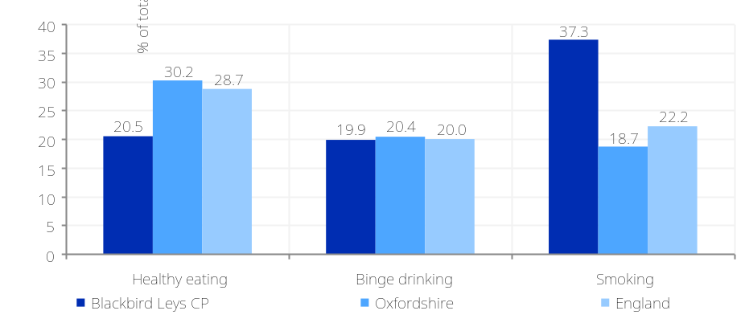
Figure: Children and adults classified as obese
Source: National Child Measurement Programme (NCMP) (2015/16 to 2017/18), Health Survey for England 2006-2008
 | 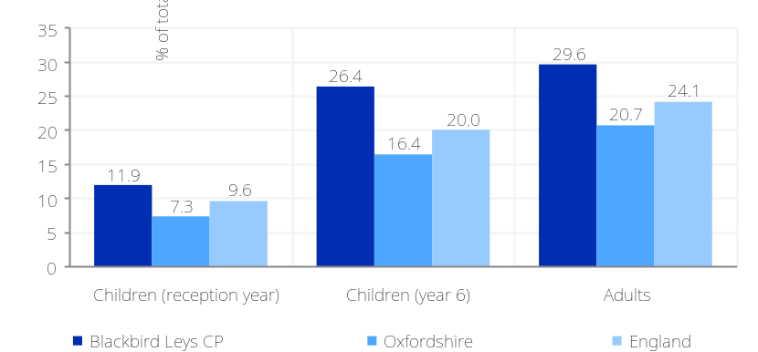

What information is shown here?  The information on this page looks at further lifestyle behaviours of people living in Blackbird Leys CP.  The chart on the top right shows the percentage of children (in reception year and year 6) classified as overweight or obese in Blackbird Leys CP. This indicator shows the number of children classified as overweight (including obese) where their BMI is on or above the 85th centile of the British 1990 growth reference (UK90) according to age and sex. The indicator can be used to estimate and monitor excess weight and obesity in children in order to reduce prevalence, inform planning and delivery of services for children, and ensure the proper targeting of resources to tackle obesity.  The chart on the bottom right shows the modelled prevalence of smoking status for people aged 15 in Blackbird Leys CP. It shows the percentage of those aged 15 who are regular smokers or regular or occasional smokers. There is a large body of evidence showing that smoking behaviour in early adulthood affects health behaviours later in life. The Government’s Tobacco Control Plan (2017) sets out their aim to reduce the number of 15 year olds who regularly smoke from 8% to 3% or less. This indicator will ensure that as well as focusing on reducing the prevalence of smoking among adults (primarily through quitting) local authorities will also address the issue of reducing the uptake of smoking among children. | Figure: Children classified as overweight or obese  Source: National Child Measurement Programme, NHS Digital (http://www.localhealth.org.uk/) (2015/16-2017/18)
 | 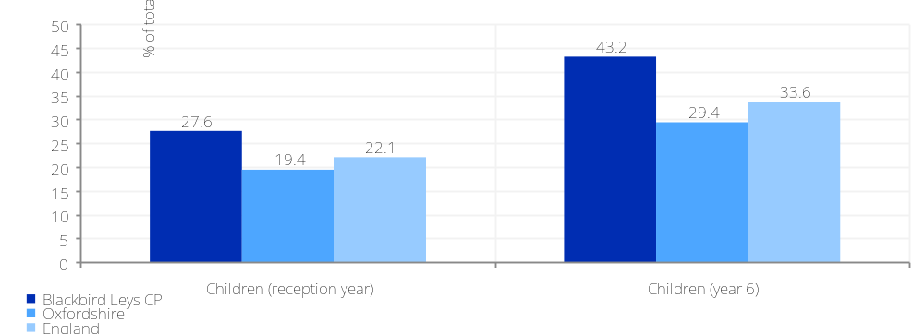
Figure: Prevalence of people aged 15 smoking status
Source: Department of Geography, University of Portsmouth and Geography and Environment, University of Southampton (http://www.localhealth.org.uk/) (2014)
 | 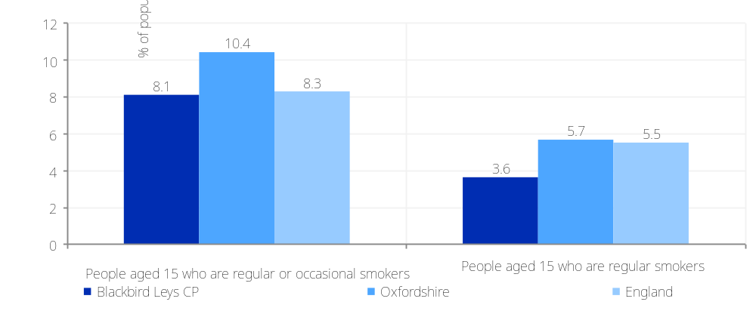

Health and wellbeing: Healthy lifestyles 2

Health and wellbeing: Healthy lifestyles 3

What information is shown here?  This chart shows estimates of the levels of physical activity among adults. The data have been produced by Sport England using a Small Area Estimation technique - modelling down from a National Survey (the Active Lives Survey 2020) to Middle Layer Super Output Area (MSOA) based on the local demographic characteristics of the local population. For more information on the modelling method see https://www.sportengland.org/know-your-audience/data/active-lives/active-lives-data-tables  The categories of physical activity follow the guidelines set by the Chief Medical Officer and are defined below:  Physically active: undertaking at least 150 minutes per week in the past month excluding gardening  Physically inactive: undertaking less than 30 minutes in the past month excluding gardening  Physical activity at least twice a month: undertaking physical activity on at least two occasions in the past month | Figure: Physical activity among adults  Source: Sport England (Active Lives Survey 2020) – small area data 2018/2019
 | 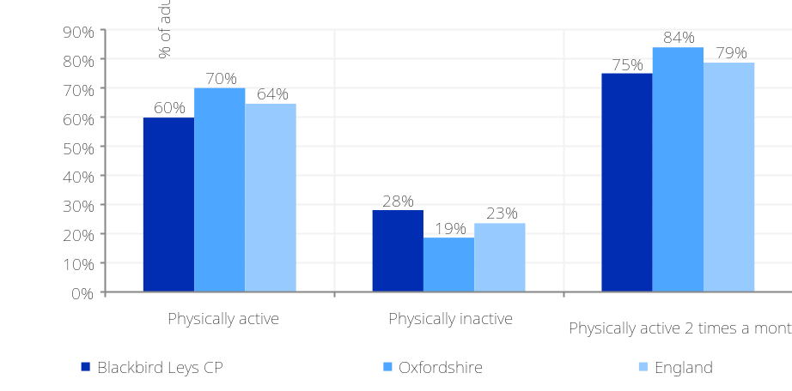

Health and wellbeing: Disease Prevalence

What information is shown here?  The information on this page looks at the estimated prevalence of a different health conditions in Blackbird Leys CP.  The estimates calculated are based on the number of people listed on GP registers in 2017/18, and the number of people recorded as having the relevant health conditions. The data from England’s GP practices was published by NHS digital.  It should be noted that these are only estimates and that they are sensitive to the accuracy of GP data reporting. For some conditions (e.g. obesity and dementia), GP-recorded prevalence is lower than the proportion of people living with the condition.  For full notes, methodology, and limitations, please see https://commonslibrary.parliament.uk/social-policy/health/diseases/constituency-data-how-healthy-is-your-area for more details.  The bar chart on the right shows a detailed breakdown of the estimated percentage of prevalence by category of health condition. | Figure: % of estimated disease prevalence  Source: House of Commons Library (2019)
 | 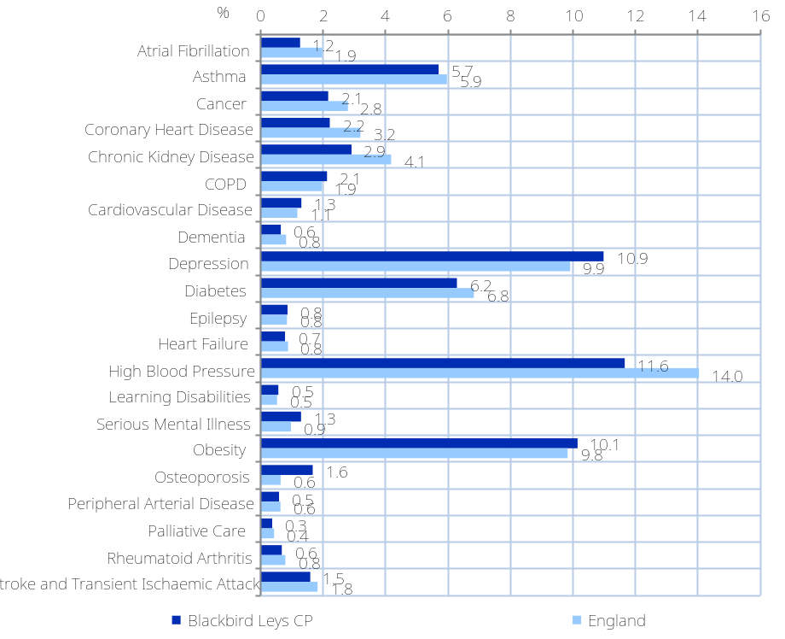

What information is shown here?  Health and wellbeing: AHAH index  The information on this page looks at the index of ‘Access to Health Assets and Hazards’ (AHAH) Version 2, a multidimensional index produced by the CDRC that measures how ‘healthy’ neighbourhoods are by looking at accessibility and geographical determinants of health. It combines indicators under four different domains of accessibility:  - Retail environment: access to fast food outlets, pubs, off-licences, tobacconists, gambling outlets,  - Health services: access to GPs, hospitals, pharmacies, dentists, leisure services, and  - Physical environment: access to Blue Spaces, Green Spaces - Active, Green Spaces – Passive (total green space areas available to each postcode in a range of a 900-metre buffer prior to creating LSOA averages),  - Air Quality: three air pollutants (Nitrogen Dioxide, Particulate Matter 10 and Sulphur Dioxide).  The information boxes on the top right show the score on each of the four domains of accessibility and the overall AHAH index score for Blackbird Leys CP. A higher score indicates a poorer health-related environment.  The bar chart on the right shows a detailed breakdown of the inputs for the retail environment and health services domains all of which show the mean distance in kilometres to each of these outlets and services.  For full notes, methodology, and limitations please see https://data.cdrc.ac.uk/dataset/ahah2 for more details.
  AHAH Retail Environment domain (CDRC 2017) |  | AHAH Health Services domain (CDRC 2017) |  | AHAH Physical Environment domain (CDRC 2017)
  16.0 |  | 14.0 |  | 16.8
  (England = 23.4) |  | (England = 20.1) |  | (England = 21.3)
AHAH Air quality domain (CDRC 2017) |  | AHAH Index (CRDC 2017)
16.4 |  | 15.8
(England = 26.8) |  | (England = 22.9)

Figure: Inputs for retail environment and health services domain
Source: CDRC (2017)
 | 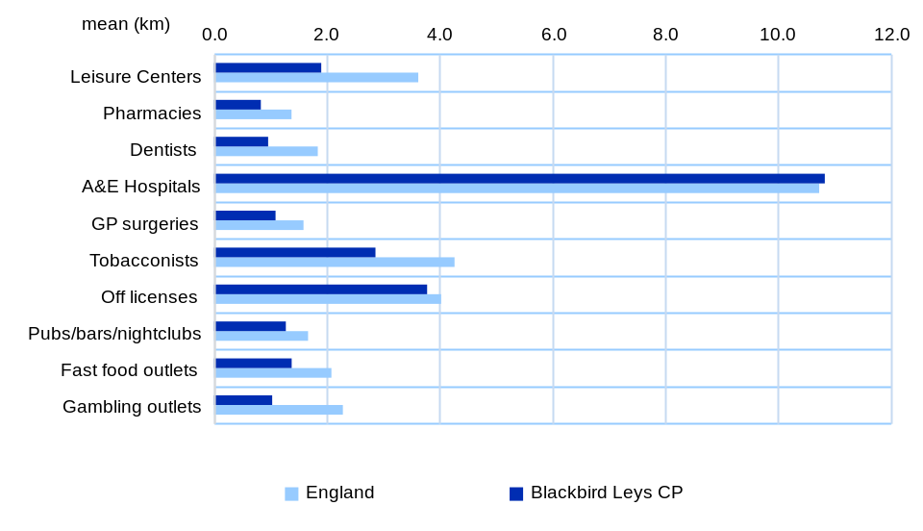

What information is shown here?  The information boxes and chart on the right show the education levels of residents in Blackbird Leys CP, showing the number and proportion of adults (aged 16+) by highest level of qualification. Note, figures in the table and charts may not add up to 100% because they do not include figures for those for who with other qualifications or unknown qualifications.  The Chart on the bottom left shows the proportion of people turning 18 between 2010-11 and 2014-15 who went on to enter higher education.
  People with no qualifications |  |  | People with highest qualification level 1 |  | People with highest qualification level 2 |  | People with highest qualification level 3
  2,398 |  |  | 1,372 |  | 1,012 |  | 596
  32.8% of working age people (England= 22.5%) |  |  | 18.8% of working age people (England= 13.3%) |  | 13.9% of working age people (England= 15.2%) |  | 8.2% of working age people (England= 12.4%)
  People with highest qualification level 4+ (degree) |  | ‘Level 1’ qualifications are equivalent to a single O-level, GCSE or NVQ. ‘Level 2’ qualifications are equivalent to five O-levels or GCSEs. ‘Level 3’ qualifications are equivalent to two A levels. ‘Level 4’ qualifications are equivalent to degree level or higher.
  1,140
  15.6% of working age people (England= 27.4%)
  Source: Census 2011
Figure: Participation in higher education (Proportion of a young cohort that has entered higher education by age 19)  Source: Office for Students (OFS) | Figure: People with no qualifications and degree level qualifications  Source: Census 2011
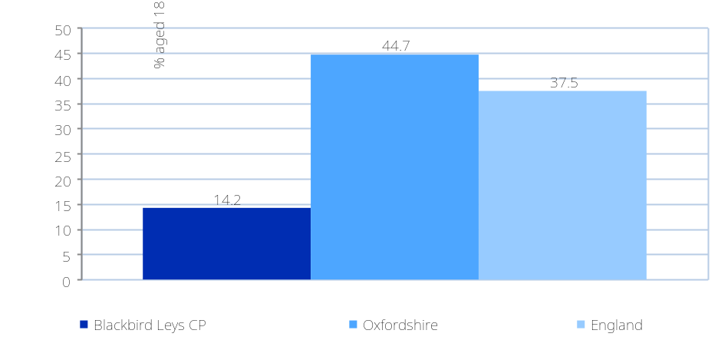 | 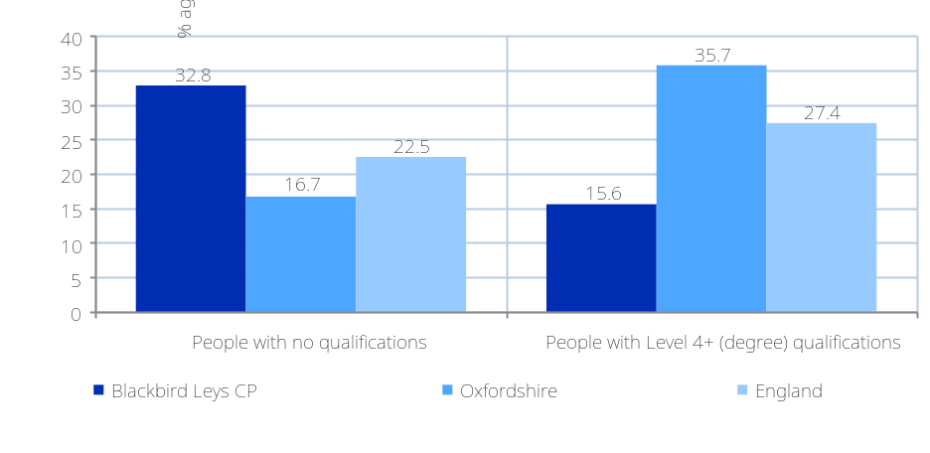

Education and skills: Qualifications and participation in higher education

Education and skills: Early years progress

What information is shown here?  The information on this page shows the outcomes of children in the Early Years Foundation Stage (EYFS), a series of tests measuring children's progress in terms of Personal, Social and Emotional Development (PSED) and Communication, Language and Literacy (CLL). These are typically 5-year-old pupils; however, a minority of slightly older and younger pupils may have been assessed.  The new Early Years Foundation Stage Profile requires practitioners to make a best fit assessment of whether children are emerging, expected or exceeding against each of the new 17 Early Learning Goals (ELGs). Children have been deemed to have reached a Good Level of Development (GLD) in the new profile if they achieve at least the expected level in the ELGs in the prime areas of learning (personal, social and emotional development; physical development; and communication and language) and in the specific areas of mathematics and literacy. These are 12 of the 17 ELGs. The Department for Education has also introduced a supporting measure which measures the total number of points achieved across all 17 ELGs and reports the average of every child’s total point score.  The chart on the right shows the percentage of pupils achieving 17 ELG and the percentage of pupils achieving a good level of development. | Figure: Early years foundation stage profile  Source: Department for Education (2013-2014)
 | 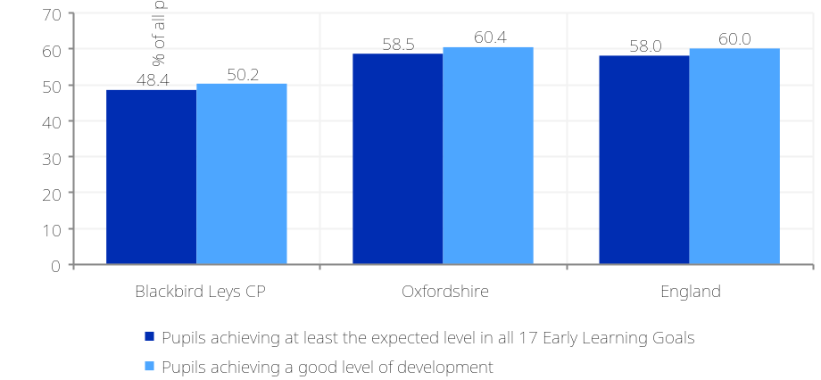

Education and skills: Pupil attainment

What information is shown here?  The chart on the top right show the education levels of pupils in Blackbird Leys CP, showing the examination results at Key Stage 1 (tests set at aged 7) Key Stage 2 (tests set at aged 11) and Key Stage 4 (GCSEs).  The figures show the Average Point Score of pupils from each of the Key Stage examinations. This adjusts for high achieving pupils as well as pupils achieving expected levels.  The chart on the top right shows Average Point Score (across all examinations) per pupil at Key Stage 1 and Key Stage 2. The chart on the bottom right compares the gap in Average Point Score at Key Stage 4 (GCSE) per pupil between Blackbird Leys CP and the national average over time. The gap is measured as the point difference against the England average. Areas with a score of greater than 1 are performing better than the national average, while areas with a score of less than 1 are performing below. | Figure: Pupil attainment at Key Stage 1 and Key Stage 2  Source: Department for Education (2013-2014)
 | 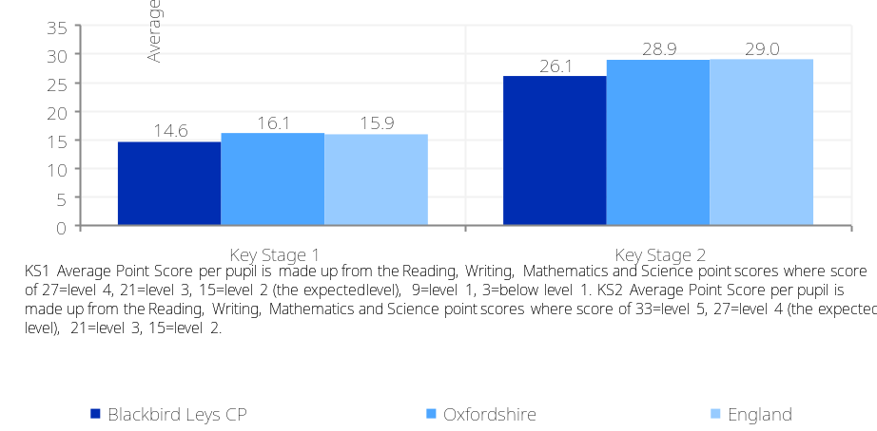

Figure: Pupil attainment at Key Stage 4  Source: Department for Education (2013-2014) | Figure: Gap in pupil attainment at Key Stage 4 (difference from the national average)  Source: Department for Education
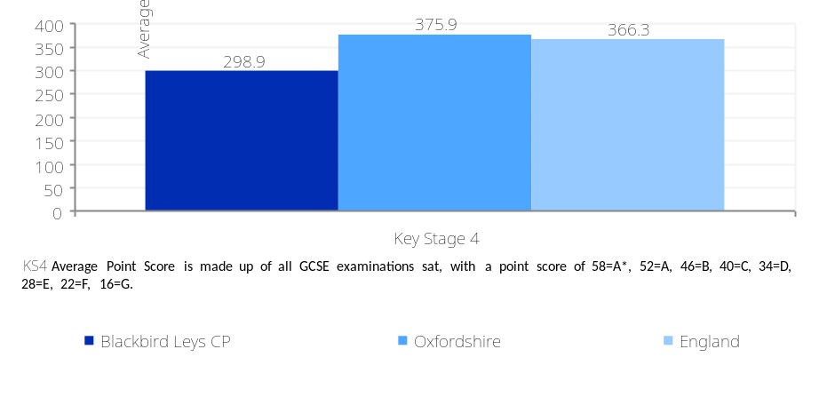 | 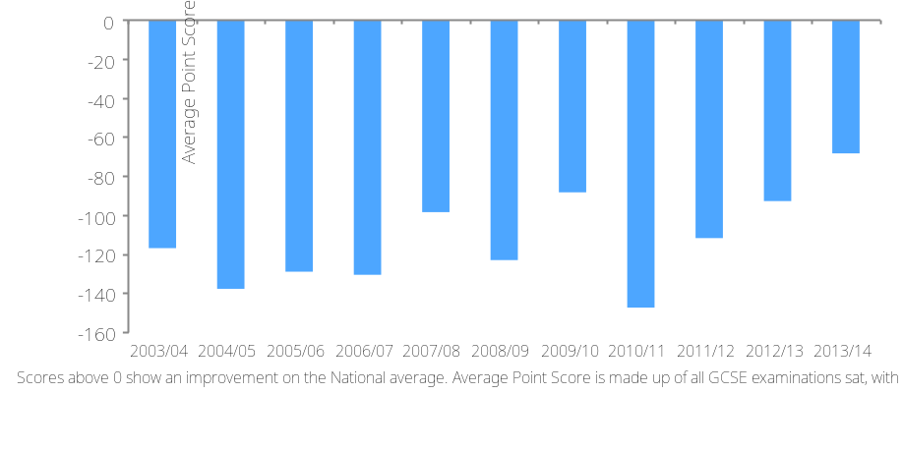

What information is shown here?  The information on this page looks at four types of income category: average household income; average equivalised household income after housing costs; households living in fuel poverty and median net equivalised household PAYE and benefits income. Fuel poverty is said to occur when in order to heat its home to an adequate standard of warmth a household needs to spend more than 10% of its income on total fuel use.  The information boxes on the top right provide an estimate of the number of households in Blackbird Leys CP below the poverty line and an estimate for the number of households in fuel poverty.  The chart on the right shows the average annual household income estimate (equivalised to take into account variations in household size) across Blackbird Leys CP and comparator areas before and after housing costs.
  Annual household income (Office for National Statistics 2017/18) |  | Annual household income, after housing costs (Office for National Statistics 2017/18) |  | Households living in ‘Fuel Poverty’ Department for Business, Energy and Industrial Strategy (2018)
  £39,851 |  | £21,456 |  | 300
  England Average = £43,966 |  | England Average = £28,248 |  | 7.3% of households (England = 10.3%)
Median net equivalised household PAYE and benefits income (Office for National Statistics 2015/16)
£23,781
England Average = £24,577

Figure: Annual household earnings (£)
Source: Office for National Statistics (2017/18)
 | 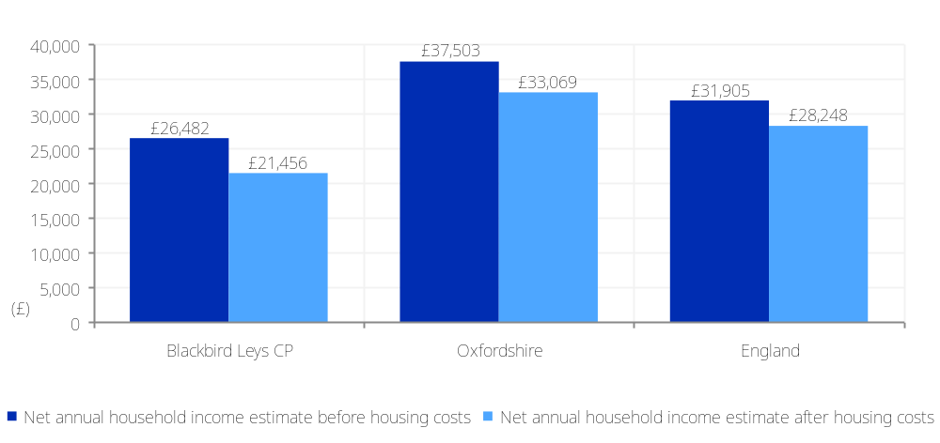

Economy: Income and fuel poverty

What information is shown here?  The levels of private debt, in the form of unsecured loans and mortgage debt per head, for Blackbird Leys CP are displayed here.  These figures, available at postcode sector level, are published by UK Finance and account for around 60% of borrowing in the UK. OCSI have modelled this data to Output Areas using an address-based lookup from postcode sector to Output Area in combination with the number of local households and the local population.  The personal debt figure is the total amount of borrowing outstanding on customer accounts divided by the population aged 18+. Personal debt includes all unsecured loans such as credit cards, credit for new cars (eg when buying on finance) and other personal loans. Student debt is not included.  The mortgage debt figure is the total borrowing outstanding on customer accounts for residential mortgages divided by the total number of households.  The SME debt figure is the total amount of borrowing outstanding on customer accounts for Small and Medium-sized enterprises divided by the population aged 18+.
  Personal debt per head |  | Residential mortgage debt per head |  | SME lending debt per head
  £949.8 |  | £26390.3 |  | £5.3
  England Average = £699.5 |  | England Average = £40892.8 |  | England Average = £1387.0
 | Source: UK Finance (March-2020)

Economy: Debt

What information is shown here?  The information on this page shows economic activity breakdowns for adults aged 16-74 in Blackbird Leys CP.  The data in the information boxes shows the number and proportion of residents who are economically active, with breakdowns for those working part time, full time or are self-employed (note, these figures do not add up to all those economically active as it excludes those economically active who are unemployed or full-time students).
  Economically active |  | Full-time employees |  | Part-time employees |  | Self-employed people |  | Economically inactive
  4,838 |  | 2,708 |  | 1,100 |  | 321 |  | 1,955
  71.2% (England average = 69.9%) |  | 39.9% (England average = 38.6%) |  | 16.2% (England average = 13.7%) |  | 4.7% (England average = 9.8%) |  | 28.8% (England average = 30.1%)
  Source: Census 2011
Figure: Economic Activity
Source: Census 2011
 | 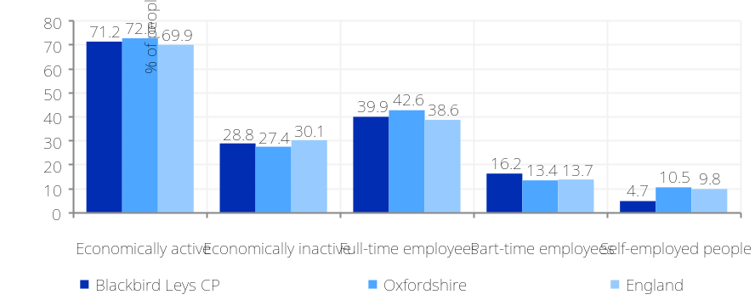

Economy: Economic activity

What information is shown here?  The information on this page shows breakdowns of the main industry sectors people in Blackbird Leys CP are working in, and their occupational status.  The data in the top information boxes shows the three largest employment sectors for residents in the local area, also the number and percentage of employed people working in each of these sectors. The lower information boxes and the chart on the right show the numbers of residents in Blackbird Leys CP by type of occupation (e.g., managers, professional, administrative).
  Largest employment sector |  | Second largest employment sector |  | Third largest employment sector
  Retail |  | Health & social work |  | Education
  811 employees (19% of 4,327 of people in employment) |  | 682 employees (16% of 4,327 of people in employment) |  | 576 employees (13% of 4,327 of people in employment)
  Managerial occupations |  | Professional (or associate) occupations |  | Administrative or secretarial occupations |  | Skilled trades occupations |  | Elementary occupations
  224 |  | 813 |  | 434 |  | 452 |  | 892
  5.2% of 4,327 people in employment (England = 10.9%) |  | 18.8% of 4,327 people in employment (England = 30.3%) |  | 10.0% of 4,327 people in employment (England = 11.5%) |  | 10.4% of 4,327 people in employment (England = 11.4%) |  | 20.6% of 4,327 people in employment (England = 11.1%)
  Source: Census 2011
Figure: People in professional and elementary occupations
Source: Census 2011
 | 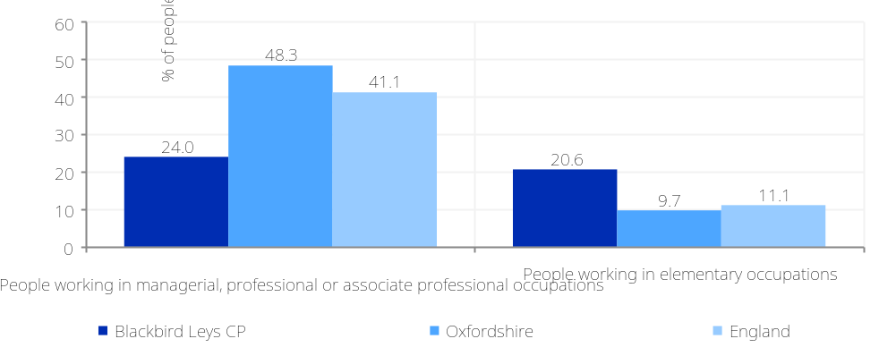

Economy: Job type

Economy: Job opportunities
What information is shown here?  The information on this page shows the number of vacant jobs in Blackbird Leys CP compared against the overall unemployment levels in the area.  The ‘Unemployment to ‘Available Jobs’ ratio, shown in the information box on the right and the line chart below is the total number of people claiming unemployment benefit (Jobseekers Allowance) divided by the total number of job vacancies notified to Jobcentre Plus expressed as a ratio.  The bar chart on the bottom right shows month-on-month changes in the number of job vacancies notified to Jobcentre Plus, that are located in the area covering Blackbird Leys CP (based on postcode location of the job). Note, this data was last updated by Jobcentre Plus for November 2012.
  Unemployment to ‘Available Jobs’ ratio | Source: Job Centre Vacancies - Office for National Statistics/Jobcentre Plus (Nov-12), Jobseekers Allowance claimant count – Department for Work and Pensions (Nov-12)
  12.04 claimants per job
  England average = 3.43
Figure: Total number of vacancies notified to Job Centre
Source: Office for National Statistics/Job Centre Plus
 | 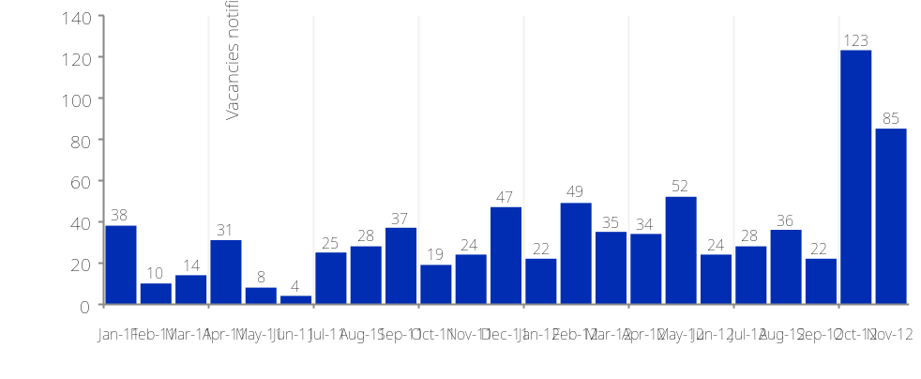
Figure: Ratio of unemployment (JSA claimants) to jobs (vacancies notified to Jobcentre Plus
Source: Office for National Statistics/Job Centre Plus, Department for Work and Pensions
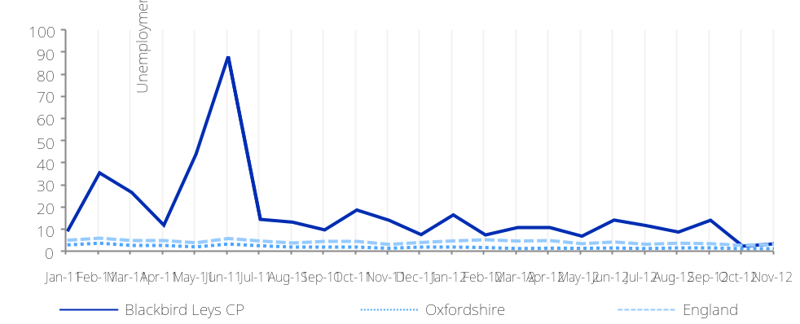

Economy: Local jobs
What information is shown here?  The information in this section shows the concentration of workforce jobs in Blackbird Leys CP. Workforce jobs are taken from the Business Register and Employment Survey (BRES) which publishes employee and employment estimates based on a survey of approximately 80,000 businesses and weighted to represent all sectors of the UK economy.  The information boxes show the three largest industry groups for workforce jobs based in Blackbird Leys CP. The bar chart on the top right shows the change in ‘Jobs Density’ (the number of jobs as a % of working age population) across Blackbird Leys CP over time. The bar chart on the bottom right shows the share of jobs broken down by public and private sector.
  Largest industry sector |  | Second largest industry sector |  | Third largest industry sector
  Retail industry |  | Transport |  | Health
  24.5% of all people in employment |  | 23.7% of all people in employment |  | 15.6% of all people in employment
  Source: Business Register and Employment Survey (BRES) (2019)
Figure: Jobs Density (jobs as a % of working age population) (2019)
Source: Business Register and Employment Survey (BRES)
 | 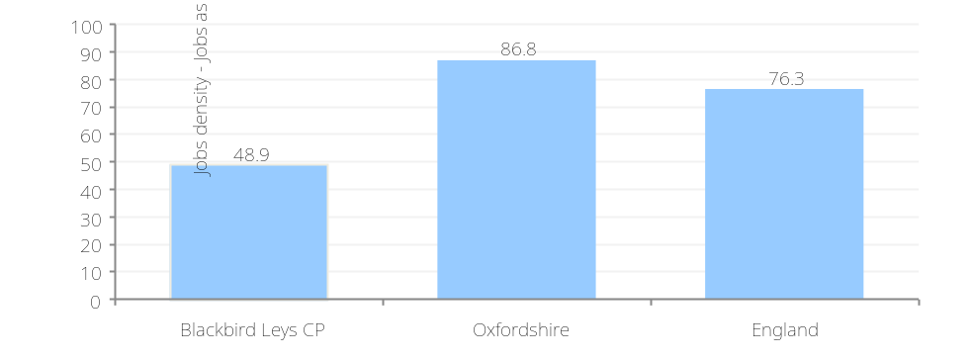
Figure: Jobs by public sector/private sector (2019)
Source: Business Register and Employment Survey (BRES)
 | 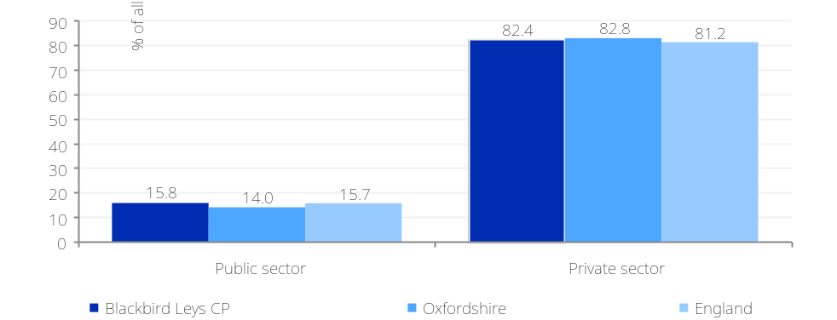

Economy: Local businesses
What information is shown here?  The information in this section shows the concentration of ‘local business units’ in Blackbird Leys CP. ‘Local business units’ are counts of businesses based on the location of an operational unit. Though larger businesses such as supermarket chains may have their head office in a large city, these figures measure all subsidiaries of that larger enterprise based on where subsidiaries are located. The figures cover all business eligible for VAT (1.7 million businesses in the UK are registered for VAT). These businesses are categorised into 16 broad industry groups derived from the Standard Industrial Classification (UKSIC (2003)).  The information boxes show the three largest industry groups for businesses based in Blackbird Leys CP. The line chart shows the change in the number of businesses per head of the population across Blackbird Leys CP over time. The bar chart shows the count of local business broken down by size of business. Businesses are broken down into four employment size bands based on the number of paid employees (0-4, 5-9, 10-19 and 20+ paid employees).
  Largest business sector |  | Second largest business sector |  | Third largest business sector
  Transport |  | Business administration & support services |  | Construction
  16.4% of all local businesses |  | 13.8% of all local businesses |  | 13.8% of all local businesses
  Source: Office for National Statistics (2020)
Figure: Businesses (VAT based local units) per 10,000 working age population
Source: Office for National Statistics
 | 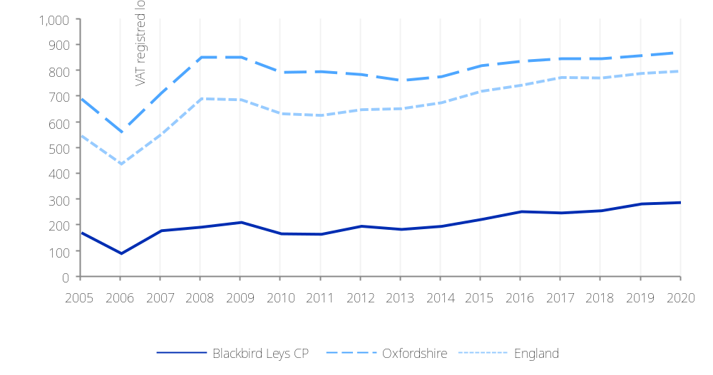
Figure: Businesses (VAT based local units) by employment size band (2020)
Source: Office for National Statistics
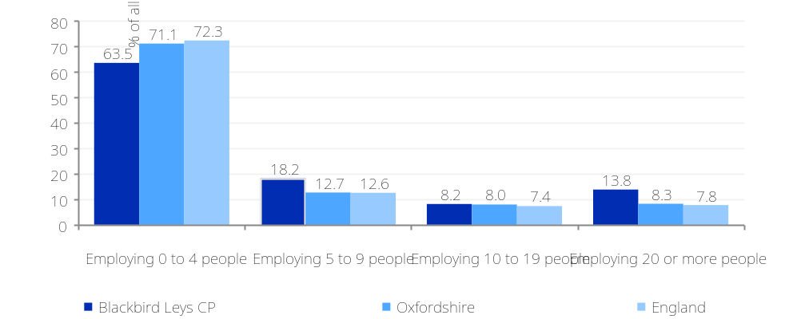

What information is shown here?  The information on the right shows details of the number of cars and vans in each household in Blackbird Leys CP. The count of cars or vans in an area is based on details for private households only. Cars or vans used by residents of communal establishments are not counted.  The information boxes show the number of households by number of cars owned across Blackbird Leys CP, while the charts show the same information (expressed as a percentage) against comparator areas.
  No cars |  | One car |  | Two cars |  | Three cars |  | Four + cars
  1,515 |  | 1,735 |  | 540 |  | 100 |  | 20
  38.7% of 3,910 households (England = 25.8%) |  | 44.4% of 3,910 households (England = 42.2%) |  | 13.8% of 3,910 households (England = 24.7%) |  | 2.5% of 3,910 households (England = 5.5%) |  | 0.6% of 3,910 households (England = 1.9%)
  Source: Census 2011
Figure: Car ownership
Source: Census 2011
 | 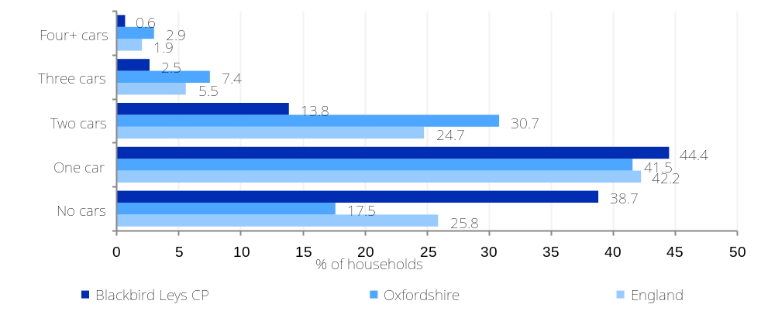
Access and transport: Car ownership

What information is shown here?  The information on this page shows the accessibility of key services and amenities to people living in Blackbird Leys CP. Accessibility is measured both in terms of distance and travel times to key services.  The information boxes on the right show average distances (in kilometres) to five key services. The chart on the right shows average travel times in minutes to key services when walking or taking public transport.
  Average road distance from Job Centre |  | Average road distance from Secondary School |  | Average road distance from GP |  | Average road distance from Pub |  | Average road distance from Post Office
  1.8km |  | 3.3km |  | 1.0km |  | 0.8km |  | 0.7km
  England average = 4.6km |  | England average = 2.1km |  | England average = 1.2km |  | England average = 0.7km |  | England average = 1.0km
  Source: Road distances - Commission for Rural Communities: Distance to Service dataset (2010)
Figure: Average travel time (mins) by walking or public transport to the nearest key service
Source: Department for Transport: Core Accessibility Indicators (2017)
 | 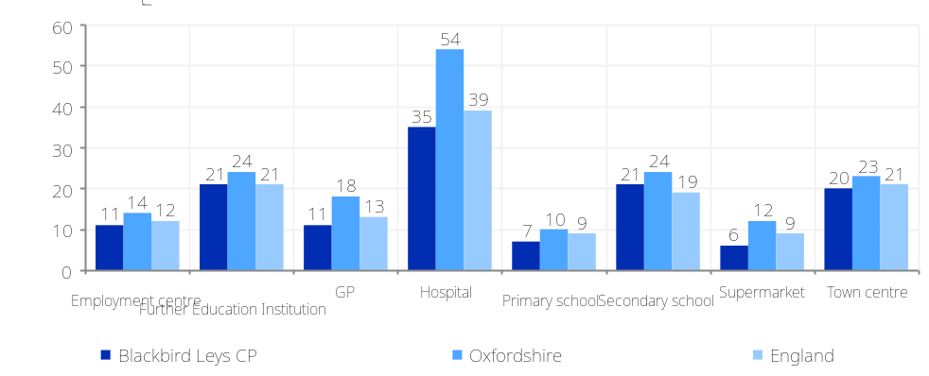

Access and transport: Distance and travel times to key services

Access and transport: Digital services

What information is shown here?  The information on this page shows two measures of access to the internet. The first measure shows information on broadband take-up, speeds and availability. It has been produced by Ofcom and contains data provided by communications providers. The data shows the average broadband line speed in Blackbird Leys CP and the proportion of premises in Blackbird Leys CP with broadband speeds below the Universal Service Obligation (USO) (download speeds at or above 10Mbit/s and upload speeds at or above 1Mbit/s including non-matched records and zero predicted speeds).  The chart on the right shows the proportion of people who responded to the 2011 Census online, compared with the proportion that filled in the Census form on paper in Blackbird Leys CP. This is a proxy measure of digital engagement as areas with a high proportion of online Census responses are more likely to be digitally engaged than those in areas with low levels of online responses.
  Premises with broadband speeds below the USO (2019) |  | Average broadband download speed (Mbit/s) (2017) |  | Average broadband upload speed (Mbit/s)  (2017)
  00 |  | 62.49 |  | 6.39
  0.0% (England average = 1.8%) |  | England average = 45.08 |  | England average = 6.05
  Source: Ofcom 2017 & 2019
Figure: Census online and paper responses
Source: Census 2011
 | 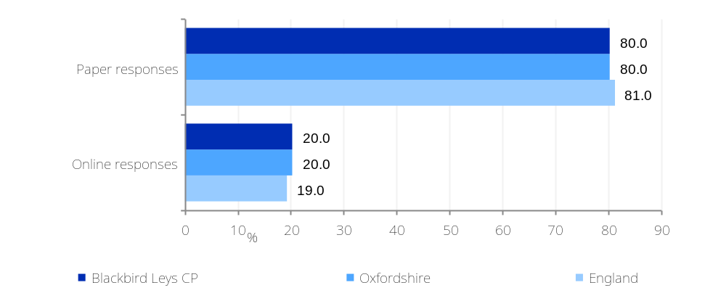

Communities and environment: Classification of neighbourhoods (1)

What information is shown here?  The information on this page looks at the characteristics of neighbourhoods across Blackbird Leys CP as defined using the Output Area Classification (OAC). OAC classifies every area in the country based on a set of socio-demographic characteristics, to provide a profile of areas to identify similarities between neighbourhoods. The information boxes on the right show the number and proportion of neighbourhoods in Blackbird Leys CP that fall within the eight supergroup categories, detailed below. The chart on the right shows the proportion of areas falling within supergroup categories across Blackbird Leys CP and comparators.
  Rural residents | Rural areas, sparsely populated, above average employment in agriculture, higher number owning multiple cars, an older married population, a high provision of unpaid care and an above average number of people living in communal establishments.
  Cosmopolitans | Residing in densely populated urban areas, high ethnic integration, high numbers of single young adults without children including students, high public transport use, above average qualification levels
  Ethnicity central | Concentrated in Inner London and other large cities, high ethnic diversity, high proportion of rented accommodation, high proportion of people living in flats, low car ownership.
  Multicultural metropolitans | Concentrated in larger urban conurbations in the transitional areas between urban centres and suburbia, high proportion of BME groups, high proportion of families.
  Urbanites | Predominantly in urban areas with high concentrations in southern England. More likely to live in either flats or terraces that are privately rented.
  Suburbanites | Located on the outskirts, in areas with high owner occupation, high numbers of detached houses, low unemployment, high qualifications and high car ownership.
  Constrained city dwellers | Higher proportion of older people, households are more likely to live in flats and to rent their accommodation, and there is a higher prevalence of overcrowding, higher proportion of people in poor health, lower qualification levels and high unemployment
  Hard-pressed living | Mostly on the fringe of the UK's urban areas, particularly in Wales and the North of England. High levels of people in terraced accommodation, high unemployment, low ethnic diversity, high levels of people employed in manufacturing
  Rural residents |  | Cosmopolitans |  | Ethnicity central |  | Multicultural metropolitans
  0 |  | 0 |  | 525 |  | 7,813
  0.0% (England average = 10.5%) |  | 0.0% (England average = 4.9%) |  | 5.3% (England average = 6.6%) |  | 79.1% (England average = 15.3%)
  Urbanites |  | Suburbanites |  | Constrained city dwellers |  | Hard-pressed living
  0 |  | 0 |  | 1,542 |  | 0
  0.0% (England average = 18.6%) |  | 0.0% (England average = 20.8%) |  | 15.6% (England average = 6.2%) |  | 0.0% (England average = 17.2%)
  Source: Office for National Statistics Output Area Classification 2011
Figure: Area Classification 2011: Proportion of people living in different types of neighbourhood (by classification type)
Source: Output Area Classification (2011)
 | 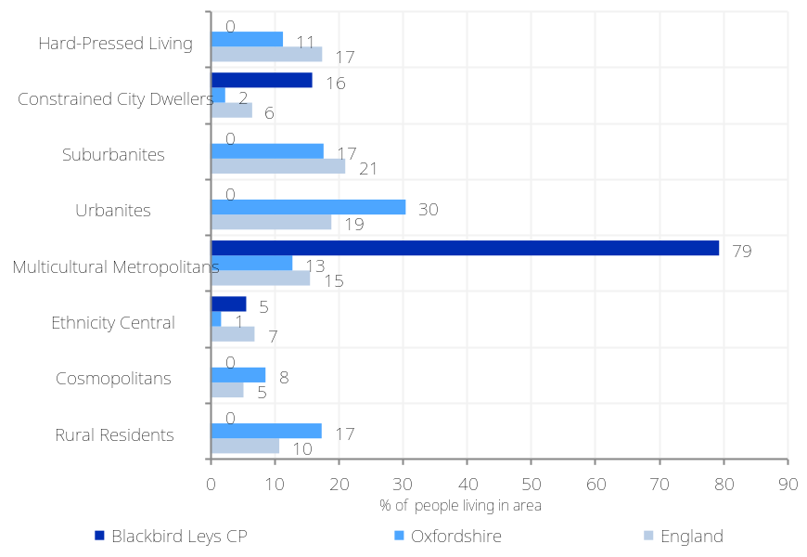

Communities and environment: Internet User Classification

What information is shown here?  The information on this page looks at the classification of neighbourhoods across Blackbird Leys CP in terms of how they interact with the Internet. The Consumer Data Research Centre (CDRC) have developed an Internet User Classification using data from the British Population Survey (BPS), which provides info on the behavioural characteristics of the population regarding various aspects of internet use, which could be linked with demographic data from the census and supplemented with data from online retailers, on online transactions and infrastructure data from OfCom on download speed. Every LSOA in England has been classified into 10 groups (summarised in the table below). The chart on the right shows the proportion of areas falling within each group across Blackbird Leys CP and comparators.  Source: Alexiou, A. and Singleton, A. (2018). ESRC Consumer Data Research Centre; Contains National Statistics data Crown copyright and database right (2017); Ofcom data (2016). CDRC data from Data Partners (2017) | Figure: Internet User Classification 2018: Proportion of people living in different types of neighbourhood (by classification type)  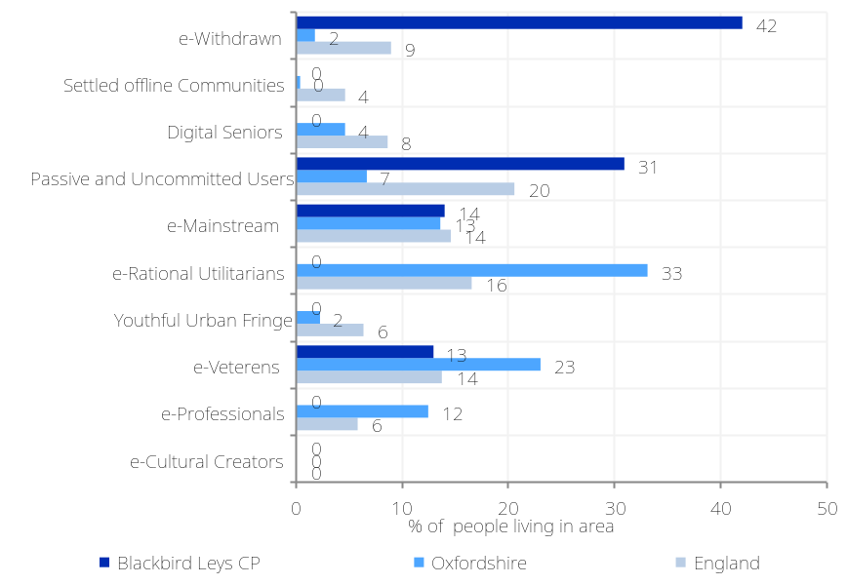
  e-Cultural Creators | High levels of Internet engagement, particularly regarding social networks, communication, streaming and gaming, but relatively low levels of online shopping, besides groceries.
  e-Professionals | High levels of Internet engagement, and comprises fairly young populations of urban professionals, typically aged between 25 and 34. They are experienced users and engage with the Internet daily and in a variety of settings.
  e-Veterans | Affluent families, usually located within low-density suburbs, with populations of mainly middle-aged and highly qualified professionals. Higher levels of engagement for information seeking, online services and shopping, less for social networks or gaming.
  Youthful Urban Fringe | Reside at the edge of city centres and deprived inner city areas, ethnically diverse, young, large student and informal household populations, access via mobile devices. High levels of Internet engagement are average over-all, with high levels of social media usage
  e-Rational Utilitarians | Comprising mainly rural/semi-rural areas with higher than average retired populations, constrained by poor infrastructure. Users undertake online shopping, the Internet is used as a utility rather than a conduit for entertainment.
  e-Mainstream | Exhibit typical Internet user characteristics in heterogeneous neighbourhoods at the periphery of urban areas or in transitional neighbourhoods.
  Passive and Uncommitted Users | Limited or no interaction with the Internet. They tend to reside outside city centres and close to the suburbs or semi-rural areas. Higher levels of employment in semi-skilled and blue-collar occupations.
  Digital Seniors | Typically White British, retired and relatively affluent. Average use of the Internet, typically using a personal computer at home. Despite being infrequent users, they are adept enough to use the Internet for information seeking, financial services and online shopping.
  Settled offline Communities | Elderly, White British, in semi-rural areas. They undertake only limited engagement with the Internet, they may have only rare access or indeed no access to it at all.
  e-Withdrawn | Least engaged with the Internet. Deprived neighbourhoods of urban regions. Highest rate of unemployment and social housing among all Lowest rates of engagement in terms of information seeking and financial services, as well as the lowest rate in terms of online access via a mobile device.

Communities and environment: Neighbourhood satisfaction & local participation (1)

What information is shown here?  The information on this page shows different measures of people’s satisfaction with their neighbourhood and their sense of community cohesion in the neighbourhood. It also shows different measures of people’s participation in volunteering and political decision making in the local area. In addition, the information box on the far bottom right shows the number of active charities per 1,000 population.  Figures are self-reported and taken from the Place Survey. The Place survey is collected at Local Authority level so does not include neighbourhood information, and ceased nationally in 2008 so is increasingly out of date.
  “People from different backgrounds get on well together in the local area” |  | People who feel that they belong to their neighbourhood |  | People who are satisfied with local area as a place to live |  | Aged 65+ "satisfied with both home and neighbourhood"
  82% |  | 49% |  | 83% |  | 81%
  (England = 76%) |  | (England = 58%) |  | (England = 79%) |  | (England = 83%)
  People involved in decisions that affect the local area in the past 12 months |  | People who believe they can influence decisions in their local area |  | People who have given unpaid help at least once per month over the last 12 months |  | Active charities
  15% |  | 29% |  | 27% |  | 4.1 per 1,000 population
  (England = 14%) |  | (England = 29%) |  | (England = 23%) |  | (England = 2.6 per 1,000)
  Source: Census 2011
Figure: Indicators of community strength  Source: Place Survey (2008) | Figure: Indicators of civic engagement  Source: Place Survey (2008)
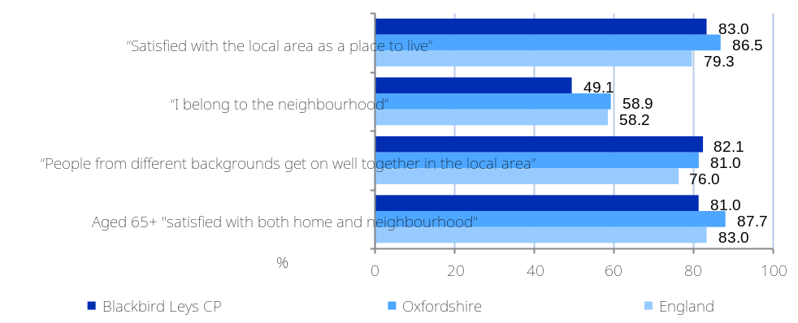 | 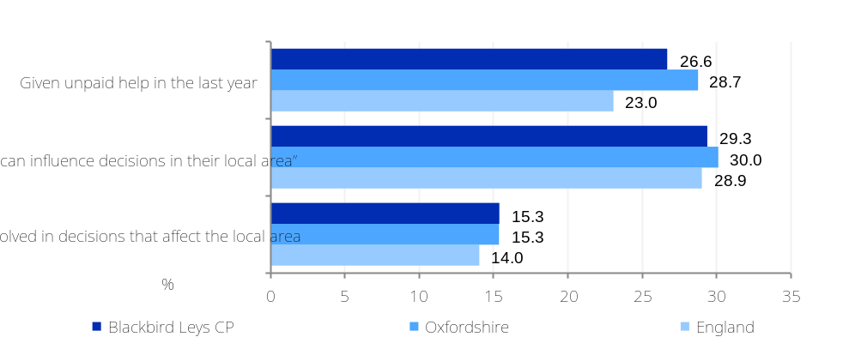

What information is shown here?  The page shows the Community Dynamics indicators for Blackbird Leys CP. The Community Dynamics data set (https://www.communitydynamics.social-life.co/) has been developed by Social Life with the aim of quantifying how people feel about the area they live in.  By modelling responses from the annual Community Life Survey and Understanding Society Survey to Output Areas, Social Life have created small area measures of: strength of local social relationships, strength of belonging to a local area and satisfaction with a local area as a place to live. Positive values represent greater belonging/relationship strength/satisfaction than the national average. Negative figures represent less belonging/relationship strength/satisfaction than the national average.  Please note that these indicators have been created by combining the survey responses of samples of the population and modelling these to Output Areas by linking survey sample demographics to the demographics of Output Areas. As a result, many implicit assumptions are built into the data which will not hold for all areas. The values presented here offer an indication of community belonging, strength and satisfaction rather than an absolute measure.  The fourth information box shows the valid voter turnout (%) at the most recent Local Council Elections. Because the electoral cycle varies in different parts of the country (with associated impacts on turnout) the turnout figures from previous years have been adjusted either upwards or downwards from the 2019 average. This is in order to reflect variation in turnout across different years. For example if turnout was 30% in 2018 and 35% in 2019 than each area in 2018 would be revised upwards using the following calculation 35/30 = 1.166*2018 turnout.
  Local social relationships |  | Belonging |  | Satisfaction with local area as a place to live |  | Voter Turnout at Local Elections (%)
  -0.063 |  | -0.123 |  | -0.016 |  | 19.6
  (England = -0.006) |  | (England = -0.011) |  | (England = 0.001) |  | (England = 33%)
  Figure: Community Dynamic scores for belonging, relationships and satisfaction  Source: Social Life (modelled from the annual Community Life Survey), 2015/2016 |  |  |  |  |  | Electoral Commission (2019)
 | 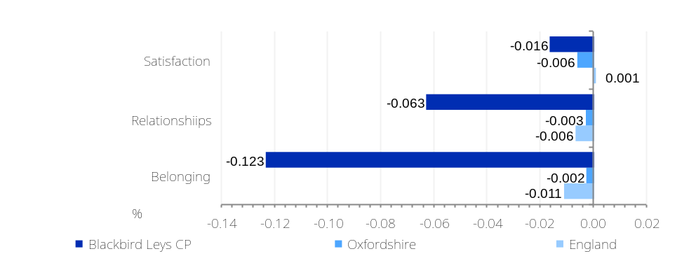

Communities and environment: Neighbourhood satisfaction & local participation (2)

Communities and environment: Air pollution

What information is shown here?  The information on this page shows background concentrations from four air pollutants: nitrogen dioxide, benzene, sulphur dioxide and particulates. The air quality data was collected for 2016 on a 1km grid and obtained from the UK National Air Quality Archive for use in the Indices of Deprivation 2019. A higher score indicates a higher concentration of the pollution with a score of greater than 1 indicating that the levels of pollution exceed national standards of clean air.
  Benzene concentrations |  | Nitrogen Dioxide concentrations |  | Particulates (PM10) concentrations |  | Sulphur Dioxide concentrations
  0.12 |  | 0.4 |  | 0.4 |  | 0.03
  (England average = 0.10) |  | (England average = 0.4) |  | (England average = 0.4) |  | (England average = 0.03)
  Source: Communities and Local Government (Indices of Deprivation 2019 - from National Air Quality Archive 2016)
Figure: Air pollution concentrations for four pollutants
Source: Communities and Local Government (Indices of Deprivation 2019 – from National Air Quality Archive 2016)
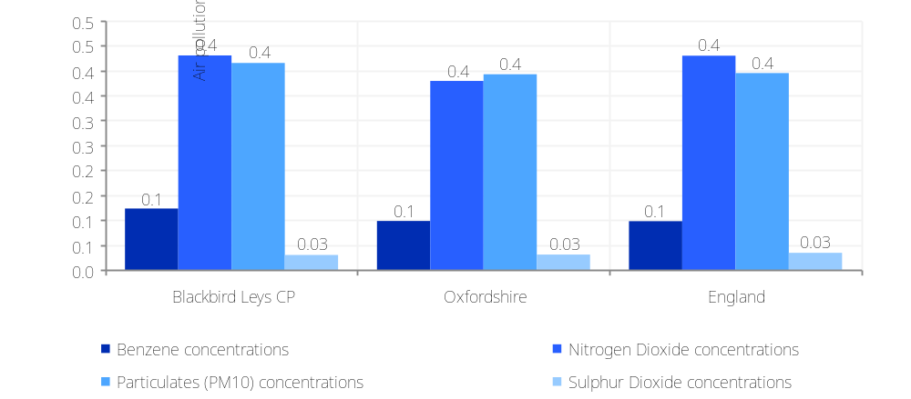

Communities and environment: Green space coverage

What information is shown here?  Ordnance Survey (OS) publish the locations and extent of green spaces that are likely to be accessible to the public. The data include the following types of green spaces: allotments or community growing spaces, bowling greens, cemeteries, religious grounds, golf courses, other sports facilities, play spaces, playing fields, public parks or gardens and tennis courts.  OCSI have intersected OS Open Greenspaces data with Output Area boundaries to produce data for the greenspace per standard geographical area (eg OA, LSOA, LA).  Two green space measures are shown here. The total green space (which includes all types of green space) and the public parks and gardens green space (only public parks and gardens).  Large rural areas such as National Parks are not included in the OS Greenspace dataset. Religious grounds are included where there is seen to be a significant amount (>500m2) of accessible greenspace. Sports stadiums and grounds which are primarily for spectating rather than participating in sports are not included. Playing fields should only be included in OS Greenspace dataset where they are used by the public at least some of the time. Playing fields such as school fields which are entirely enclosed and only for use of the school, would not be expected to be included.  Wooded areas that function as public parks (i.e. are freely accessible to the public in their entirety and are managed for recreation) should be included, however, the constraints of the capture method employed to create the data mean that in many cases these may not yet be included.  OS data © Crown copyright and database right 2017
  Total green space |  | Public parks and gardens greenspace
  16.0% |  | 3.72%
  27.8 hectares (England average = 2.2%) |  | 6.4 hectares (England average = 0.8%)
  Source: OS data © Crown copyright and database right 2017
Figure: Percentage of green space coverage
Source: OS data © Crown copyright and database right 2017
 | 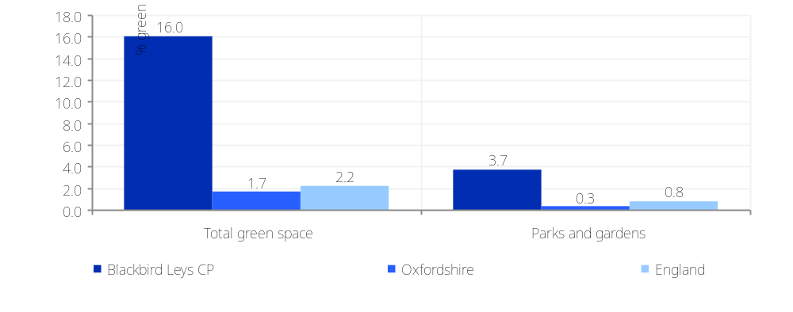

Communities and environment: Community Needs Index

What information is shown here?  The Community Needs Index that was developed to identify areas experiencing poor community and civic infrastructure, relative isolation and low levels of participation in community life. The index was created by combining a series of 19 indicators, conceptualised under three domains: Civic Assets, Connectedness and Active and Engaged Community. A high score indicates that the area has high levels of need.  - Civic Assets: measures the presence of key community, civic, educational and cultural assets in a close proximity of the area. These include pubs, libraries, green space, community centres, swimming pools – facilities that provide things to do often, at no or little cost, which are important to how positive a community feels about its area.  - Connectedness: measures the connectivity to key services, digital infrastructure, isolation and strength of the local jobs market. It looks at whether residents have access to key services, such as health services, within a reasonable travel distance. It considers how good public transport and digital infrastructure are and how strong the local job market is.  - Active and Engaged Community: measures the levels of third sector civic and community activity and barriers to participation and engagement. It shows whether charities are active in the area, and whether people appear to be engaged in the broader civic life of their community.
  Community Needs Score |  | Civic Assets score |  | Connectedness score |  | Active and engaged community score
  52.8 |  | 7.8 |  | 10.7 |  | 34.3
  (England average = 68.4) |  | (England average = 23.2) |  | (England average = 21.3) |  | (England average = 23.9)
  Source: Oxford Consultants for Social Inclusion (OCSI) and Local Trust (https://localtrust.org.uk/insights/research/left-behind-understanding-communities-on-the-edge/)
Figure: Community Needs Index
Source: Oxford Consultants for Social Inclusion (OCSI) and Local Trust (2019)
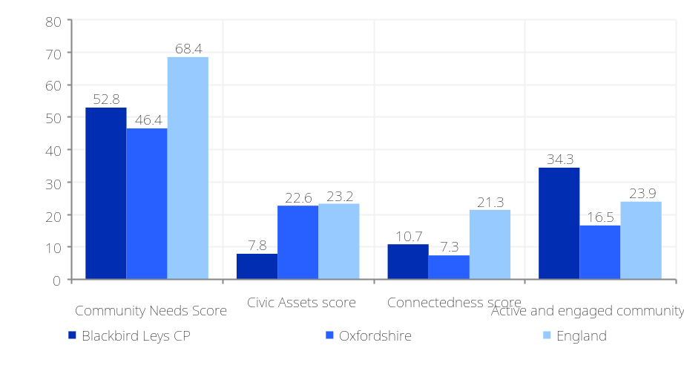

Communities and environment: Funding

What information is shown here?  This page looks at funding and includes data on the Big Lottery Fund and grant funding from national grant giving organisations.  Big lottery figures on this page are taken from data on grants made to projects and organisations in local areas in the UK by the Big Lottery Fund, modelled down to standard statistical geographies from ward grants data published by Big Lottery in conjunction with the 360Giving initiative. Big Lottery used the 360Giving standard to produce a dataset of all the grants made from 2004-2015 as well as 2004-2010 and 20011-2015. Note the (N) figure refers to total funding in the area (in £1000s) over the period.  The fourth information box shows the total combined grant funding from the largest national grant giving organisations whose data has been subject to the 360giving standard. The data is based on the location of grant recipients rather than the location of beneficiaries. Organisations included: Sport England, The Henry Smith Charity, The Tudor Trust, Lloyds Bank Foundation for England and Wales, Barrow Cadbury Trust, Department for Transport, Esmée Fairbairn Foundation, Masonic Charitable Foundation, Nationwide Foundation, Co-operative Group, Paul Hamlyn Foundation, Woodward Charitable Trust, Power to Change, The Dulverton Trust, Virgin Money Foundation, The Clothworkers Foundation, A B Charitable Trust, Seafarers UK, Three Guineas Trust, Nesta, The Joseph Rank Trust, National Churches Trust, LandAid Charitable Trust, True Colours Trust, Pears Foundation, Wates Family Enterprise Trust, The Blagrave Trust, Tuixen Foundation, Samworth Foundation, Tedworth Charitable Trust, Road Safety Trust, Wates Foundation, Staples Trust, The David & Elaine Potter Foundation, Gatsby Charitable Foundation and ZING.  For more information on the 360Giving data format and initiative please visit www.threesixtygiving.org/
  Big Lottery funding (in £1000s)  (2004-2015) |  | Big Lottery funding  (in £1000s)  (2004-2010) |  | Big Lottery funding  (in £1000s)  (2011-2015) |  | Total grants awarded from major funders  (in £1000s) (2019)
  £01,532 |  | £00,817 |  | £00,711 |  | £00,961,224
  (£154 per head) England average = £102 per head |  | (£82 per head) England average = £56 per head |  | (£72 per head) England average = £46 per head |  | (£105 per head) England average = £34 per head
  Source: Big Lottery, 360Giving
Figure: Big Lottery grant funding per head, 2004-2015
Source: Big Lottery, 360Giving, 2015
 | 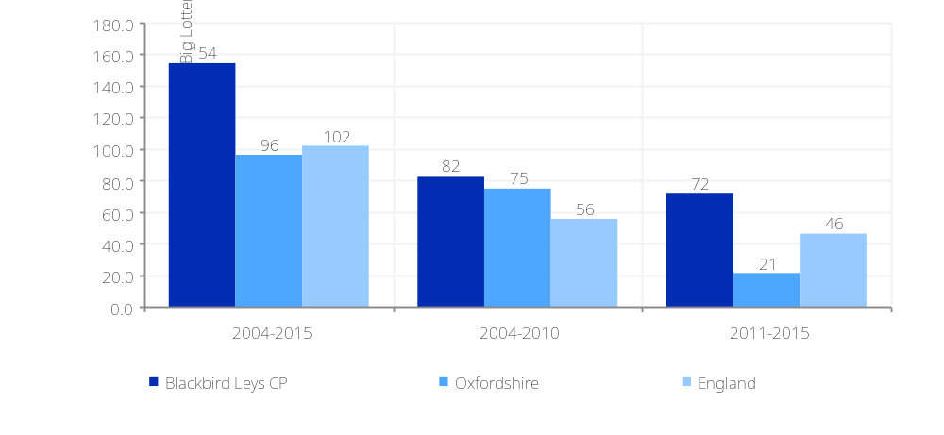

How we have identified the “Blackbird Leys CP” area  Appendix A: About the data and geographies used in this report  This report is based on the definition of the “Blackbird Leys CP” area (this area can be viewed on the Local Insight map, through finding the area on the ‘show services’ dropdown in the top left hand corner of the map. We have aggregated data for all the neighbourhoods in “Blackbird Leys CP” to create the data used in this report.  Alongside data for the “Blackbird Leys CP” neighbourhood we also show data for selected comparator areas.  Data in this report is based on regularly updated open data published by government sources  All the data in this report is based on open data published by more than 50 government agencies, collected and updated by OCSI on weekly basis. Data is updated on regular basis, with the reports and mapped data on the website reflecting the latest available data.  Details of the individual datasets are provided on the pages where the data is presented, with information on dates and sources presented alongside the charts and tables. On the website, information about each source is available on the popup “About the indicator” link at the top-right of the map. | Standard geographies used in this report  Super Output Areas (SOAs): SOAs are a statistical geography created for the purpose of presenting data such as the Census, Indices of Deprivation, and other neighbourhood statistics. There are two layers to the SOA geography: ‘lower layer’ (LSOA) and ‘middle layer’ (MSOA). SOAs are designed to produce areas of roughly equal population size - 1,500 people for LSOAs and 7,200 for MSOAs. The majority of data used in this report is based on LSOA boundaries; of which there are 32,844 in England (there were changes to around 4% of LSOA definitions in Census 2011).  Output Areas (OAs): OAs are a more detailed statistical geography than SOAs, with each covering around 300 people, or 120 households. There are 171,372 OAs in England (there were changes to around 5% of OA definitions in Census 2011).  Wards: A small number of datasets are published at ward level. These are on average four times larger than LSOAs. Data is less detailed than LSOA level datasets and wards vary greatly in size, from less than 200 residents (Isles of Scilly), to more than 36,000 residents (in Sheffield).

Appendix B: Data source details by theme

Theme | Data | Data source/ time period | Date published | Date next update
Population | Total population and by age | Mid-Year Estimates (ONS) 2019 | Annually (published September 2020) | Sep-21
Population | Population by ethnicity | Census 2011 | 10 yearly (published August 2013) | 2023
Population | Population by country of birth | Census 2011 | 10 yearly (published August 2013) | 2023
Population | Population by household language | Census 2011 | 10 yearly (published August 2013) | 2023
Population | People who have moved address within the last 12 months | Census 2011 | 10 yearly (published August 2013) | 2023
Population | National Insurance no. registrations of overseas nationals | DWP 2019/20 | Annually (published June 2020) | June-21
Population | Level of inward and outward migration (by age) | ONS 2010 | Irregular (published 2011) | No publication date confirmed
Population | Population by household composition | Census 2011 | 10 yearly (published August 2013) | 2023
Population | Population by religion | Census 2011 | 10 yearly (published August 2013) | 2023
Vulnerable groups | Unemployment benefit (JSA and Universal Credit) | DWP Oct-20 | Monthly (published November 2020) | Dec-20
Vulnerable groups | Jobseekers Allowance claimants, claiming for over 12 months | DWP Oct-20 | Monthly (published November 2020) | Dec-20
Vulnerable groups | Youth unemployment (18-24 receiving JSA or Universal Credit) | DWP Oct-20 | Monthly (published November 2020) | Dec-20
Vulnerable groups | Older person unemployment (50+ receiving JSA or Universal Credit) | DWP Oct-20 | Monthly (published November 2020) | Dec-20
Vulnerable groups | Unemployment benefit (JSA and Universal Credit), male | DWP Oct-20 | Monthly (published November 2020) | Dec-20
Vulnerable groups | Unemployment benefit (JSA and Universal Credit), female | DWP Oct-20 | Monthly (published November 2020) | Dec-20
Vulnerable groups | Working age workless benefit claimants | DWP May-20 | Quarterly (published November 2020) | Feb-21
Vulnerable groups | Incapacity Benefit claimants | DWP May-20 | Quarterly (published November 2020) | Feb-21
Vulnerable groups | Disability Living Allowance claimants | DWP May-20 | Quarterly (published November 2020) | Feb-21
Vulnerable groups | Attendance Allowance claimants | DWP May-20 | Quarterly (published November 2020) | Feb-21
Vulnerable groups | Personal Independence Payments (PIP) | DWP April-20 | Quarterly (published June 2020) | Sept-20
Vulnerable groups | Universal Credit households with Limited Capability for Work Entitlement | DWP August-20 | Quarterly (published November 2020) | Feb-21
Vulnerable groups | Universal Credit by Conditionality | DWP Oct-20 | Monthly (published November 2020) | Dec-20
Vulnerable groups | Working age DWP Benefit claimants | DWP Nov-16 | Quarterly (published May 2017) | Discontinued
Vulnerable groups | Female working age benefit claimants | DWP Nov-16 | Quarterly (published May 2017) | Discontinued
Vulnerable groups | Male working age benefit claimants | DWP Nov-16 | Quarterly (published May 2017) | Discontinued
Vulnerable groups | Income Support (IS) claimants | DWP May-20 | Quarterly (published November 2020) | Feb-21
Vulnerable groups | Housing Benefit claimants | DWP August-20 | Quarterly (published November 2020) | Feb-21
Vulnerable groups | Universal Credit claimants | DWP Oct-20 | Monthly (published November 2020) | Dec-20
Vulnerable groups | Indices of Deprivation (ID) 2019 by domain | MHCLG (Indices of Deprivation 2019) | Irregular (September 2019)
Vulnerable groups | Children in low income families | DWP 2018 | Annual (published March 2020) | March-21
Vulnerable groups | Children in lone parent households | DWP 2012 | Irregular | No publication date confirmed
Vulnerable groups | Children in poverty | DWP 2016 | Annually (published December 2018) | Delay in publication
Vulnerable groups | Child Wellbeing Index | CLG (Child Wellbeing Index 2009) | Irregular (published 2009) | No publication date confirmed
Vulnerable groups | Private pensioner households with no car or van | Census 2011 | 10 yearly (published August 2013) | 2023
Vulnerable groups | Households of one pensioner | Census 2011 | 10 yearly (published August 2013) | 2023
Vulnerable groups | Pension credit claimants | DWP May-20 | Quarterly (published November 2020) | Feb-21
Vulnerable groups | State Pension total claimants | DWP May-20 | Quarterly (published November 2020) | Feb-21
Vulnerable groups | Loneliness index | Age UK 2011 | Irregular (published January 2016) | No publication date confirmed
Vulnerable groups | Mental health related benefits | DWP May-20 | Quarterly (published November 2020) | Feb-21
Vulnerable groups | Households suffering multiple deprivation | Census 2011 | 10 yearly (published August 2013) | 2023
Vulnerable groups | Household is not deprived in any dimension | Census 2011 | 10 yearly (published July 2014) | No publication date confirmed
Vulnerable groups | Household is deprived in 1 dimension | Census 2011 | 10 yearly (published July 2014) | No publication date confirmed
Vulnerable groups | Household is deprived in 2 dimensions | Census 2011 | 10 yearly (published July 2014) | No publication date confirmed
Vulnerable groups | Household is deprived in 3 dimensions | Census 2011 | 10 yearly (published July 2014) | No publication date confirmed
Vulnerable groups | People providing unpaid care | Census 2011 | 10 yearly (published August 2013) | 2023
Vulnerable groups | Unpaid care (50+ hours per week) | Census 2011 | 10 yearly (published August 2013) | 2023
Housing | Dwelling type breakdowns | Census 2011 | 10 yearly (published August 2013) | 2023
Housing | Housing tenure breakdowns | Census 2011 | 10 yearly (published August 2013) | 2023
Housing | Average house prices by housing type | Land registry September19-August20 | Quarterly (published October 2020) | Jan-21
Housing | Households by Council Tax Band | Valuation Office Agency (VOA) 2019 | Annually (published November 2019) | Under consultation
Housing | Housing affordability gap, average house prices and savings ratio | ONS House Price Statistics for Small Areas Oct16-Sep17; ONS earnings data 2015/2016 | Irregular (published April 2018) | Earnings data April-19
Housing | Population density (persons / hectare) | ONS 2016 | Annually (published November 2018) | Nov-19
Housing | Housing Environment | Census 2011 | 10 yearly (published August 2013) | 2023
Housing | Dwelling size | Census 2011 | 10 yearly (published August 2013) | 2023
Housing | Electricity and Gas consumption | Department for Business, Energy and Industrial Strategy, 2018 | Irregular (published March 2019) | No publication date confirmed
Housing | Households not connected to the gas network | Department for Energy and Climate Change (DECC) 2018 | Annually (published January 2020) | January 2021
Housing | Energy efficiency ratings | DCLG. Data collected between 2009-2016 | Irregular (published 2017) | No publication date confirmed
Housing | Communal establishments by type | Census 2011 | 10 yearly (published August 2013) | 2023
Crime and safety | Recorded crime offences | Police UK September19-August20 | Quarterly (published October 2020) | Jan-21
Health and wellbeing | Life expectancy | ONS 2013-2017 | Irregular (published 2019) | No publication date confirmed
Health and wellbeing | Healthy Life Expectancy | ONS 2009-2013 | Annually (published 2016) | Delay in publication
Health and wellbeing | Disability-free Life Expectancy | ONS 2009-2013 | Annually (published 2016) | Delay in publication
Health and wellbeing | Incidence of cancer by cause | ONS 2012-2016 | Annually (published 2019) | Jun-20
Health and wellbeing | Cancer mortality by cause | ONS 2013-2017 | Annually (published 2019) | Jun-20
Health and wellbeing | Number of people living in health deprivation ‘hotspots’ | CLG (Indices of Deprivation 2015) | Irregular (September 2015) | 2019
Health and wellbeing | People with a limiting long-term illness | Census 2011 | 10 yearly (published August 2013) | 2023
Health and wellbeing | Babies born with a low birth weight | ONS 2011-2015 | Annually (published 2017) | Jan-19
Health and wellbeing | Hospital admissions | ONS 2013/14 – 2017/18 | Annually (published 2019) | Jun-20
Health and wellbeing | Musculoskeletal conditions by type | Arthritis UK (2011) | Irregular (published 2017) | No publication date confirmed
Health and wellbeing | “Healthy eating” (consumptions of 5+ fruit and veg a day), binge drinking and smoking | Health Survey for England 2006-2008 | Irregular (published 2014) | No publication date confirmed
Health and wellbeing | Children classified as obese | National Child Measurement Programme (NCMP) (2015/16 to 2017/18) | Irregular (published 2019) | No publication date confirmed
Health and wellbeing | Adults classified as obese | Health Survey for England 2006-2008 | Irregular (published 2014) | No publication date confirmed
Health and wellbeing | Physical activity among adults | Sport England (Active Lives Survey) 2020 | Irregular (published April 2020) | No publication date confirmed
Health and wellbeing | Index of Access to Health Assets and Hazards (AHAH) | 2016 | No update planned (published 2017) | No plans to update
Education and skills | Qualifications by level | Census 2011 | 10 yearly (published August 2013) | 2023
Education and skills | Participation in Higher Education | Office for Students (OFS) | Irregular | No publication date confirmed
Education and skills | Early years foundation stage profile | DfE 2013-2014 | Annually (published June 2015) | Delay in publication
Education and skills | Pupil attainment at Key Stage 1, Key Stage 2 and Key Stage 4 | DfE 2013-2014 | Annually (published June 2015) | Delay in publication
Economy | Annual household income | ONS 2017/18 | Irregular (published March 2020) | March-21
Economy | Annual household income, after housing costs | ONS 2017/18 | Irregular (published March 2020) | March-21
Economy | Households living in ‘Fuel Poverty’ | Department for Business, Energy and Industrial Strategy (2018) | Annually (published June 2020) | June-2021
Economy | Debt | UK Finance (March-2020) | Biannually (published April 2020) | Sept-20
Economy | Economic activity by type | Census 2011 | 10 yearly (published August 2013) | 2023
Economy | Employment type by sector | Census 2011 | 10 yearly (published August 2013) | 2023
Economy | Job centre vacancies | ONS/Jobcentre Plus (Nov-12) | Irregular (published December 2012) | No publication date confirmed
Economy | Jobs by sector | Business Register and Employment Survey (BRES) (2018) | Annually (published 2019) | Oct-20
Economy | Business VAT based local units by sector and size | ONS 2020 | Annually (published September 2020) | Sep-21
Access and transport | Car ownership by number | Census 2011 | 10 yearly (published August 2013) | 2023
Access and transport | Road distances to key services by type | Commission for Rural Communities: Distance to Service dataset (2010) | Irregular (published 2011) | No publication date confirmed
Access and transport | Average travel time (mins) by walking or public transport to the nearest key service | DfT 2016 | Annually (published July 2018) | Aug-19
Access and transport | Broadband speed | Ofcom 2017 | Annually (published December 2017) | Jan-19
Access and transport | Census online and paper responses | Census 2011 | 10 yearly (published August 2013) | 2023
Communities and environment | Area classifications by type | ONS Output Area Classification 2011 | 10 yearly (published July 2014) | No publication date confirmed
Communities and environment | Internet User Classification | Consumer Data Research Centre | Annually (published 2018) | 2019
Communities and environment | Indicators of community strength and civic engagement | Place Survey (2008) | Irregular (published June 2009) | No publication date confirmed
Communities and environment | Active charities | National Council for Voluntary Organisations (NCVO) (2009) | Irregular (published 2009) | No publication date confirmed
Communities and environment | Community Dynamic scores for belonging, relationships and satisfaction | Social Life (modelled from the annual Community Life Survey), 2015/2016 | Irregular | No plans to update
Communities and environment | Air pollution concentrations for four pollutants | CLG, Indices of Deprivation 2015 - from National Air Quality Archive 2012 | Irregular (September 2015) | 2019
Communities and environment | Greenspaces and parks | OS data © Crown copyright and database right 2017 | Irregular (published May 2017) | No publication date confirmed
Communities and environment | Big Lottery funding | Big Lottery, 360Giving, 2004-2015 | Irregular | No publication date confirmed
Communities and environment | Community Needs Index | OCSI, Local Trust 2019 | Irregular (published September 2019) | No publication date confirmed

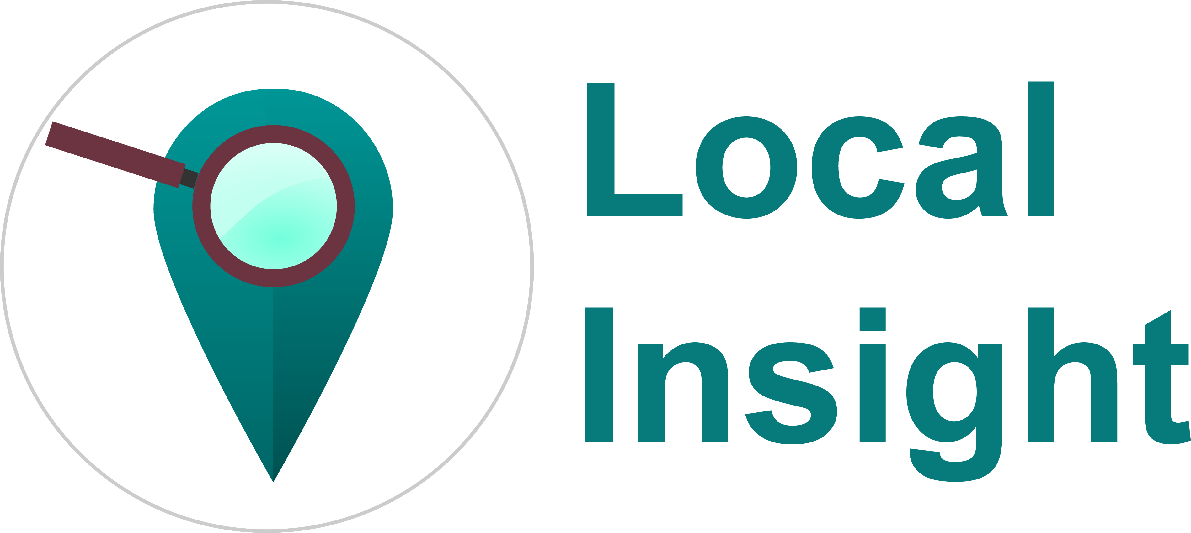 | Local Insight gives you the data and analysis you need to ensure your services are underpinned by the best possible knowledge of local communities, levering the power of information right across your organisation, from high-level visualisations for Board level to detailed reports on local neighbourhoods. Saving you time and money, Local Insight gives you the most relevant and up-to-date data on the communities where you work, with no need to invest in specialist mapping and data staff, consultancy or software. See http://local.communityinsight.org/ for more information.  Local Insight is developed by OCSI, based on a project that was jointly developed by HACT and OCSI.
 | OCSI work with public and community sector organisations to improve services. We turn complex datasets into engaging stories; making data, information and analysis accessible for communities and decision-makers. See www.ocsi.co.uk for more information.

Please note that there are currently no planned updates for this dataset, however we still consider it to be relevant.
The seven domains of deprivation included are: Employment deprivation, Income deprivation, Health deprivation and disability, Education, skills and training deprivation, Crime, Living environment deprivation, Barriers to housing and services.
Please note that there are currently no planned updates for this dataset, however we still consider it to be relevant.
Material wellbeing - children experiencing income deprivation; Health and disability – children experiencing illness, accidents and disability; Education - education outcomes including attainment, school attendance and destinations at age 16; Crime - personal or material victimisation of children; Housing - access to housing and quality of housing for children; Environment - aspects of the environment that affect children’s physical well-being; Children in need – vulnerable children receiving LA services.

