
OXFORD CHARACTER
ASSESSMENT TOOLKIT


DETAILED CHARACTER ASSESSMENT

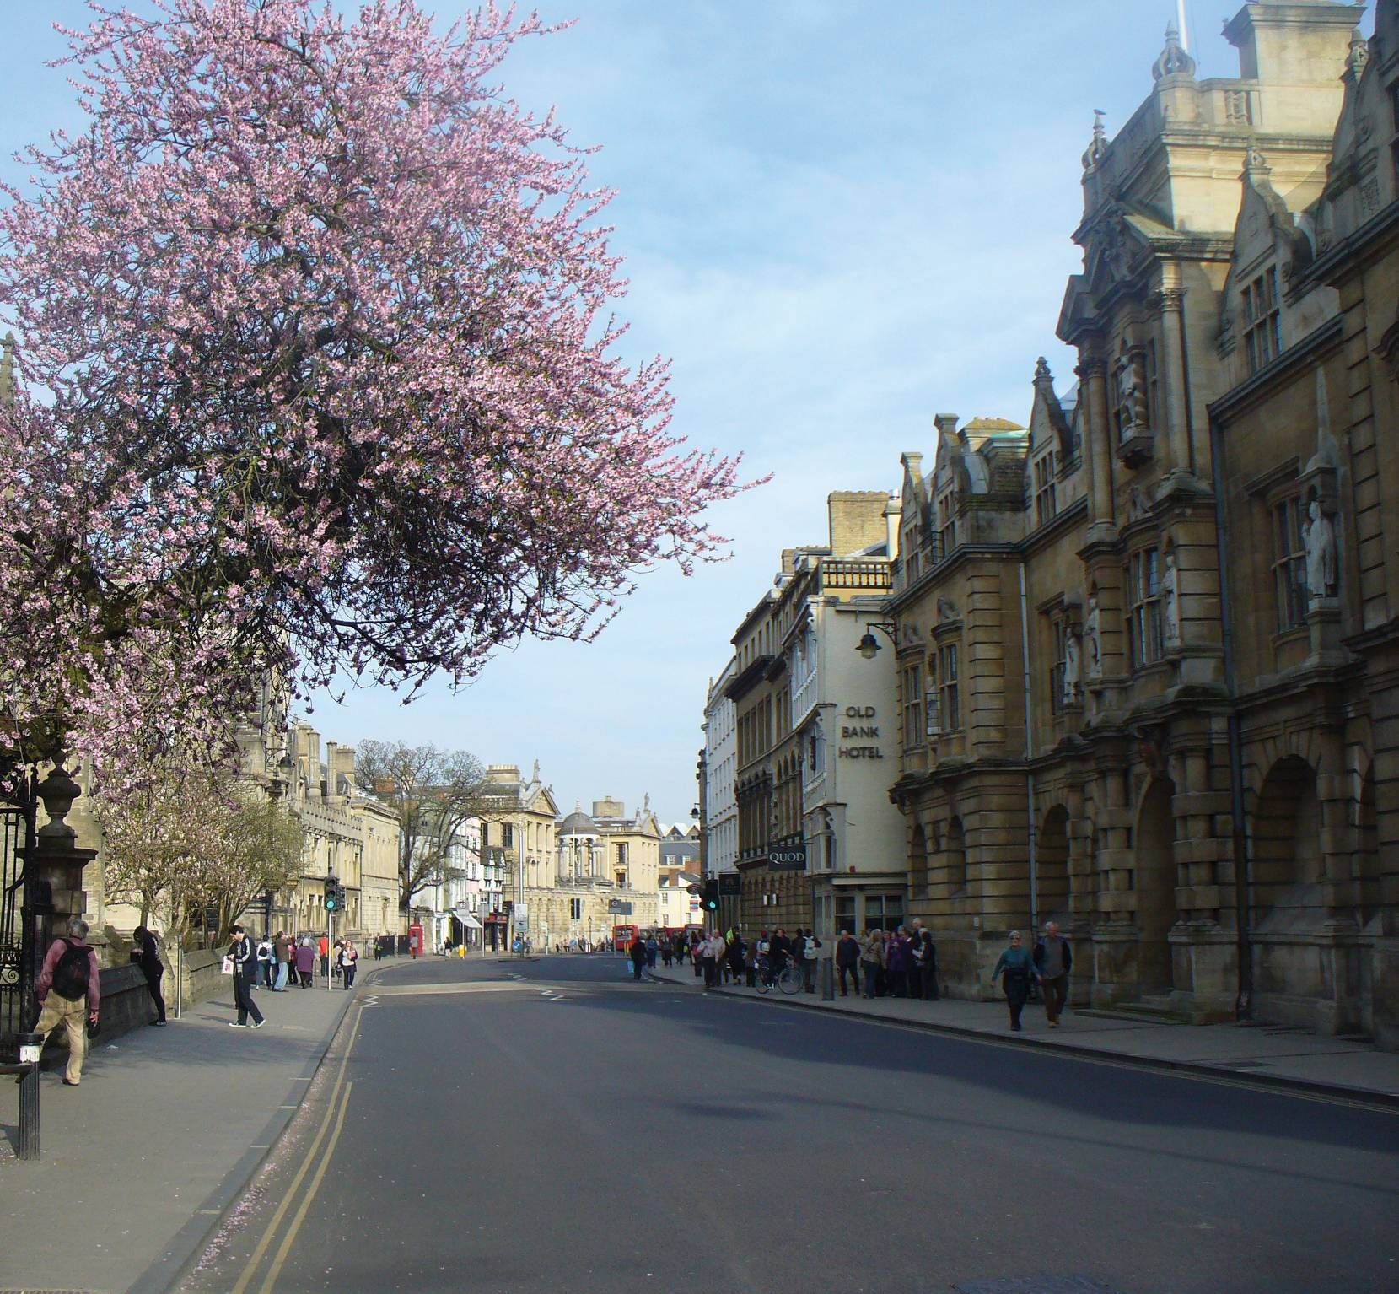

Contents

Introduction 1
How to use the toolkit 2
Survey Details 4
1. Initial Reaction 4
2. Spaces 5
3. Buildings 6
4. Views 7
5. Landscape 8
6. Ambience 8
7. Final Reaction 9
8. Spirit of Place 9

Introduction

This character assessment toolkit is designed to help you examine the character of areas, buildings and places in areas of Oxford to identify the features that contribute to their distinctiveness, interest and amenity. It also provides opportunities to identify features or issues that detract from the character of areas, spaces and buildings.

How the toolkit will be used
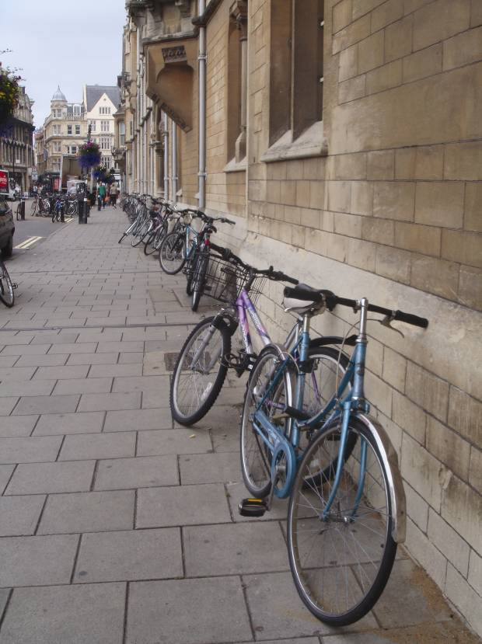
The historic environment makes an important contribution to the character of the city as a distinctive, interesting and special place. The buildings, spaces, associations and history that combine to create places mean different things to different people. The toolkit should help people to analyse the character of areas, spaces and buildings in a structured way. This should help to identify, define and understand the significance and value of different features of the environment that contribute to its character and distinctiveness.

While there is an accepted need for change to occur within many places in the city, proposals for change should be measured against their existing significance to ensure that their present values are not eroded. This should help to ensure that change enhances and sustains the value of the historic environment to the city for ourselves and future generations. The evidence and understanding provided by the process will enable management of change in an effective and positive manner.

What makes up character?

Elements of character include both the uses of an area and its physical features, such as styles of building, construction materials, architectural details or green landscape features. Others elements of character may be more emotional or personal perceptions of a place, such as historical or cultural associations with a place or building. Others may be relatively ephemeral or transitory, such as the smells and sounds associated with particular activities, which may occur only at certain times of the day or year. The features, listed in the Survey Sheets below, are common components of character, but the list is not exhaustive.
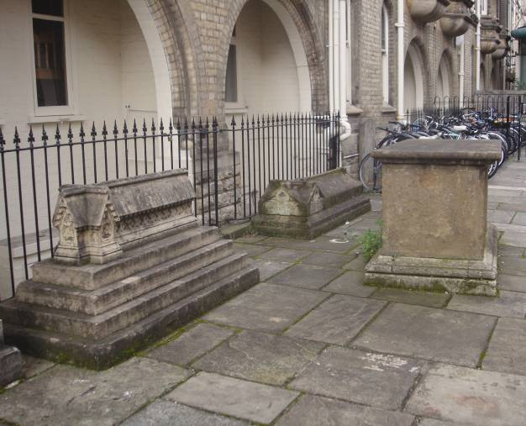

How to use the toolkit

Undertaking your character assessment

In undertaking your assessment it is important to visit the area/building/space to complete a visual survey. In pilot studies, people have found they prefer to take photos and make brief notes whilst in the area, giving them time to examining the surroundings. They then make more detailed notes on the questionnaire, once they have completed the survey. Although there is no prescribed method for carrying out an assessment, the following structure may be helpful:

- It works best on a street by street basis. If you wish to assess a larger area it will be worth surveying each street individually and putting together an overall picture after all the surveys are finished.
- Take an initial walk around your survey area. Use this opportunity to note your initial thoughts/perceptions of the area and assign a score (see below) to the broad character features.
- Taking photographs is strongly recommended as they can illustrate and visually explain any comments you make on the questionnaire. They are also useful to look back over after you have completed the survey.
- Annotating a street plan/map is also a useful way to explain certain features e.g. direction of views, location of key buildings, spaces, etc.
- Make comments using the explanation of terms to prompt your thoughts.
- Give a score to each feature based on your opinion of its negative or positive contribution to the space.
- It is also worth noting how the building/space/area being assessed relates to its wider context e.g. how a building sits within a street or a street within an area. The setting and interrelationships between the single element, such as a building, and the wider context, such as the street, are just as important as the quality of the buildings themselves.

The tool kit is divided into a series of themed questionnaires that will prompt you to consider the contribution of different features that might contribute to the character of the area/building/space. The features listed are the main components of character but the list is not exhaustive. Depending upon the asset being assessed e.g. a building, street, space etc, not every feature in the list may be relevant and a comment should be entered only where applicable.

Each feature requires a brief comment of how you feel it contributes to the character and value of the area. The option is provided to assign a numerical score to reflect your perception of the significance of each feature to the character of the asset. The ‘scores’ given may vary from one individual to another. However, trends will be seen when comparing different surveys of the same asset.
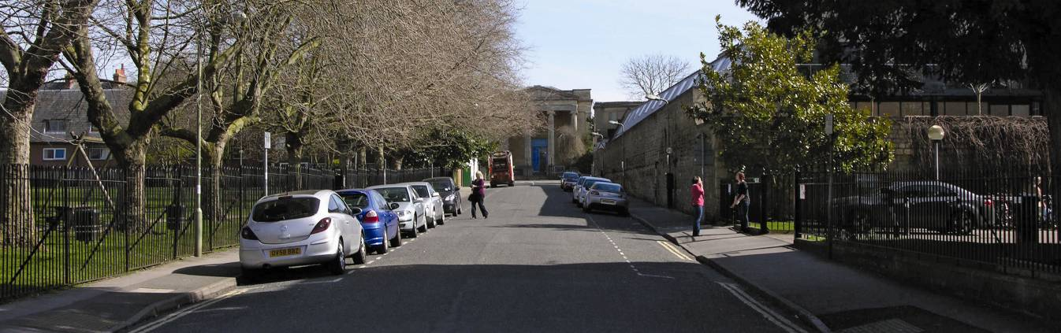
Initial Reaction to an Area

The initial reaction is a summary of what you see and feel when you first enter the area being assessed.

Survey

In the main body of the toolkit, the character features outlined in the ‘Initial Reaction’ section are broken down into individual questionnaires. These prompt a finer level of analysis of each of the broader character themes. Again, not every feature in the list may be relevant and a comment and a numerical value should be entered only where applicable.

Final Reaction

This prompts a reassessment of your initial reactions. It allows you to see if your perception of the asset’s character has changed as a result of the in-depth study. Try placing the nine character groups in an order of preference, with ‘1’ being the feature you feel the most important contribution to its character and ‘9’ the least.

Spirit of Place

This is an open question allowing you to articulate what you feel about the place and how it influences all your senses

Need more help?

A guidance document is available to view on the Character Assessment Toolkit Website. This includes explanations of some of the terms used in the questionnaires and some prompts to help you think about the contribution of different types of features to the character of the area. If you feel there is an additional feature, feel free to make a note of that separately in the comments box at the end of the questionnaire. Not every feature in the list may be relevant and you need only enter a comment where you feel it is applicable.

Further Research

A visual study may only take you so far in understanding what is special about an area. By researching its history you may develop a better understanding of how the buildings and spaces reflect its evolution and its unique character. You may wish to focus this research on how the physical characteristics reflect the process of its development, such as the formal design of a landscape, the functional and artistic elements of a building that reflect its use, or the social and economic processes that have influenced the evolution of a settlement. The Character Assessment Toolkit website includes a Research Area with tips and links to help you get started with your research. Some of the information may be readily accessible as online resources, whilst others may require visiting the local studies library, record office or other archives.

Assigning numerical values to features
Assigning a numerical value or score provides a mechanism for analysing and interpreting results over a wider area. Without scoring consistent interpretation and evaluation of text and written comments can be difficult

- +1 to +5: Positive features that add to the character or special nature of an area. This ranges from +1, slightly adds to the character, to +5, that significantly adds to the character.
- 0: Neutral features that are neutral. They neither detract nor add from/to the character of the area.
- -5 to -1: Negative features that detract/take away from the area. This ranges from -5, significantly detract, to -1, slightly detract.

SURVEY DETAILS

STREET/BUILDING/

AREA NAME

DATE

TIME

WEATHER

1: Initial Reaction: What do you first see as making the most important contribution to the character of the area? Is the area’s character defined by the public or private spaces, groups of buildings or particular views, the presence of particular materials or its trees and greenery? Do these reflect particular aspects of the area’s history? Are less tangible features, such as the activity, noises and smells of the area significant? Please provide a few brief reasons for your choices.
FEATURE | COMMENTS | VALUE  -5 TO +5

SPACES

BUILDINGS

VIEWS

LIGHT/DARK

SURFACES

GREENERY & LANDSCAPE

USES AND ACTIVITY

NOISES AND SMELLS

GENERAL COMMENTS

2: Spaces: A ‘space’ is normally the gap between buildings and other features. They may be formally designed or develop informally over time. They may be enclosed by surrounding buildings, trees and foliage, have structure created by the alignment and spacing of surrounding buildings or property boundaries, and be narrow or wide and open. The character of areas can depend on their uses and vibrancy, as well as the choice of paving, kerbs, seating, telephone or post boxes or the presence of formal planting or other greenery.
FEATURE | COMMENTS | VALUE  -5 TO +5

FORMAL / INFORMAL SPACES

GAPS BETWEEN BUILDINGS

MEANS OF ENCLOSURE

BUILDING PLOTS

WIDE/OPEN SPACES

NARROW / ENCLOSED SPACES

WINDING / STRAIGHT SPACES

RELATIONSHIP OF THE SPACE TO BUILDINGS AND STRUCTURES

USES AND ACTIVITY

PAVING MATERIALS

STREET FURNITURE

IMPACT OF VEHICLES AND TRAFFIC

USABILITY AND ACCESSIBILITY OF THE SPACE

3.0 BuildingS: Do buildings make an important contribution to the character of the area and if so what features are significant to their contribution? Do buildings reflect an important period in the area’s history and is this reflected in their past or current use? Do buildings share a uniform scale and size, or is there a high degree of variation that is visually attractive? Are the buildings very old or do they form a single development with shared or similar architectural detailing? Do styles of windows, doors or other features add to the visual interest of the buildings, reflect their origins and use, or form part of a designed scheme? What condition are the buildings in? Have changes increased or reduced their interest, or have they lost important features?
FEATURE | COMMENTS | VALUE  -5 TO +5

CONTRIBUTION OF BUILDINGS TO THE SPACE

SIZE/SCALE

AGE

MATERIALS

WINDOWS

DOORS

ROOFS / CHIMNEYS / GABLES

USES (PAST AND PRESENT)

CAN YOU TELL IF A BUILDING HAS BEEN ALTERED?

CONDITION

4.0 ViewS: Are there views of interest and distinction? Is a view well known because of a historical event, painting, prose or poetry, or is it popular with local residents as a part of a public place? Are views glimpsed through gaps between buildings, channelled by lines of trees or buildings, or open and expansive? Does the shape of a street create a series of views, or is a single viewing point particularly important? What features of the view contribute to its interest? Does a landmark, such as a building or group of trees, form a focal point? Does the view include an attractive frontage or roofscape? Is the view urban or rural in character? Do background features like the city’s rural setting contribute to the view’s attractiveness?
FEATURE | COMMENTS | VALUE  -5 TO +5

HISTORIC / POPULAR VIEWS

FORM OF VIEW:

SHORT OR LONG,

UNFOLDING,

GLIMPSED, CHANNELLED OR WIDE AND OPEN

FOCAL POINTS

STREETSCAPE

ROOFSCAPE

URBAN/RURAL VIEWS

VIEWS OUT OF THE SPACE

5.0 LandscapE: What landscape features contribute to the area’s character and how do they affect it? Do hedgerows or grass verges create a rural feel or do street trees provide a leafy suburban character. What hard surfaces are present, are they attractively designed or do they use materials that are out of keeping with the area? Does their maintenance affect their contribution? Is a river of canal a significant feature in the area? Does it have scenic or wildlife value?
FEATURE | COMMENTS | VALUE  -5 TO +5

LEAFY AND/OR GREEN IMAGE

HARD URBAN LANDSCAPE

PUBLIC/PRIVATE GREENERY

DOES WATER FORM A KEY FEATURE OF THE AREA

TOPOGRAPHY

6.0 AmbiencE: Many less tangible features, such as activity, changes in light during the day, shadows and reflections affect reaction to an area. How does the area change between day and night? Do dark corners or alleyways feel unsafe at night time? What smells and noises are you aware of and is the area busy or tranquil? What affect, if any, does vehicle traffic have on character?
FEATURE | COMMENTS | VALUE  -5 TO +5

ACTIVITIES

LEVEL OF ACTIVITY

TRAFFIC

DARK, SHADY, LIGHT, AIRY

DAY AND NIGHT

SMELLS

NOISES

7.0: Final ReactioN: Take a moment to consider the notes and scores that you made, in your initial reactions survey sheet and the subsequent pages. Are there any features that you would now rate as having a greater positive or negative value, or are there particular aspects of these features that you would highlight as having a high significance to the character of the area? Try ranking the features in order of their relative importance in forming the area’s character and appearance.

RANK IN ORDER OF CONTRIBUTION BETWEEN 1 (HIGH) AND 9 (LOW)
FEATURE | EXAMPLE | YOUR HIERARCHY
BUILDINGS | 1
SPACES | 5
LONG/SHORT VIEWS | 2
LIGHT/DARK | 4
SURFACES | 3
GREENERY & LANDSCAPE FEATURES | 6
NOISE, SMELL AND TRAFFIC | 7

8.0 Spirit of Place: Having undertaken the survey and scoring now try to sum up the character of the area in a few brief sentences, picking out the most significant positive and negative features of its character and appearance.

